**ZYNQ Platform - Linux Device Driver for Custom IP**

* ***Version 0.1***

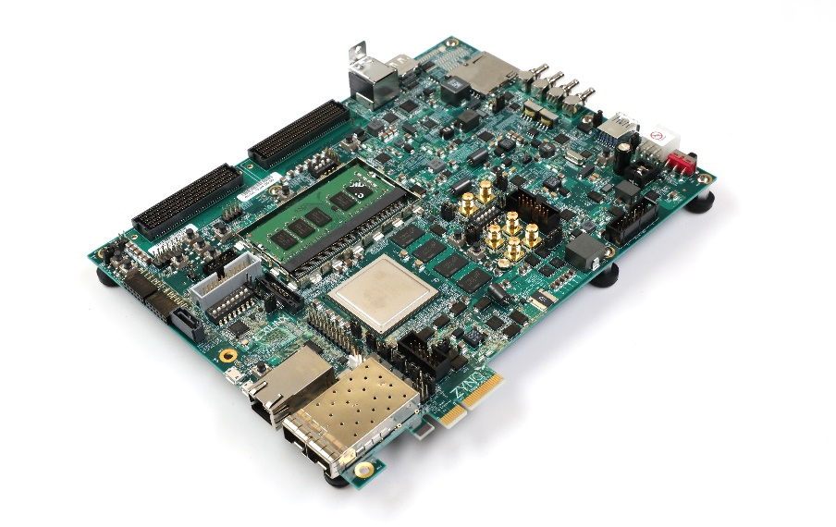 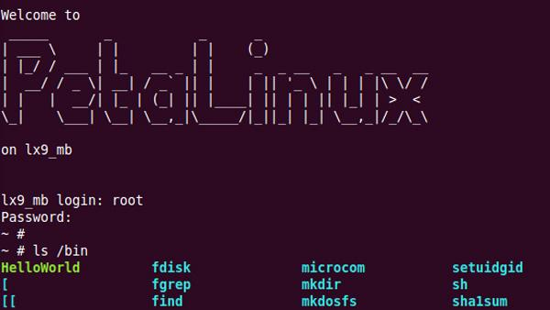

**Author: Erik Morales**

**Date: July, 2019**

**Version: 0.1**

**Email: 150014739@qq.com**

|  |  |  |  |
| --- | --- | --- | --- |
| **Rev** | **Description of Change** | **Author** | **Release Date** |
| 0.1 | First version release | Eric | July 9, 2019 |
|  |  |  |  |
|  |  |  |  |

**Content**

1 Overview 7

1.1 Purpose 7

1.2 Linux Character Device 8

1.3 Scope 9

1.4 Acronyms 9

1.5 Hardware/Software Requirement 10

2 Petalinux Installation 11

2.1 Petalinux Introduction 11

3 Vivado Project 11

3.1 Step 1 - Create Project 12

3.2 Step 2 - Create Custom Module 16

3.3 Step 3 - Create Block Design 23

4 Petalinux Project 42

4.1 Step 1 - Create Petalinux Project 42

4.2 Step 2 - Config Petalinux Project 42

4.3 Step 3 - Build Petalinux Project 44

4.4 Step 4 - Create Custom Modules 45

4.5 Step 5 - Build Petalinux Project 46

4.6 Step 6 - Package Petalinux Project 47

5 Linux Application Development 48

5.1 Step 1 – Board Setup 48

5.2 Step 2 – Tera Term Setup 49

5.3 Step 3 – Linux Setup 51

5.4 Step 4 – Linux Application 56

6 Reference 62

**Figure**

1‑1 System Overview 7

1‑2 Different Linux Devices 8

1‑3 Driver Interface for Hardware Devices 9

1‑4 Development Environment – Dell Laptop and ZCU106 Board 10

2‑1 Petalinux Installation Guide 11

3‑1 Vivado Block Diagram 12

3‑2 New Vivado Project – Project Name 12

3‑3 New Vivado Project – Select Project Type 13

3‑4 New Vivado Project – Add Sources 14

3‑5 New Vivado Project – Add Constraints 14

3‑6 New Vivado Project – Select Board 15

3‑7 New Vivado Project – Finish 15

3‑8 Custom Module – Create New IP 16

3‑9 Custom Module – Create Peripheral 17

3‑10 Custom Module – Peripheral Details 17

3‑11 Custom Module – Add Interfaces 18

3‑12 Custom Module – Finish 18

3‑13 Custom Module Modification – Part 1 19

3‑14 Custom Module Modification – Part 2 20

3‑15 Custom Module Modification – Part 3 20

3‑16 Open “IP Catalog” 21

3‑17 Open “Edit in IP Packager” 21

3‑18 Open Custom IP Project 22

3‑19 Custom Module - Merge Changes 22

3‑20 Custom Module – Re-Package IP 23

3‑21 Create Block Design 24

3‑22 Add Block Diagram File 24

3‑23 Add ZYNQ Processor 25

3‑24 ZYNQ Module in Block Diagram 25

3‑25 Add IP to Block Design 26

3‑26 Click Block Automation 26

3‑27 Run Block Automation 27

3‑28 Click Connection Automation 27

3‑29 Run Connection Automation 28

3‑30 Full Block Diagram 28

3‑31 Regenerate Layout 29

3‑32 Regenerated Results 29

3‑33 Make LED External Step 1 30

3‑34 Make LED External Step 2 31

3‑35 Make SW External Step 1 31

3‑36 Make SW External Step 2 32

3‑37 Make Pin External Results 32

3‑38 Validate Design 33

3‑39 Waring – No Pin Assignment 33

3‑40 Create HDL Wrapper 34

3‑41 Run HDL Wrapper 34

3‑42 Generated System Wrapper 35

3‑43 Add Sources 35

3‑44 Add or Generate Constraints 36

3‑45 Add or Create Constraints 36

3‑46 Set Up Constraint File Name 37

3‑47 Create Constraint File 37

3‑48 Edit Constraint File 38

3‑49 Generate Bitstream 38

3‑50 Export Hardware 39

3‑51 Export Hardware – Include Bitstream 39

3‑52 Click “Launch SDK” 40

3‑53 Launch SDK 41

3‑54 Xilinx SDK 41

4‑1 Create Petalinux Project 42

4‑2 Copy hdf file to Virtual Machine 42

4‑3 Config Petalinux Project 43

4‑4 Move to “DTG Seetings” 43

4‑5 Change Machine Name 43

4‑6 Build Petalinux Project 44

4‑7 Generated Files by Build Command 44

4‑8 Content in “pl.dsti” File 45

4‑9 Create Custom Modules 45

4‑10 Custom Modules Direction 46

4‑11 Custom Modules Default Driver 46

4‑12 Build Petalinux Project 47

4‑13 Move to Package Folder 47

4‑14 Package Petalinux Files 47

4‑15 Package Results 48

5‑1 Petalinux Files for SD Card 48

5‑2 Board Running Configuration 49

5‑3 Open Tera Term 49

5‑4 Open Teraterm “Serial Port...” 50

5‑5 Set Teraterm “Serial Port...” 50

5‑6 Login to Board 51

5‑7 Login Status 51

5‑8 Move to Extra Folder 52

5‑9 Input “dmesg” Command 52

5‑10 Display Driver Status 53

5‑11 Display Devices 53

5‑12 Default Devices 54

5‑13 Make Custom Module Device 54

5‑14 Display Devices 55

5‑15 Updated Devices with Custom Device 55

5‑16 Create Linux Application Project 56

5‑17 Linux Project Configuration 57

5‑18 Select Linux Project Template 57

5‑19 Update Helloworld.c 58

5‑20 Open “Run Configurations…” 58

5‑21 Create “Xilinx C/C++ application (System Debugger)” 59

5‑22 Get Board IP 59

5‑23 Create Linux Agent 60

5‑24 Linux Agent Configuration 60

5‑25 Run Linux Application 61

5‑26 Linux Application Message Out 61

# Overview

## Purpose

ZYNQ is a very hot topic, but most of introduction just focuses on how to develop bare-mental program. This project shows one full project demo including custom IP development, Petalinux project development, Linux character device driver development. It could give user the full story on how to develop Linux device driver for custom module.

This document shows how to develop one custom module for LED and control LED by Linux program.

1. We will first develop hardware project in Vivado - Windows Environment;
2. Then develop Linux Device driver in Petalinux - Ubuntu Environment;
3. Later develop Linux program by Xilinx SDK - Windows Environment;

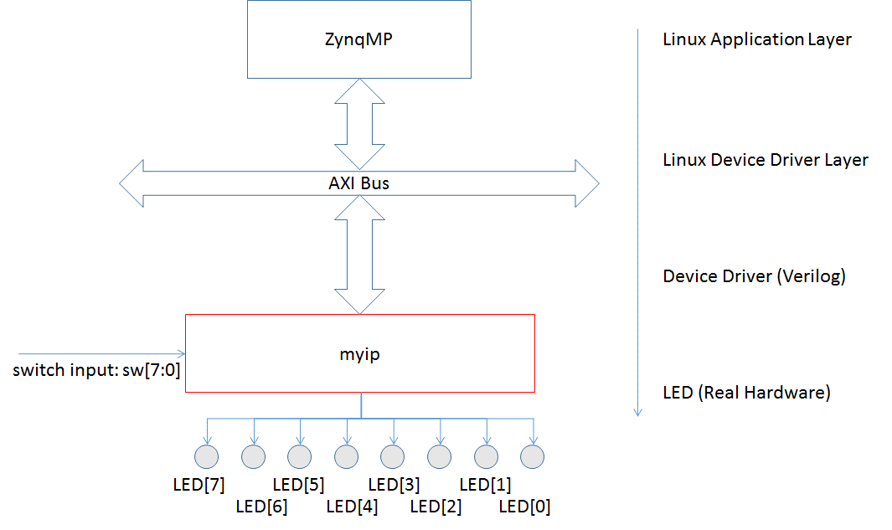

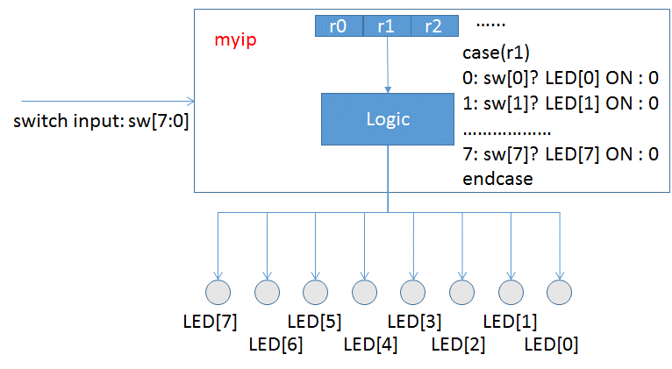

1‑1 System Overview

## Linux Character Device

Each Linux module usually implements one of three types, and thus is classifiable as a char module, a block module, or a network module. The three classes are the following:

* Character devices
  + A character (char) device is one that can be accessed as a stream of bytes (like a file)
* Block devices
  + Like char devices, block devices are accessed by filesystem nodes in the /dev directory. A block device is something that can host a filesystem, such as a disk.
* Network interfaces
  + Any network transaction is made through an interface, that is, a device that is able to exchange data with other hosts.

In Linux, hardware devices are accessed by the user through special device files. These files are grouped into the /dev directory, and system calls *open, read, write, close, lseek, mmap* etc. are redirected by the operating system to the device driver associated with the physical device. The device driver is a kernel component (usually a module) that interacts with a hardware device. In this project, we are going to implement one Character Device Driver as an example how to driver it through Linux. The most important step is how to implement system call functions like *open, read, write, close, probe* and so on.

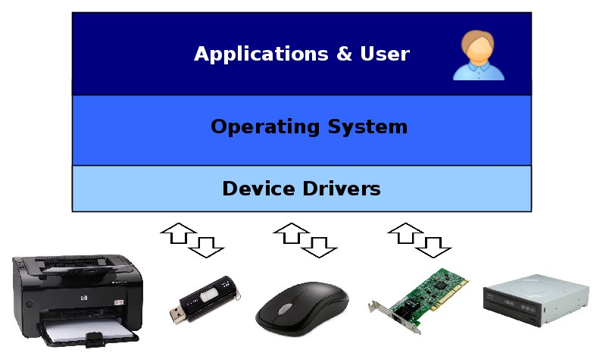

1‑2 Different Linux Devices

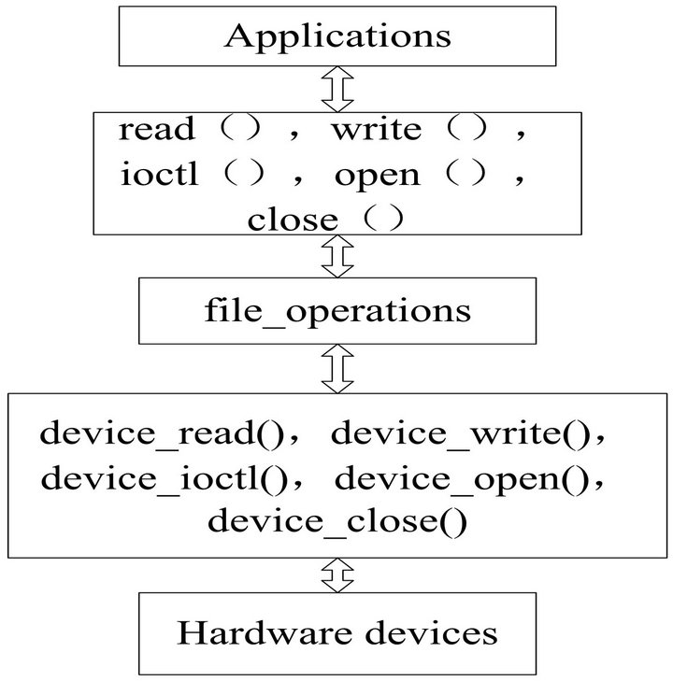

1‑3 Driver Interface for Hardware Devices

## Scope

This document is intended as a general summary of below topics.

* Petalinux Installation
* Vivado Hardware Project
* Petalinux Project
* Linux Application
* Reference

## Acronyms

* FPGA – Field Programmable Gate Array
* SoC – System on Chip

## Hardware/Software Requirement

We are doing testing on the Windows 10 machine with Ubuntu 16.4 on virtual machine. The detailed software and hardware configuration is as the following.

* Hardware
  + Dell laptop, Windows 10;
  + Intel® Core™ i5-8250U CPU @ 1.60GHz × 8;
  + 8GB memory;
  + Xilinx Zynq UltraScale+ MPSoC ZCU106 Evaluation Kit;
* Software
  + VMware® Workstation 14 Pro, 14.1.3 build-9474260;
  + Ubuntu 16.04 LTS;
  + Petalinux - petalinux-v2018.1-final-installer.run, 6.5GB;
  + Xilinx Vivado - Xilinx_Vivado_SDK_2018.1_0405_1.tar.gz, 17.7GB;

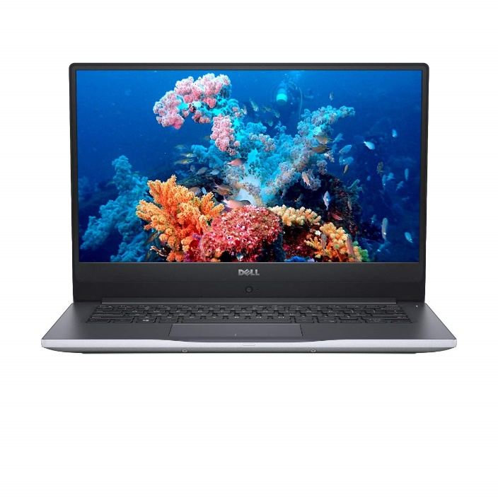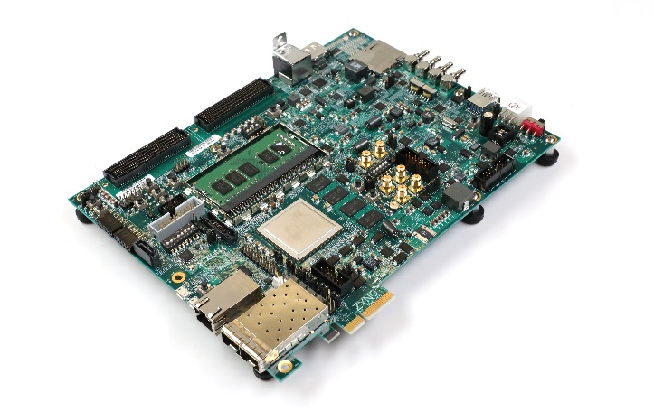

[Dell Inspiron 14 7472](https://laptopmedia.com/laptop-specs/dell-inspiron-14-7472-3/) Xilinx Zynq UltraScale+ MPSoC ZCU106 Evaluation Kit

1‑4 Development Environment – Dell Laptop and ZCU106 Board

# Petalinux Installation

## Petalinux Introduction

To install Petalinux, please refer to ug976. Remember that you first need to install Ubuntu 16.04 LTS on Virtual Machine. Then you can install Petalinux on Ubuntu.

* <https://www.xilinx.com/support/documentation/sw_manuals/petalinux2014_2/ug976-petalinux-installation.pdf>

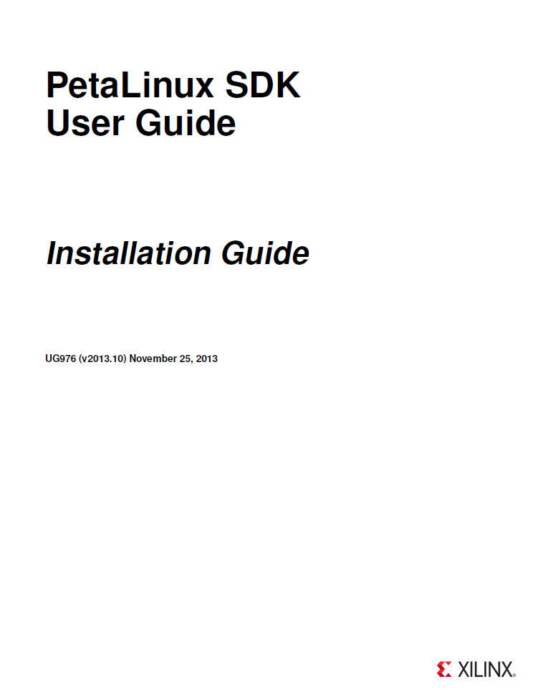

2‑1 Petalinux Installation Guide

# Vivado Project

This project, we are going to use ZYNQ to control LED ON/OFF in Linux. First we need to create hardware project and generate hdf file for software developer. The following pictures shows full block diagram for Vivado project. Next, we will introduce how to generate this block diagram step by step.

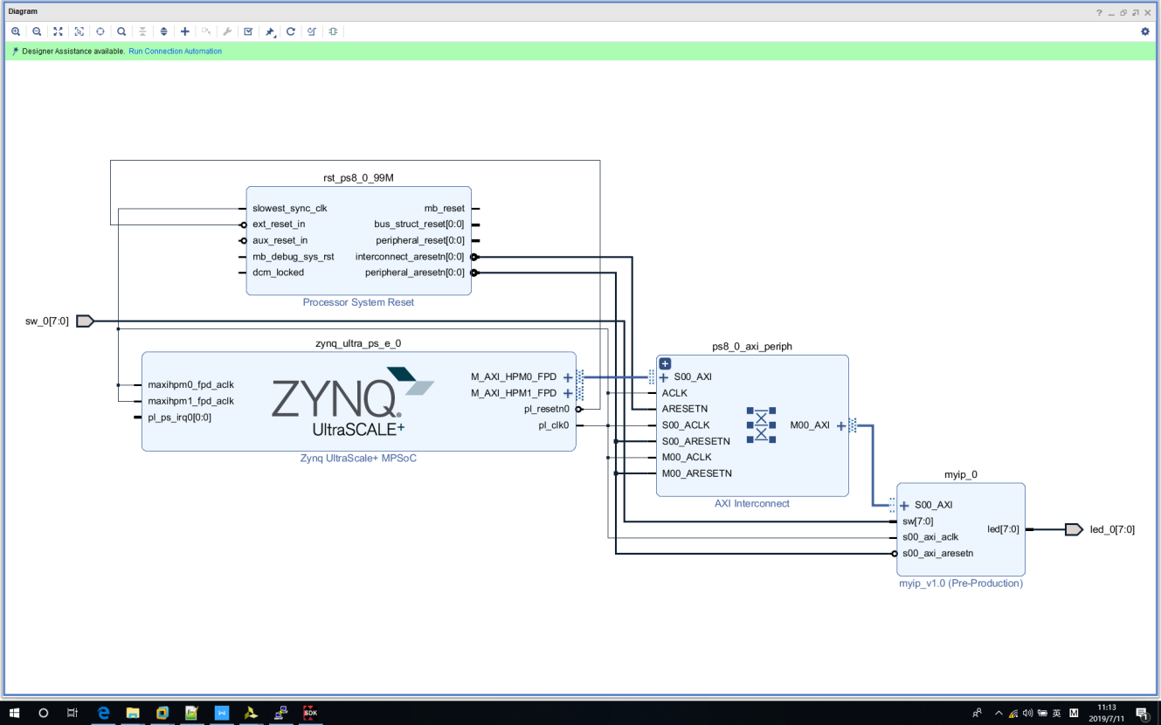

3‑1 Vivado Block Diagram

## Step 1 - Create Project

Click “*File->Project->New...”*

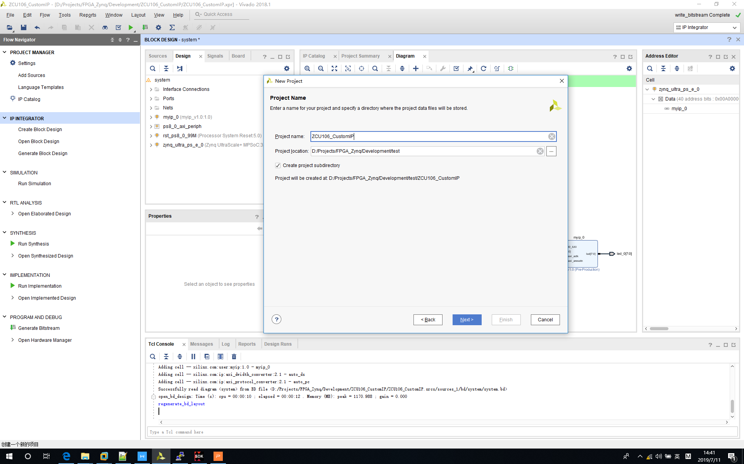

3‑2 New Vivado Project – Project Name

Select *“RTL Project”* option.

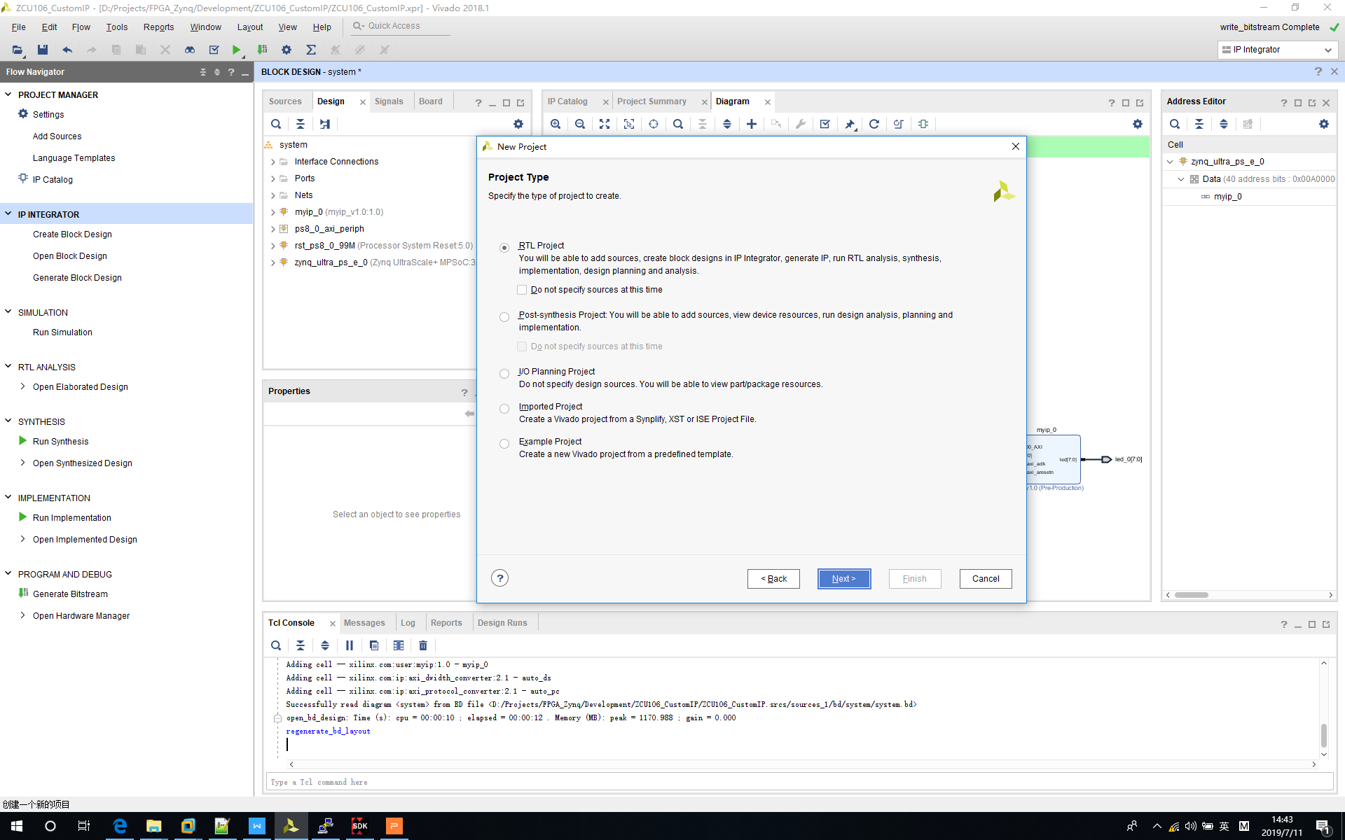

3‑3 New Vivado Project – Select Project Type

Leave empty here right now - Add verilog sources page.

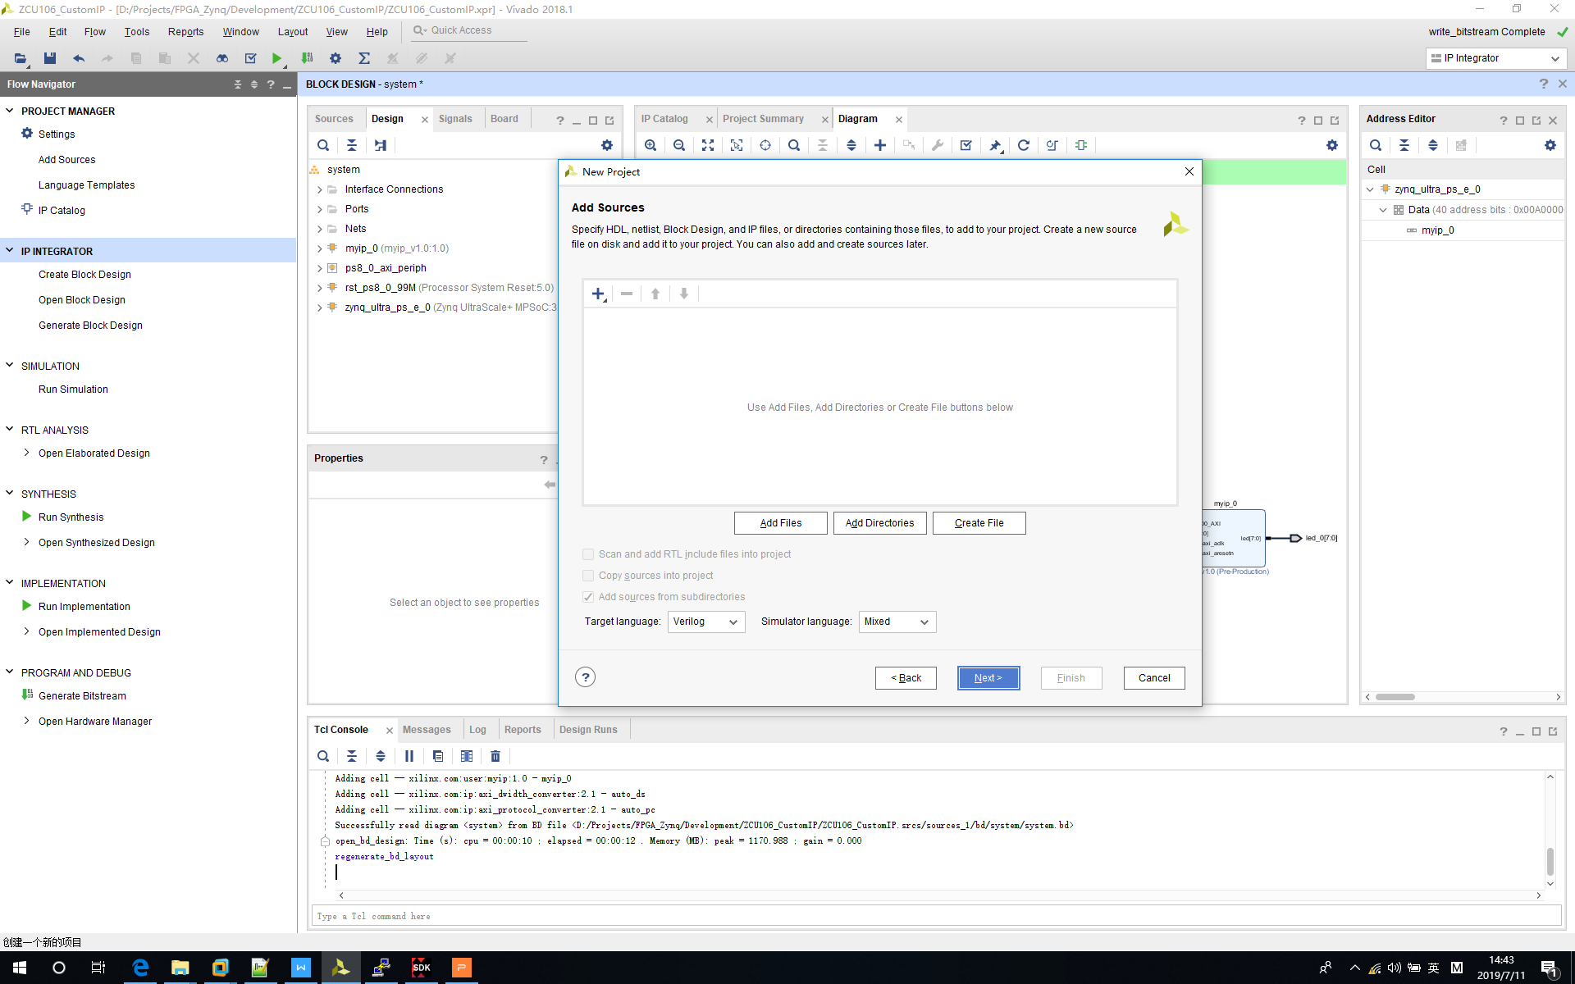

3‑4 New Vivado Project – Add Sources

Leave empty here right now - Add constraint sources page.

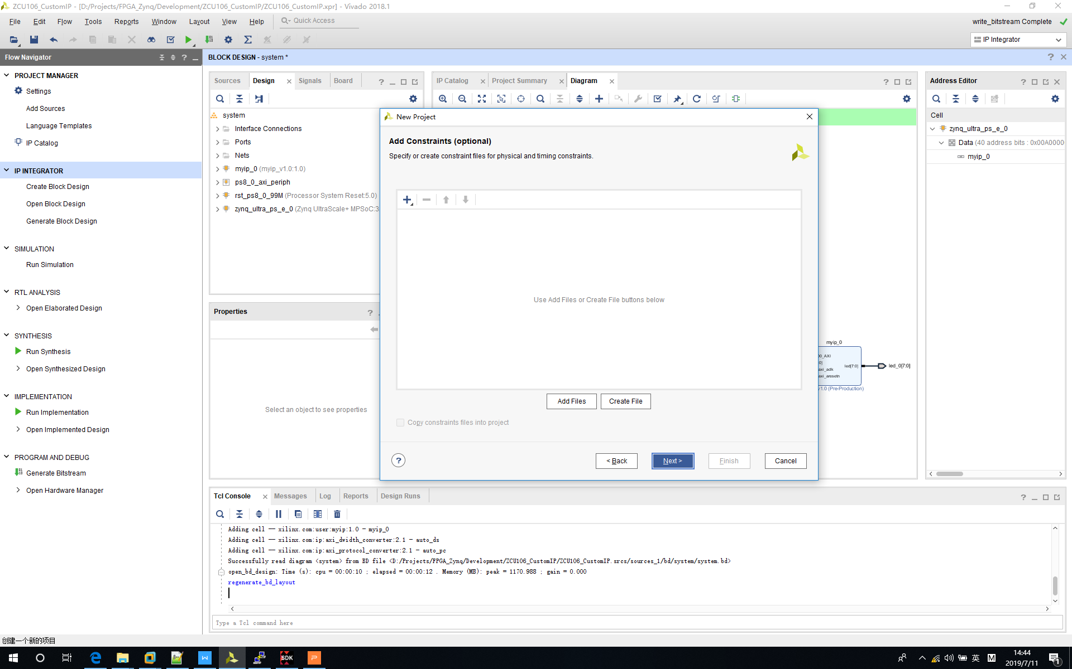

3‑5 New Vivado Project – Add Constraints

Select “*ZCU106*” board for current project.

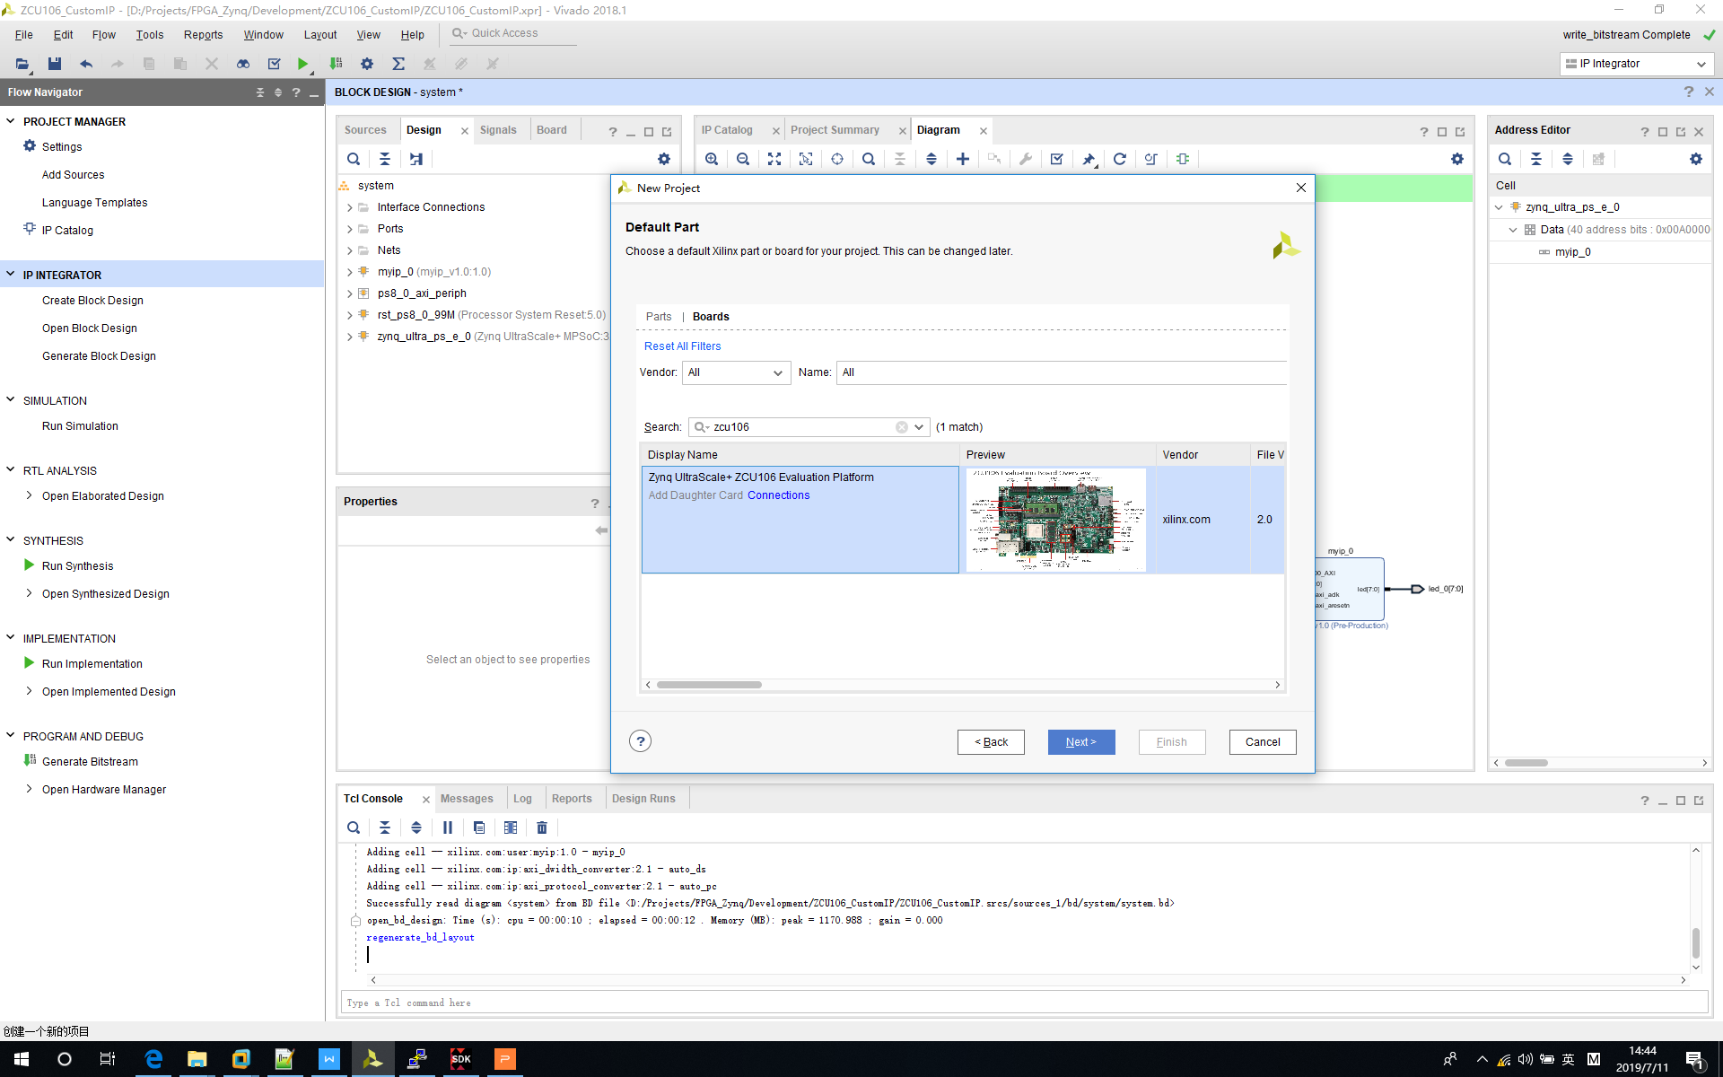

3‑6 New Vivado Project – Select Board

Click “Finish”.

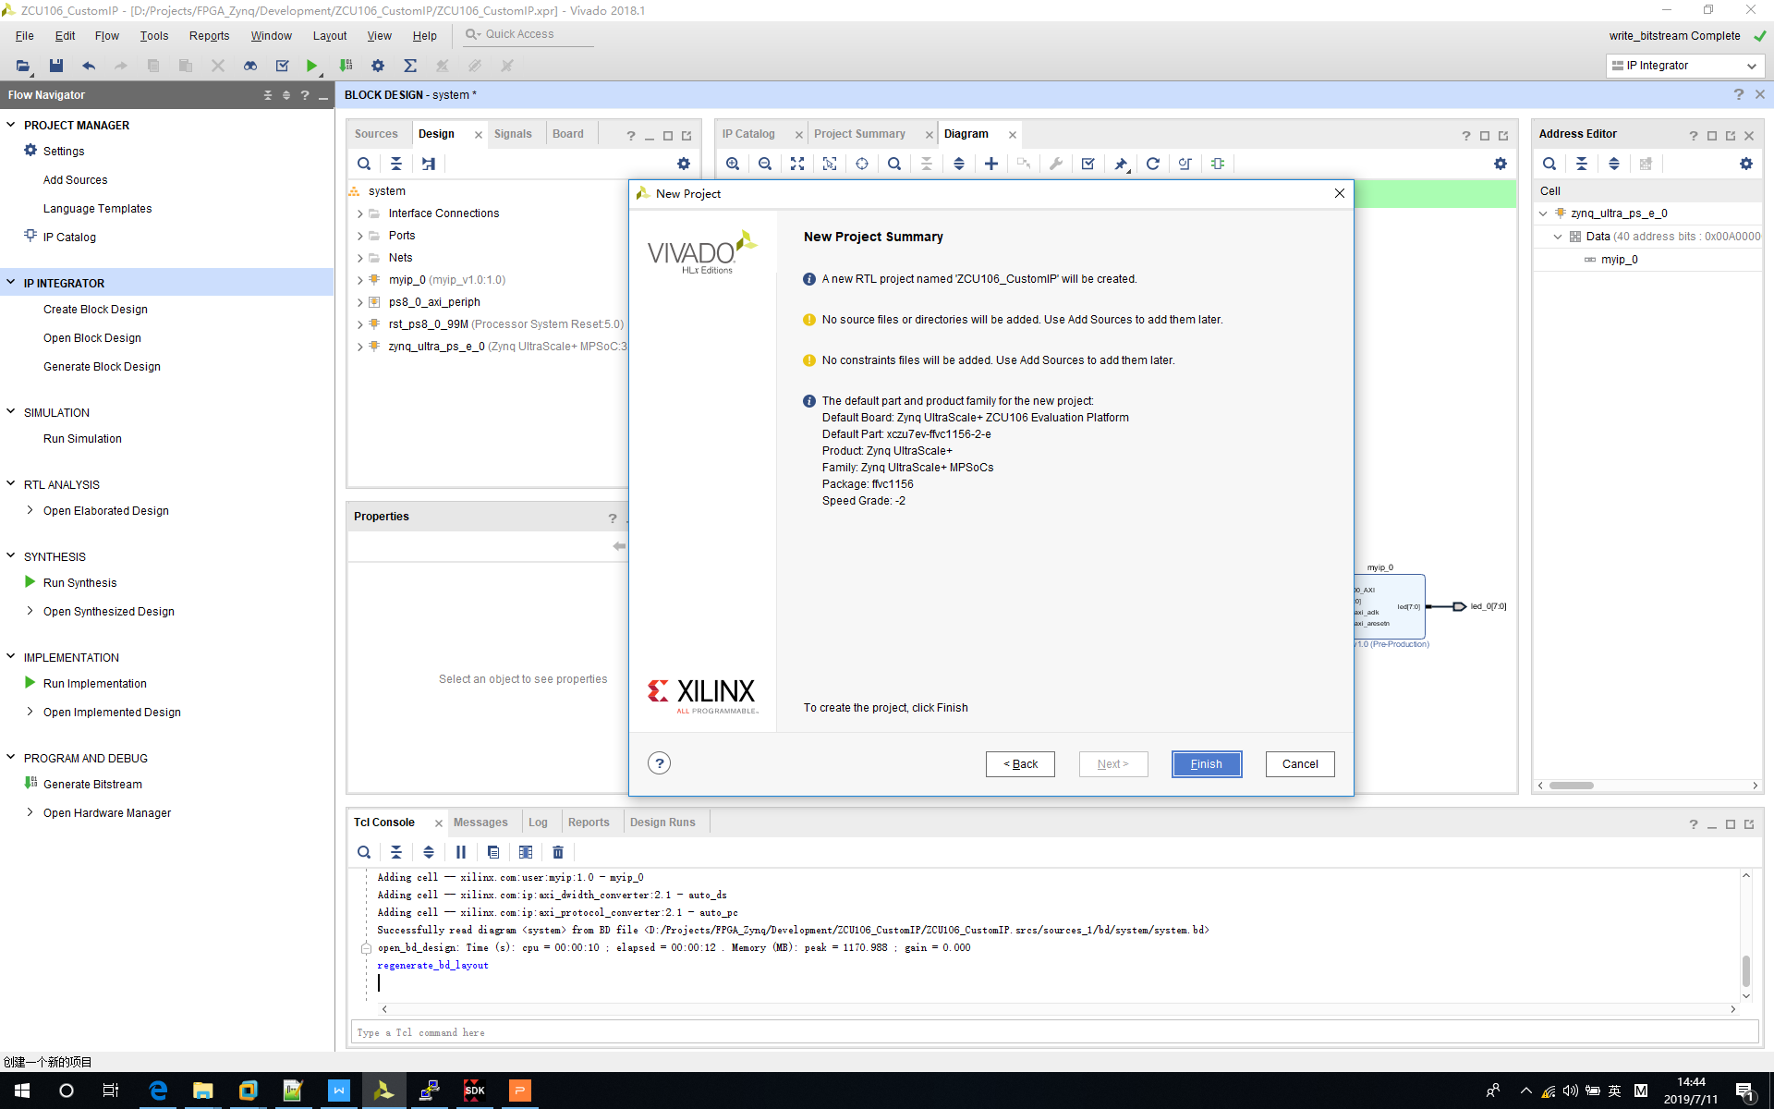

3‑7 New Vivado Project – Finish

## Step 2 - Create Custom Module

Until now, we have crated Vivado project, but we still need custom module and use that module to control LED.

Click “*Tools->Create and Package New IP...”.*

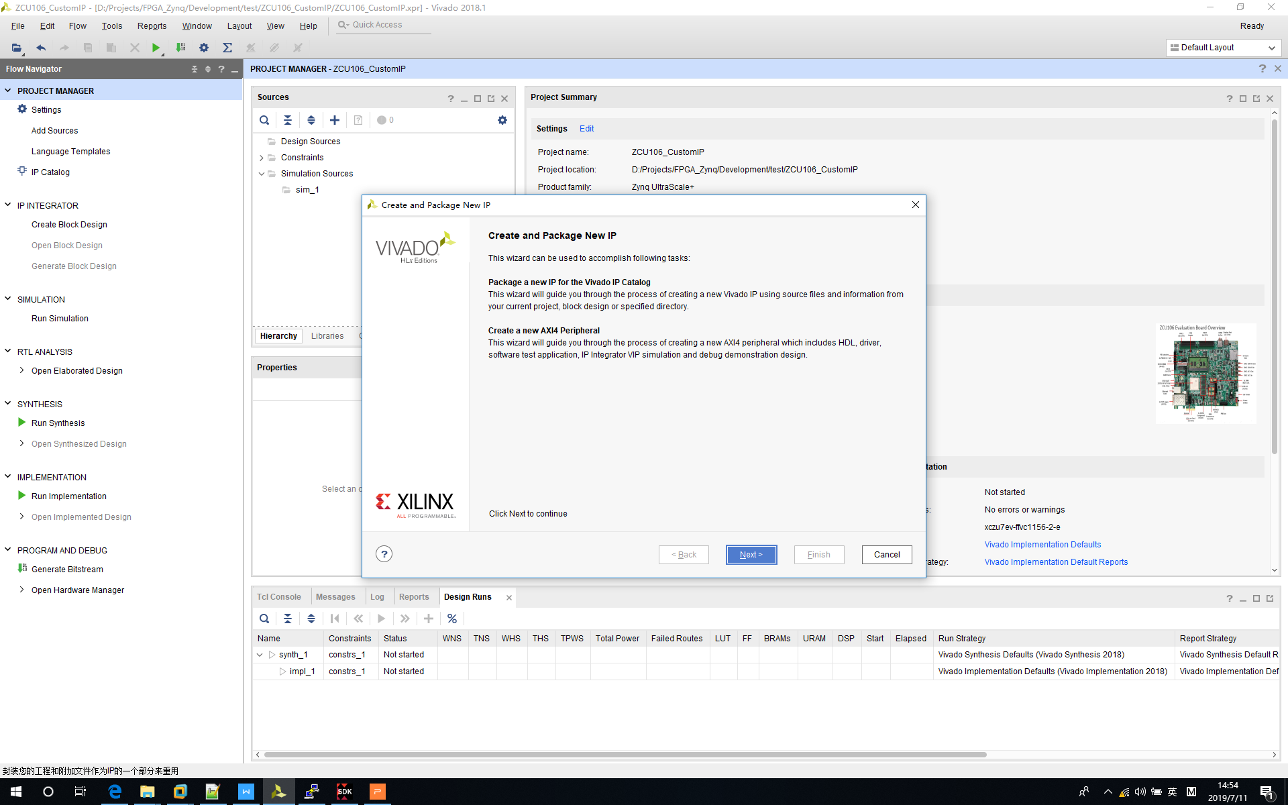

3‑8 Custom Module – Create New IP

Select “*Create a new AXI4 peripheral*”.

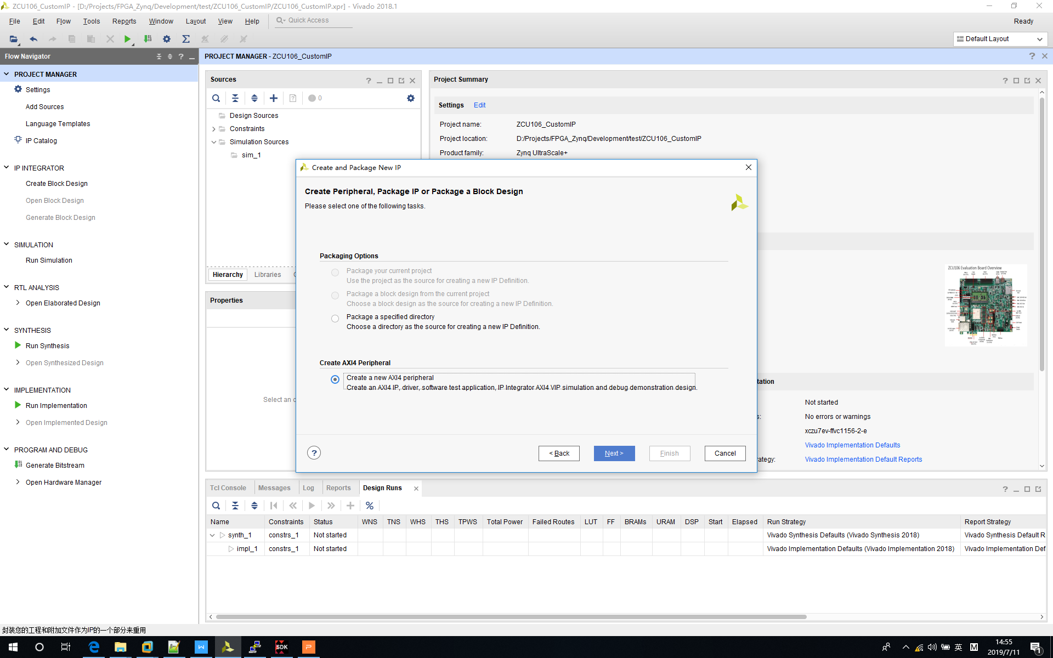

3‑9 Custom Module – Create Peripheral

Change repository path to current project (Not mandatory).

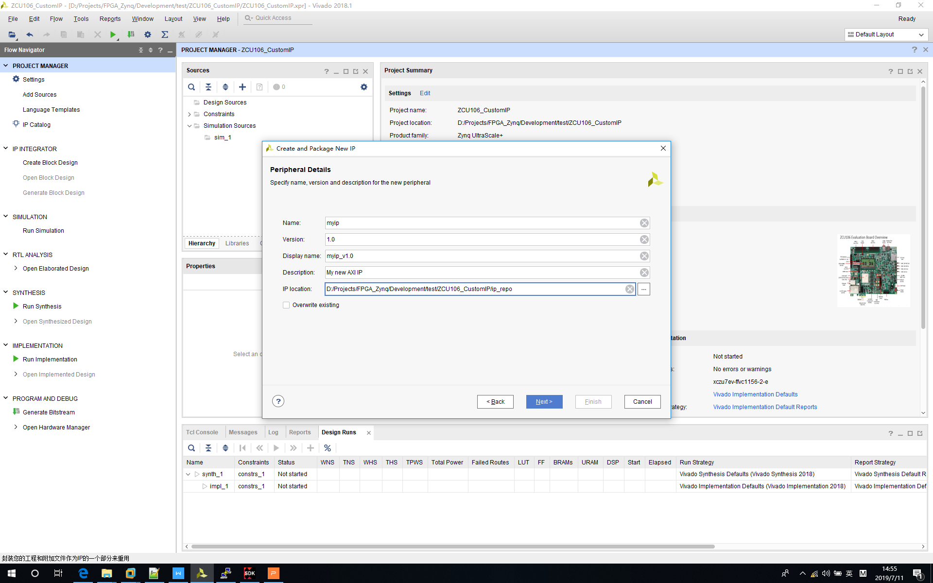

3‑10 Custom Module – Peripheral Details

Set “*Number of Resisters*” to 128.

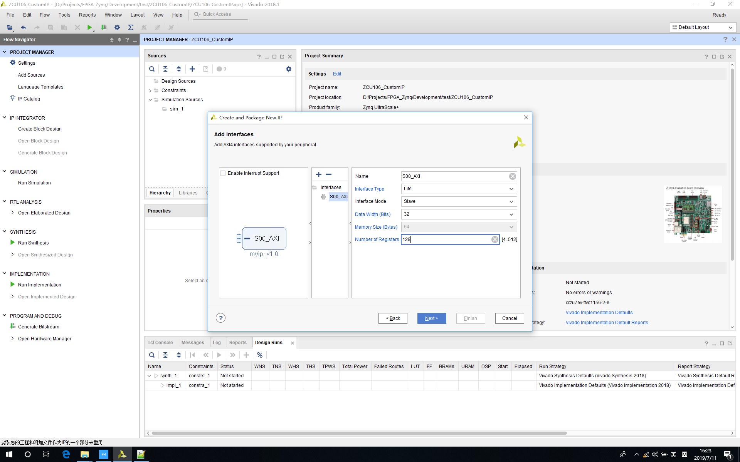

3‑11 Custom Module – Add Interfaces

Click “Finish”.

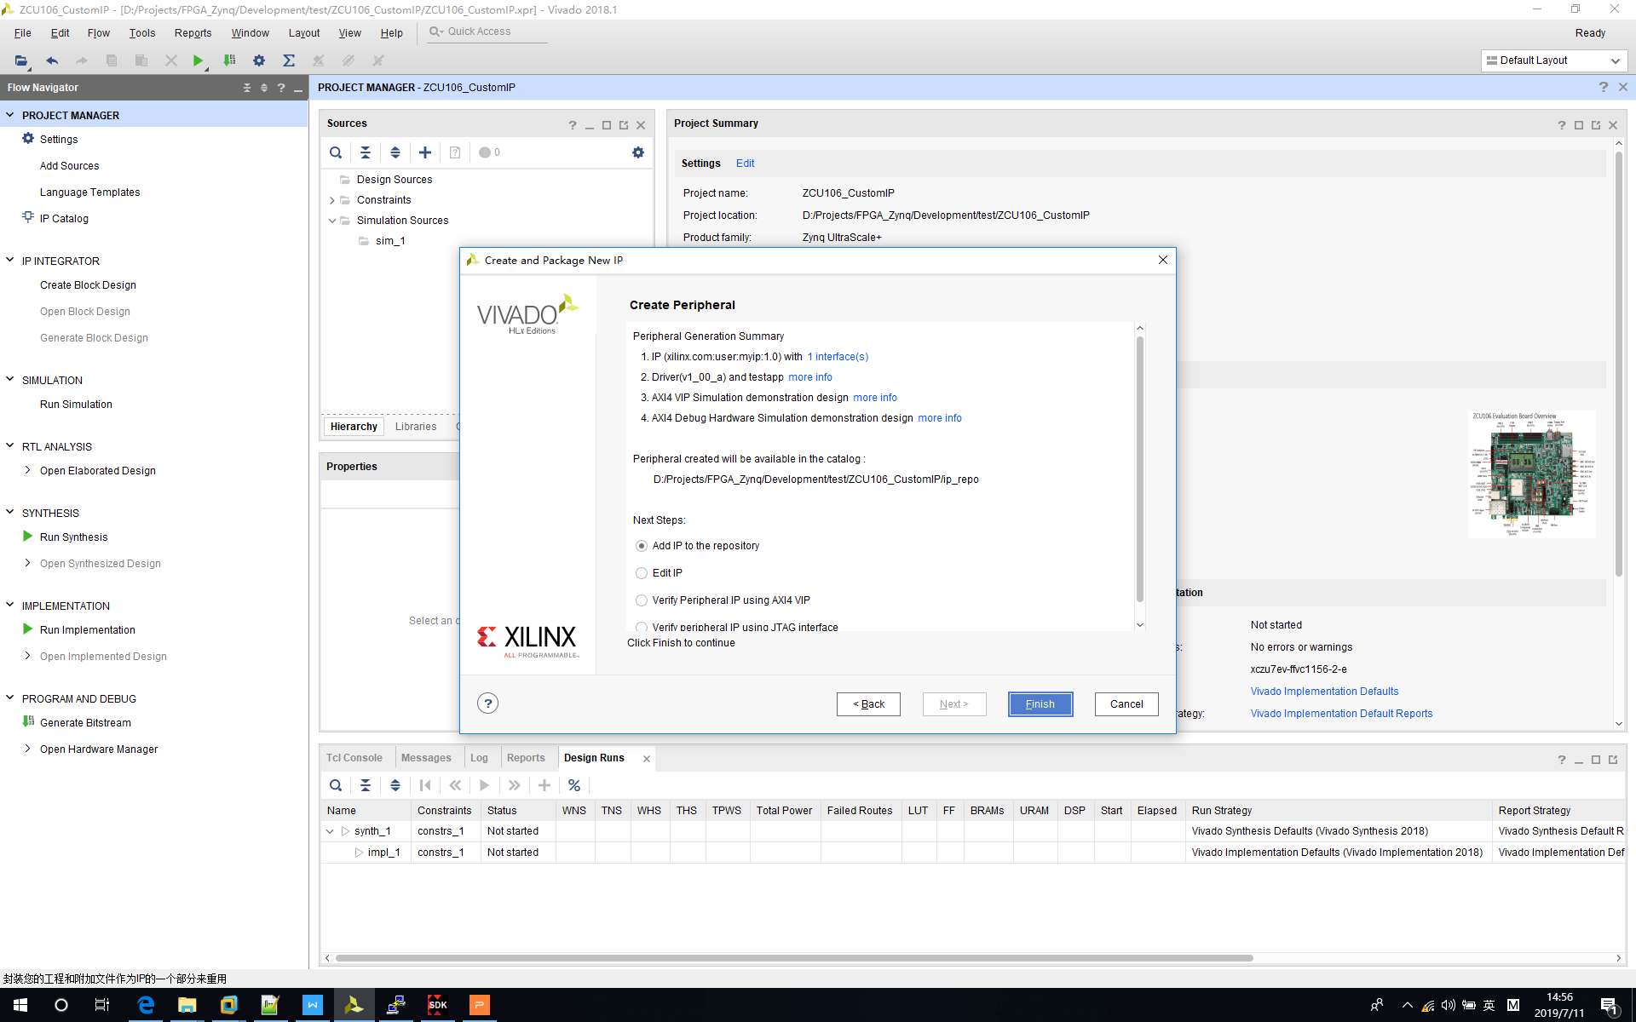

3‑12 Custom Module – Finish

After we have created standard IP module, we should make some modifications to control LEDs on board.

* Go into <project folder>/ip_repo/myip_1.0/hdl folder.
* Make modification to myip_v1_0.v according to the following pictures.

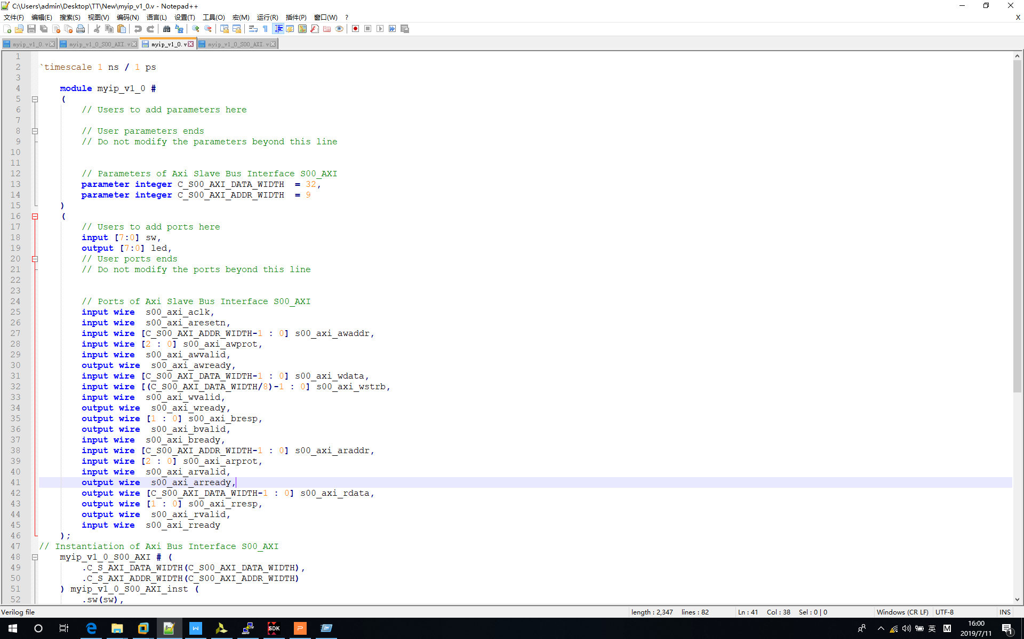

3‑13 Custom Module Modification – Part 1

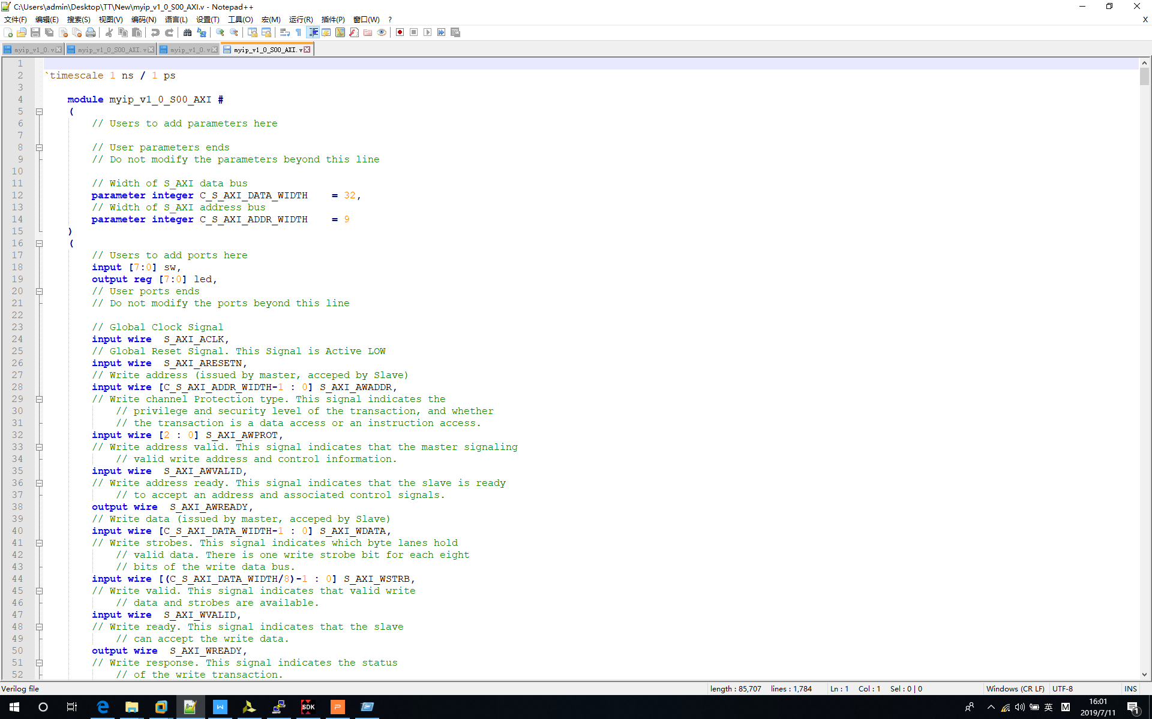

3‑14 Custom Module Modification – Part 2

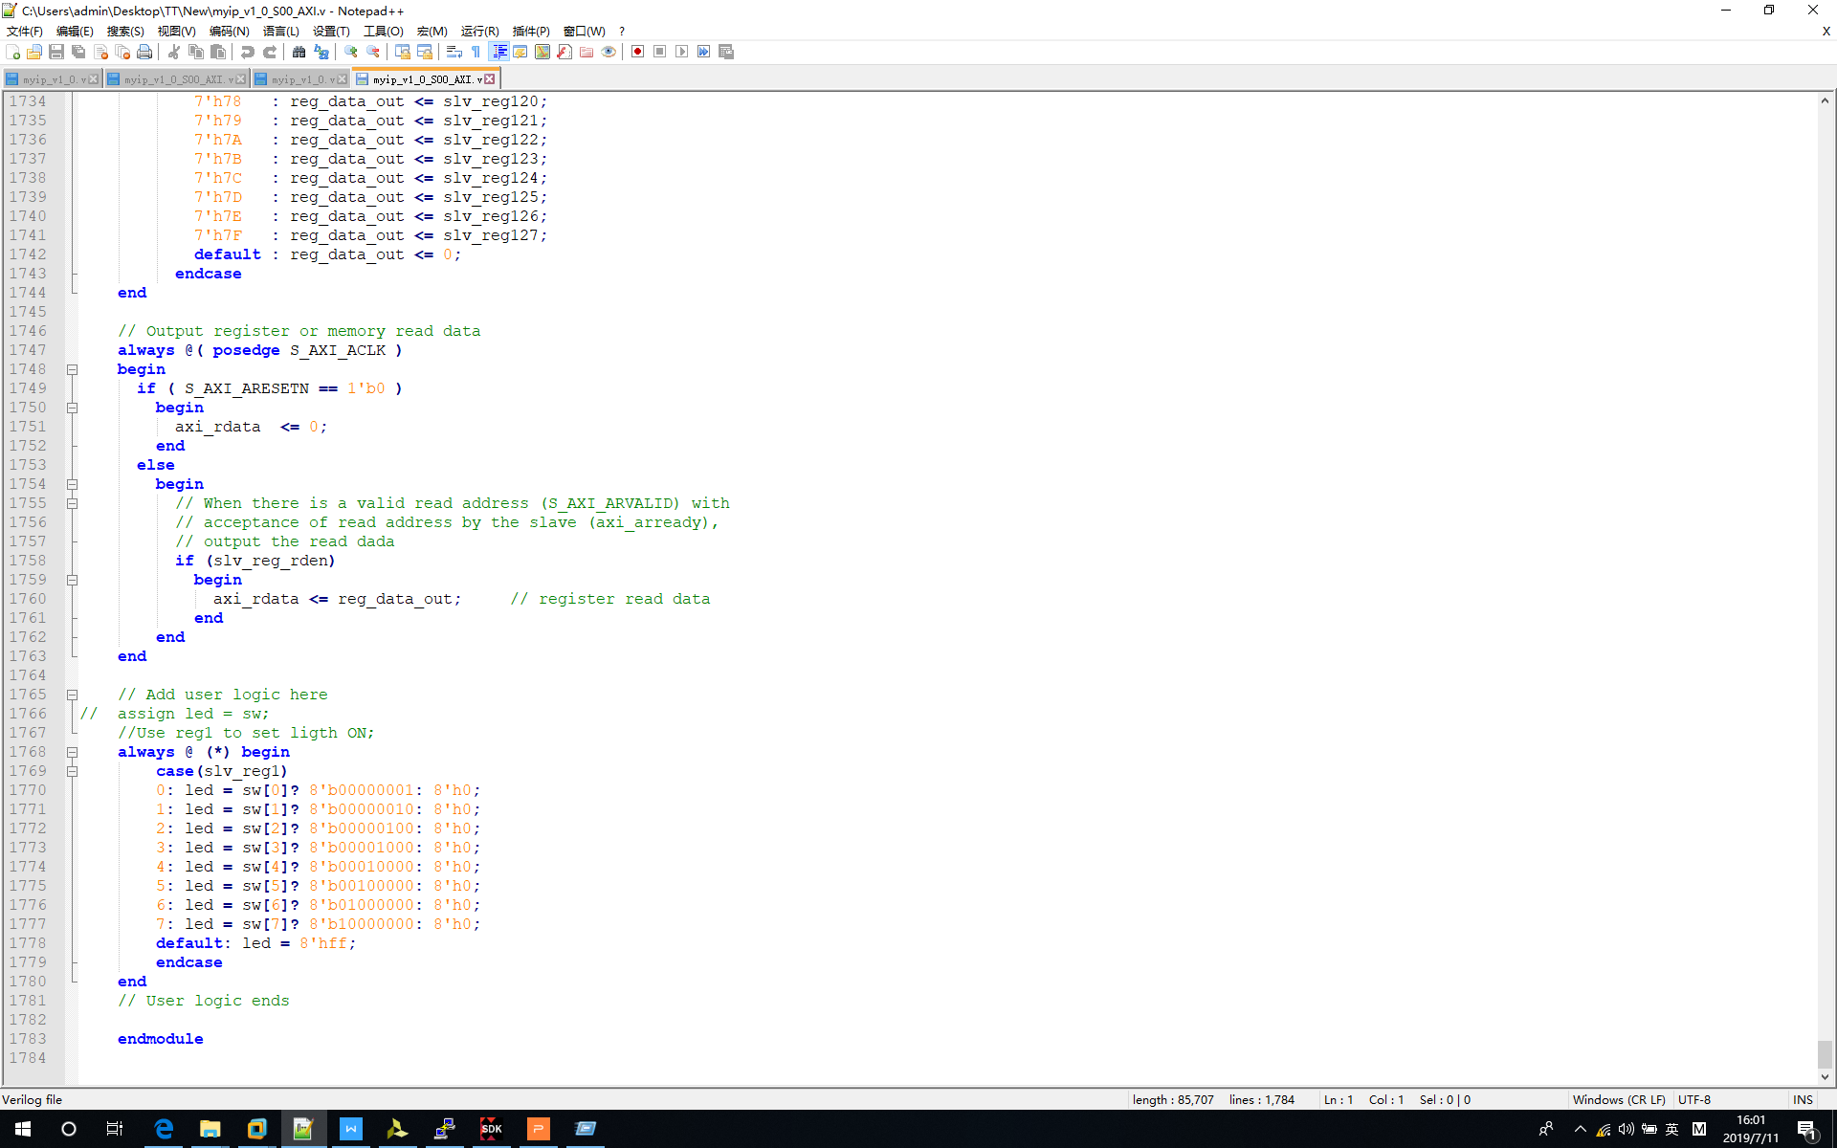

3‑15 Custom Module Modification – Part 3

After you make modification, please update IP library to include updated content.

Click “*Window->IP Catalog*”.

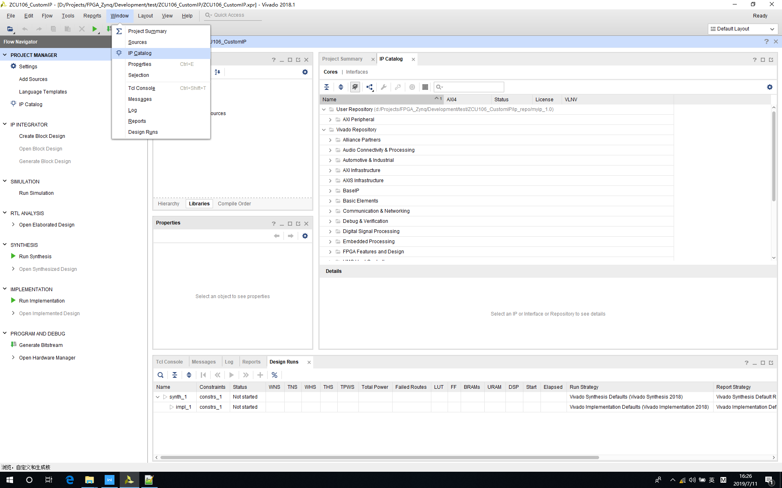

3‑16 Open “IP Catalog”

Click ”*Edit in IP Packager*”.

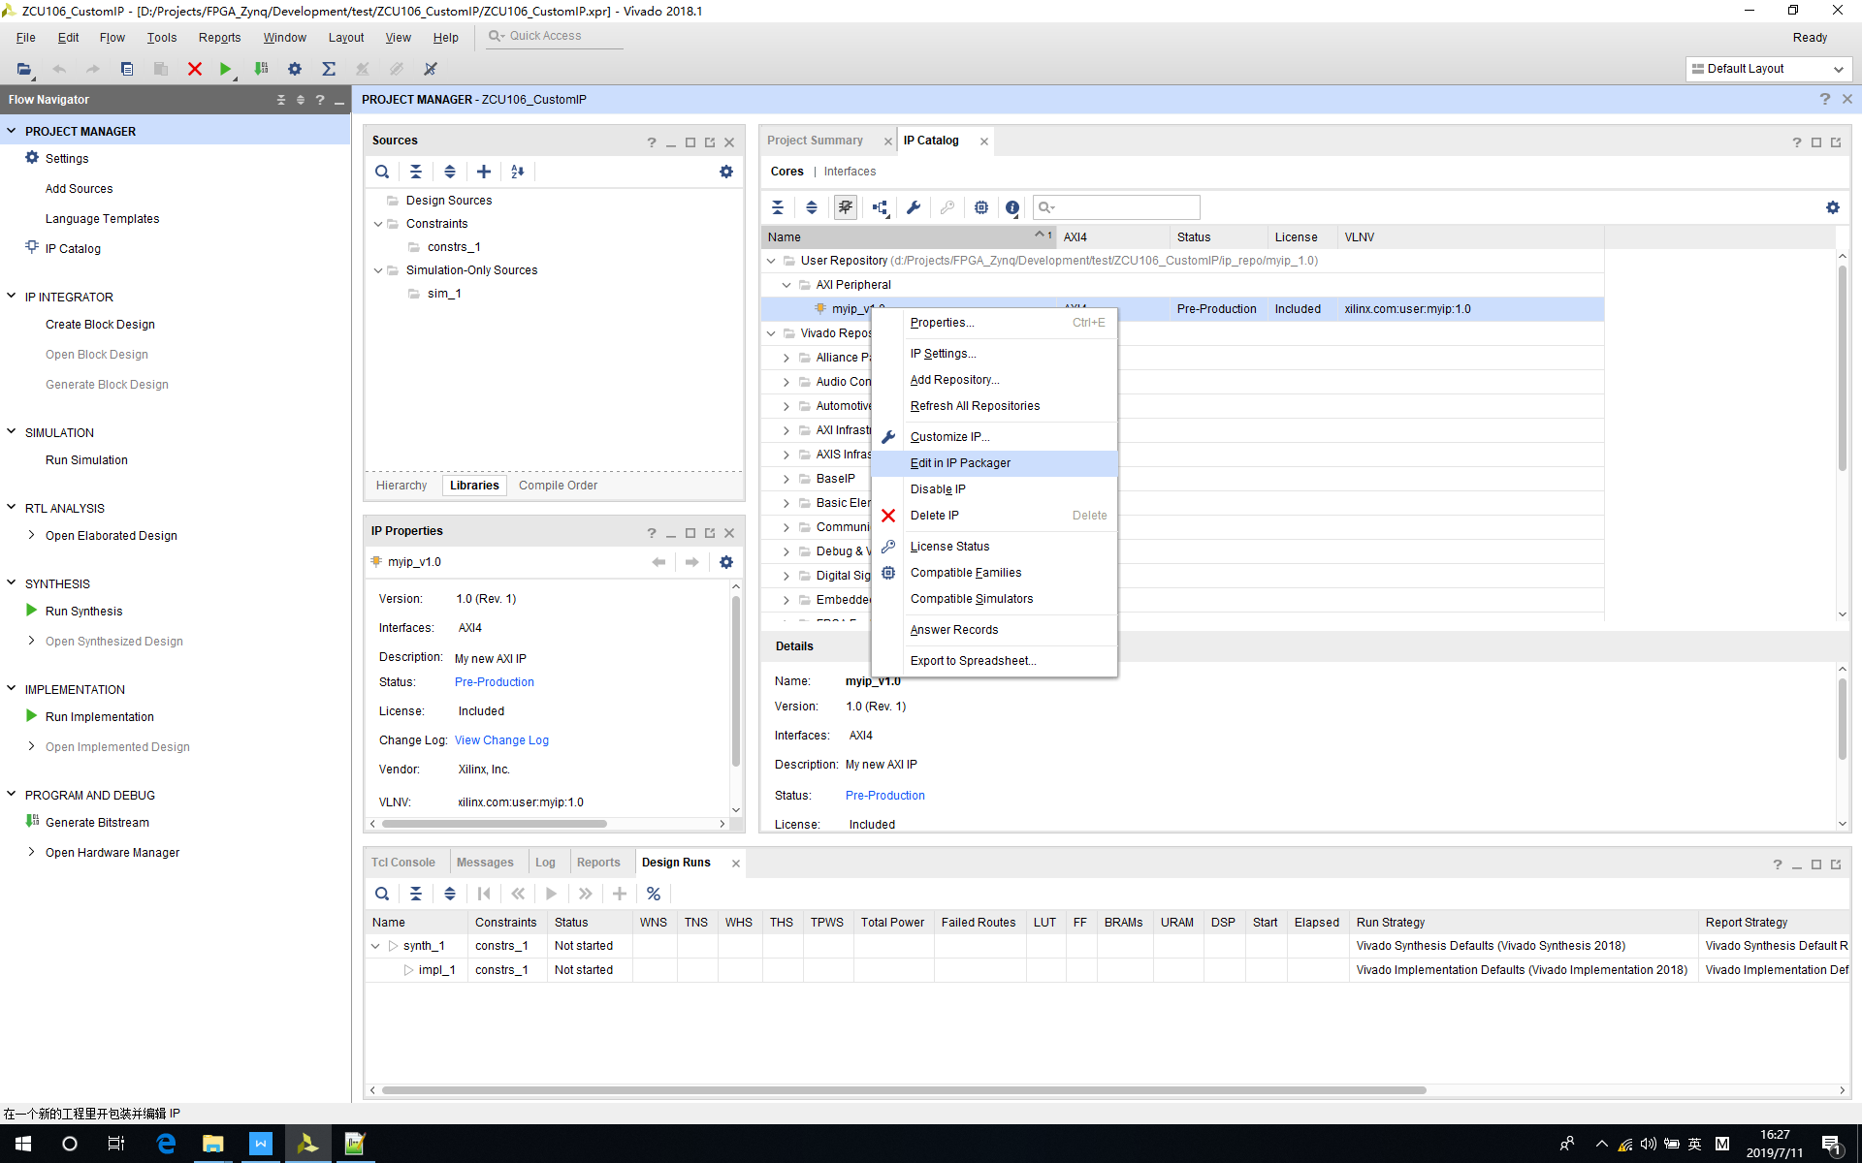

3‑17 Open “Edit in IP Packager”

Click ”*OK*”.

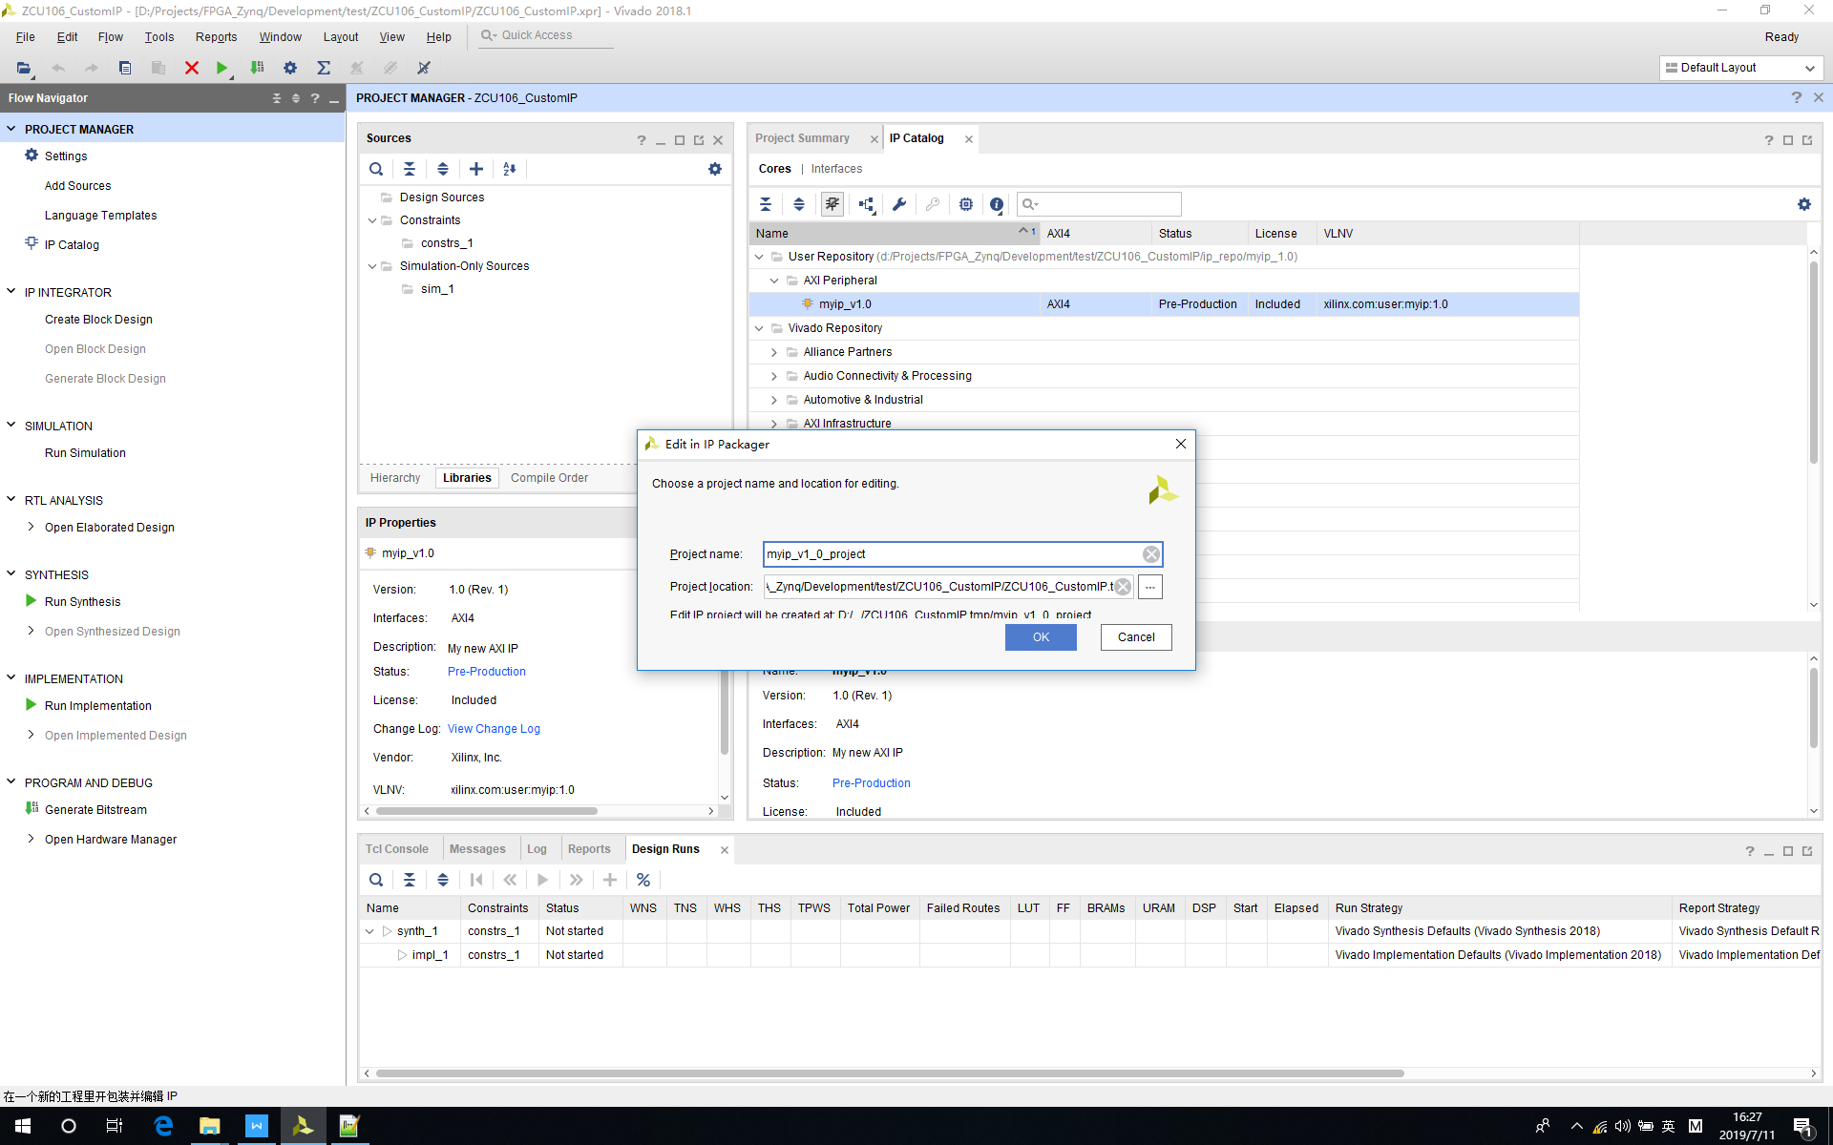

3‑18 Open Custom IP Project

Click “*Review and Package*” and Click All “*Merge Changes*”

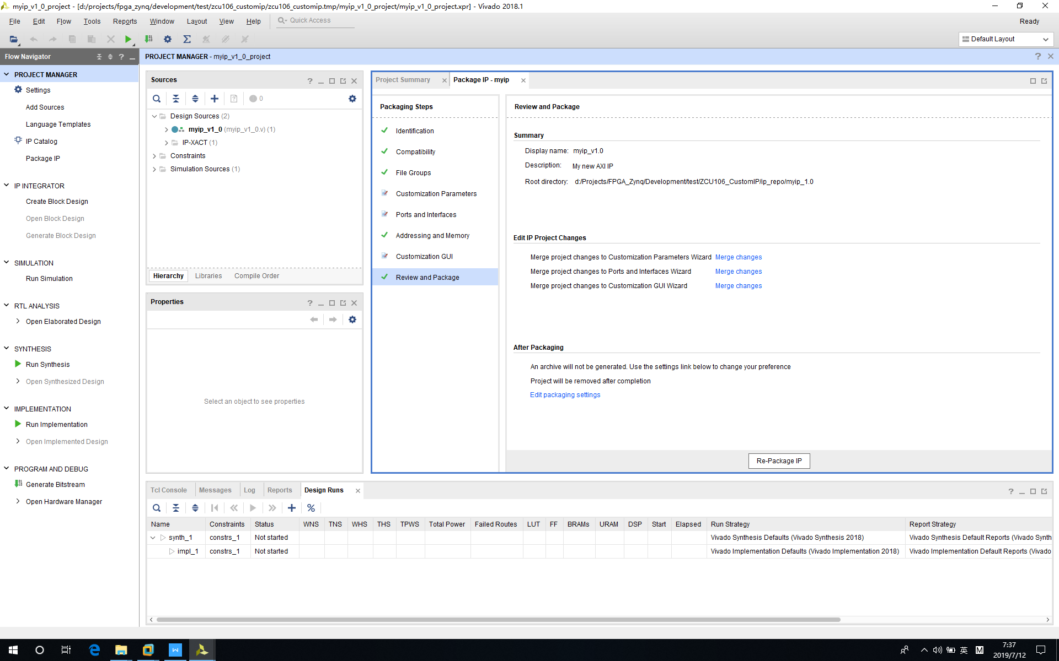

3‑19 Custom Module - Merge Changes

Click “*Re-Package IP*”

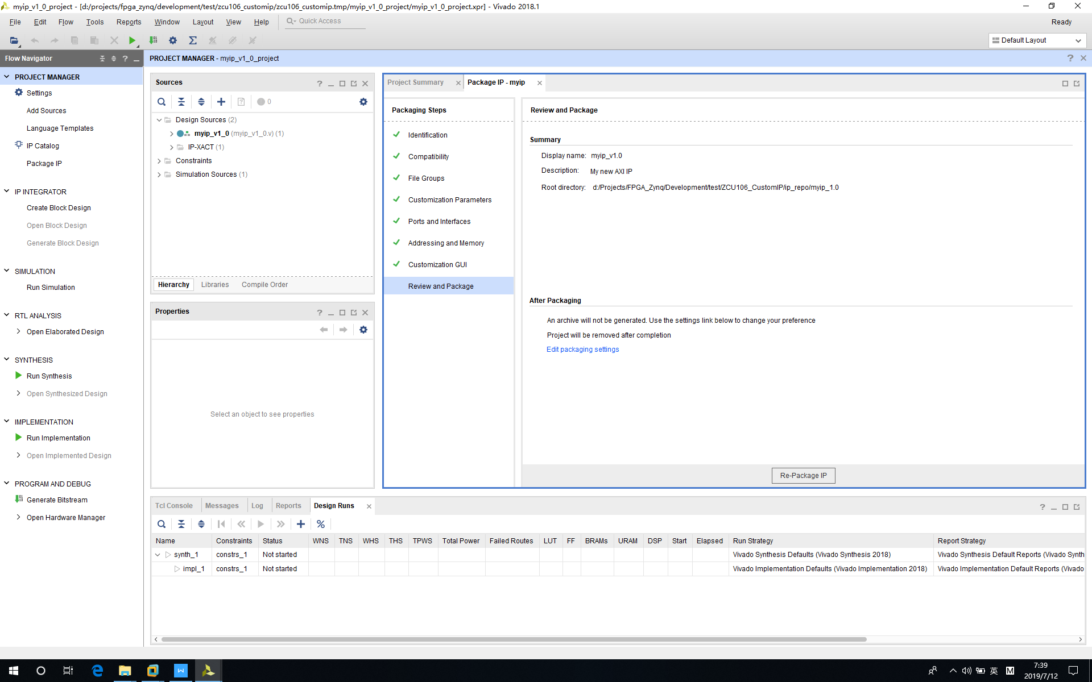

3‑20 Custom Module – Re-Package IP

## Step 3 - Create Block Design

Now we need to create block design to instantiate ZNYQ processor and myip module.

Click “*Create Block Diagram*” and rename it to “*system*”.

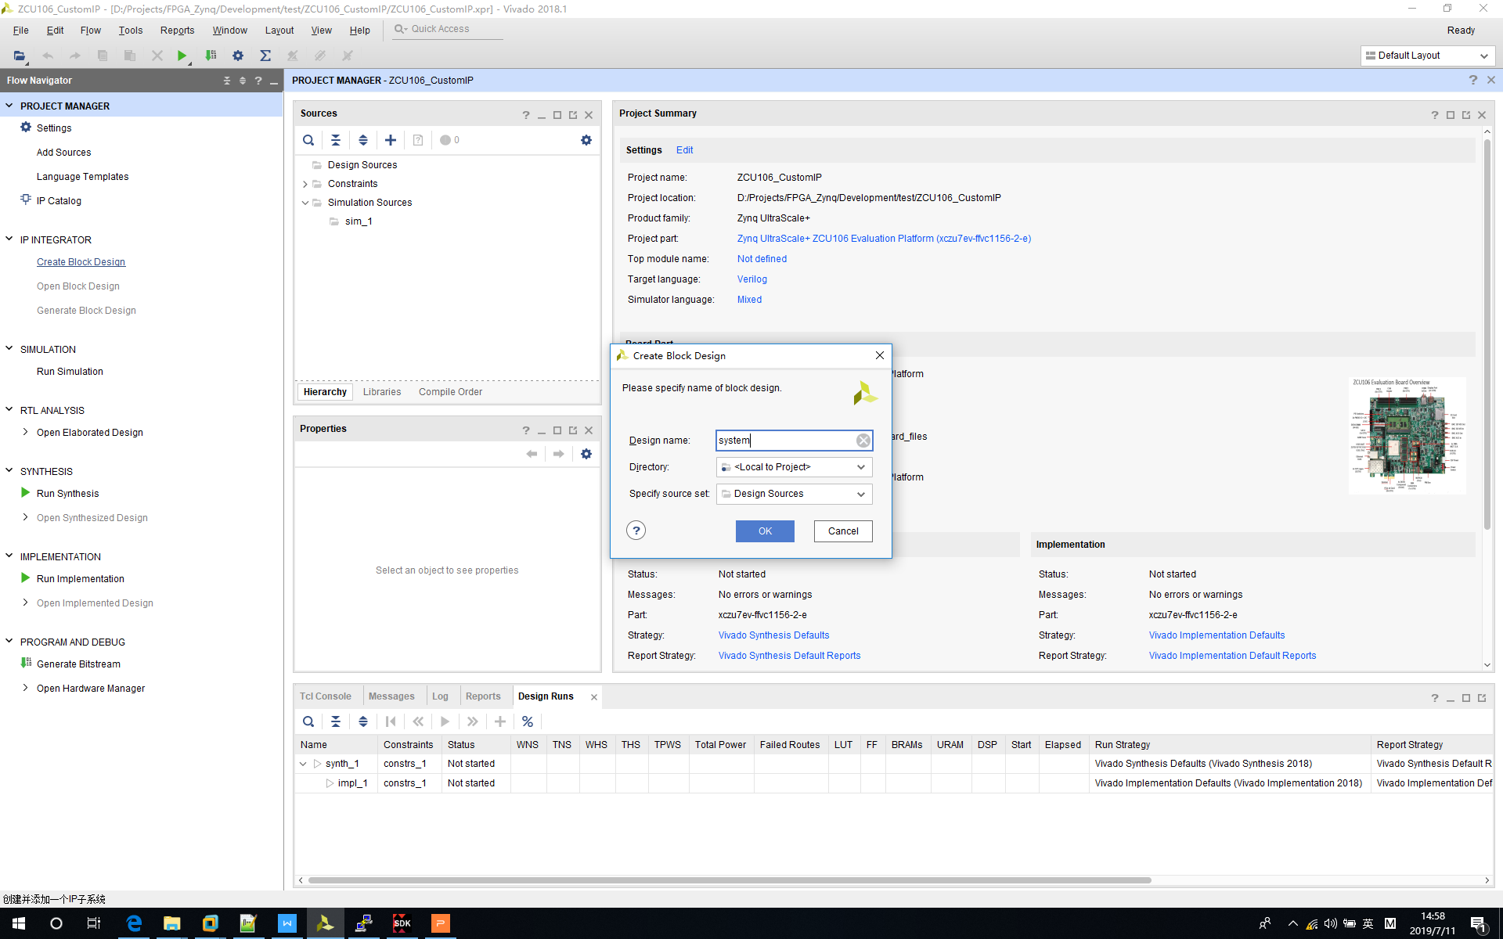

3‑21 Create Block Design

Click “+” button in diagram window.

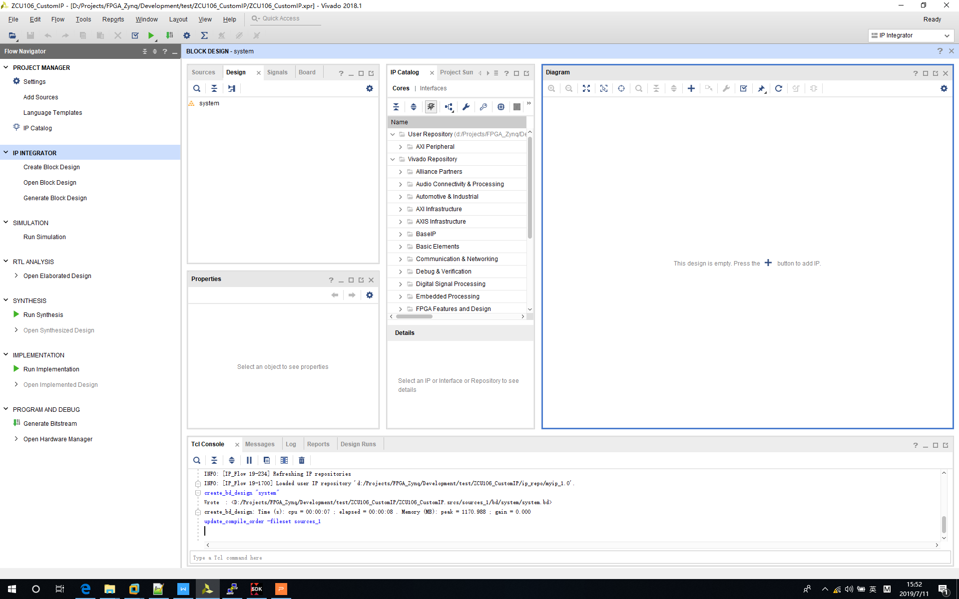

3‑22 Add Block Diagram File

Input “*zynq soc*” to to select “*Zynq UltraScale+MPSoC*”.

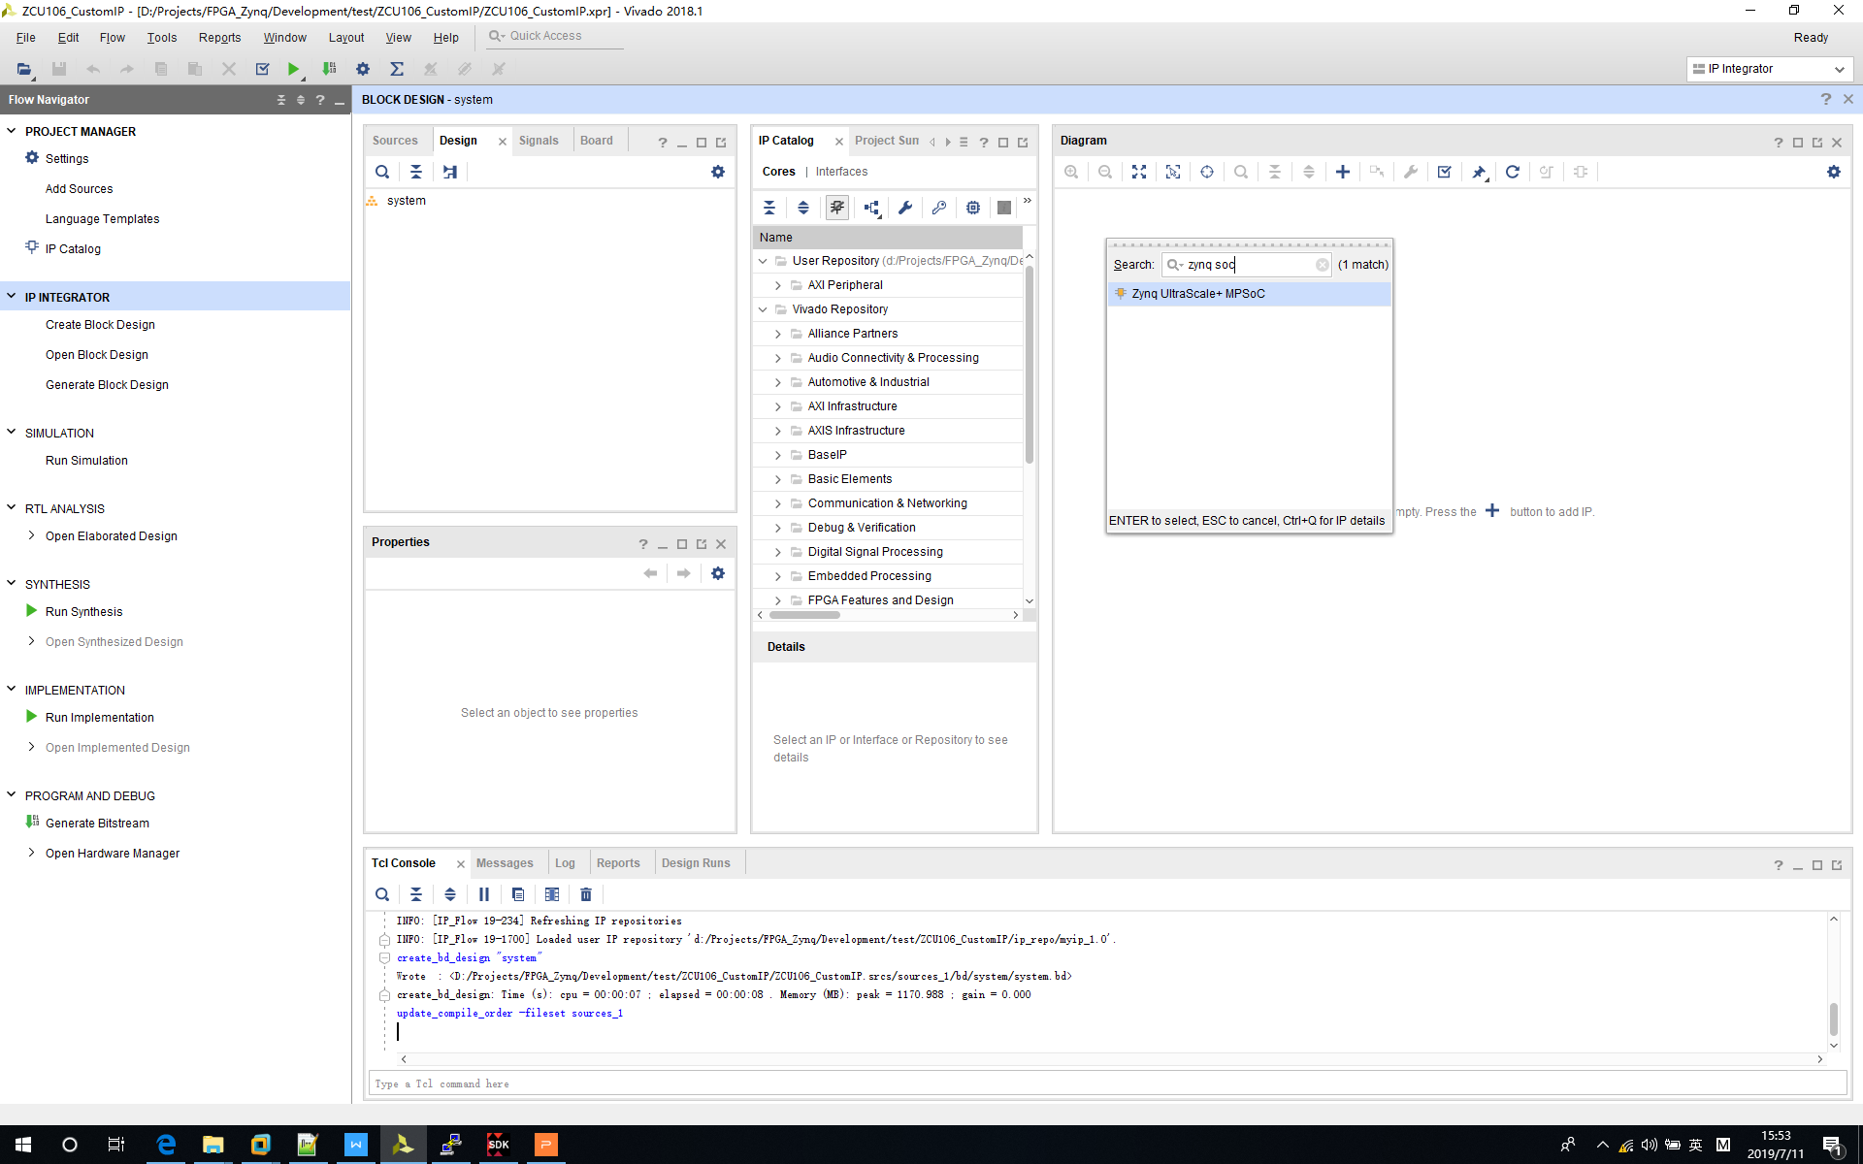

3‑23 Add ZYNQ Processor

ZYNQ module is displayed in diagram.

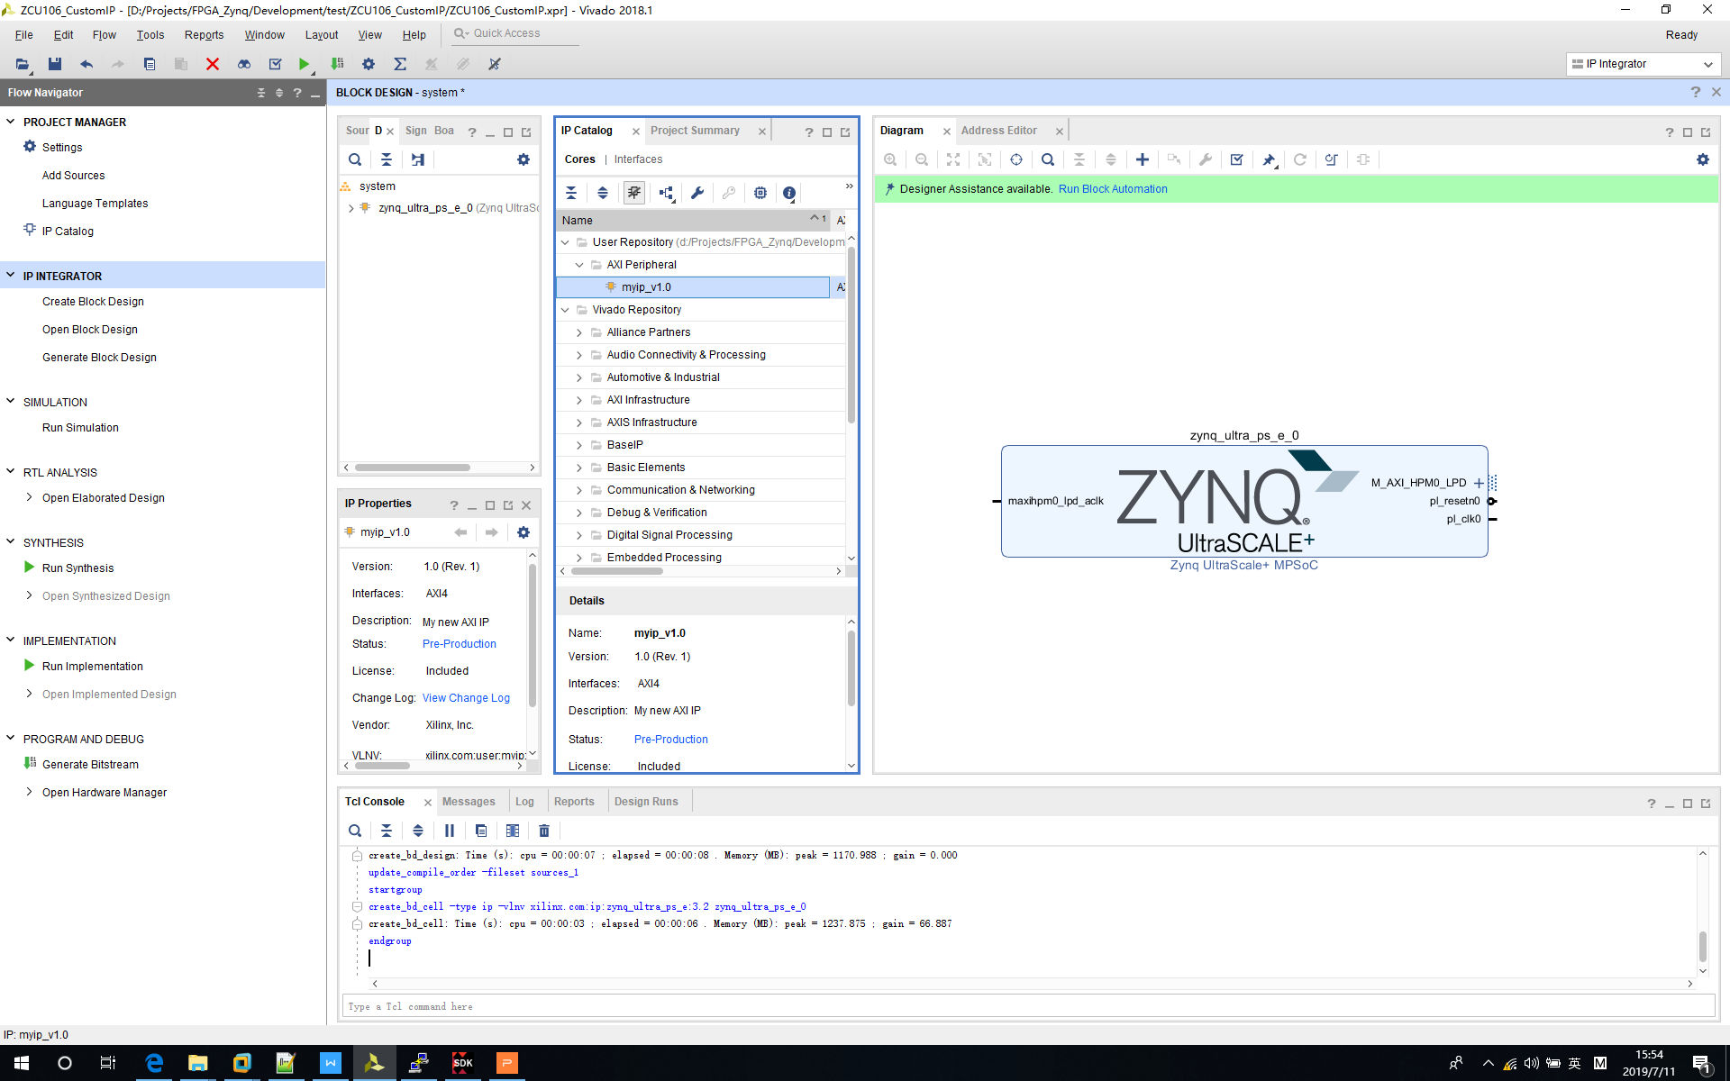

3‑24 ZYNQ Module in Block Diagram

Double click “*myip*” in repository and click “*Add IP to Block Design*”.

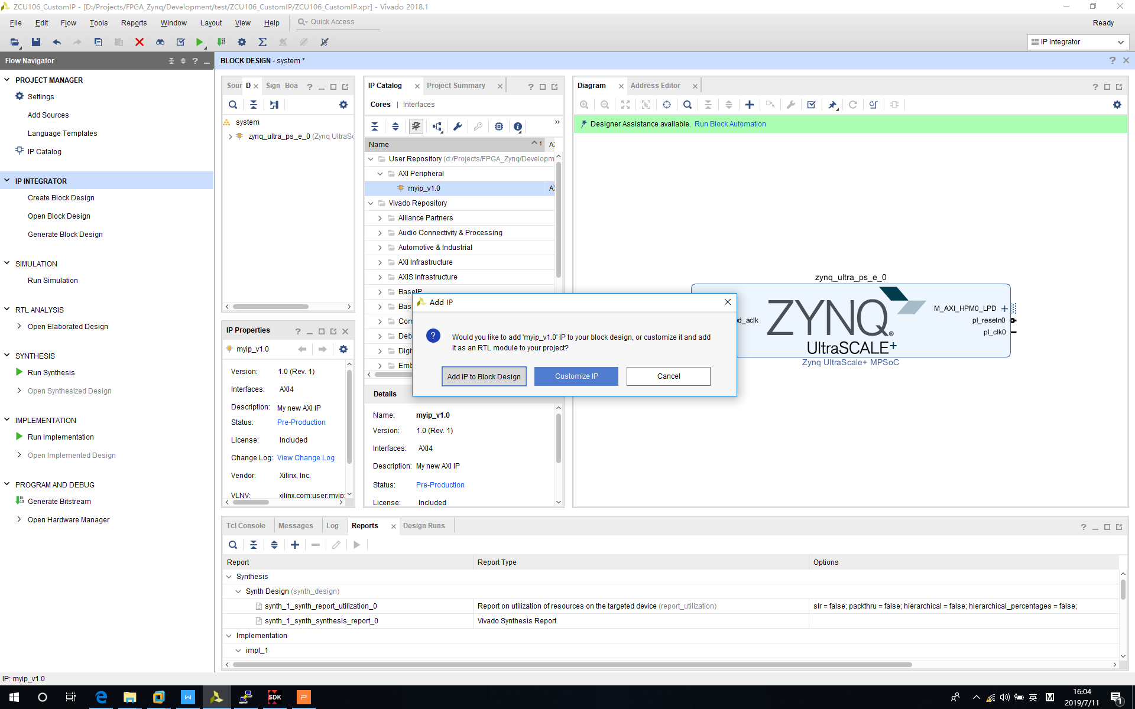

3‑25 Add IP to Block Design

Click “*Run Block Automation*” (Might run it several times).

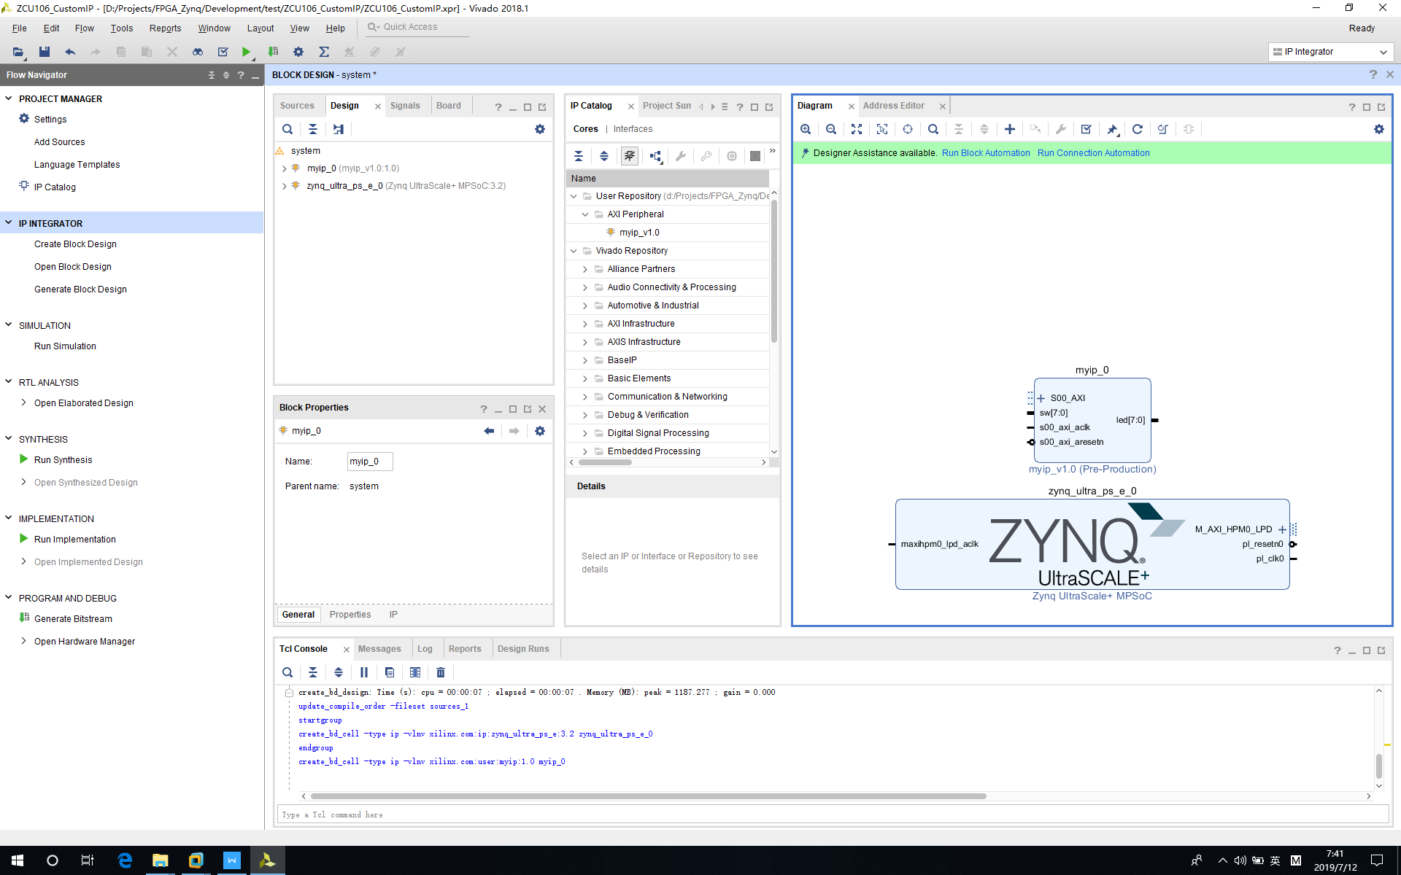

3‑26 Click Block Automation

Click “*OK*” to run block automation.

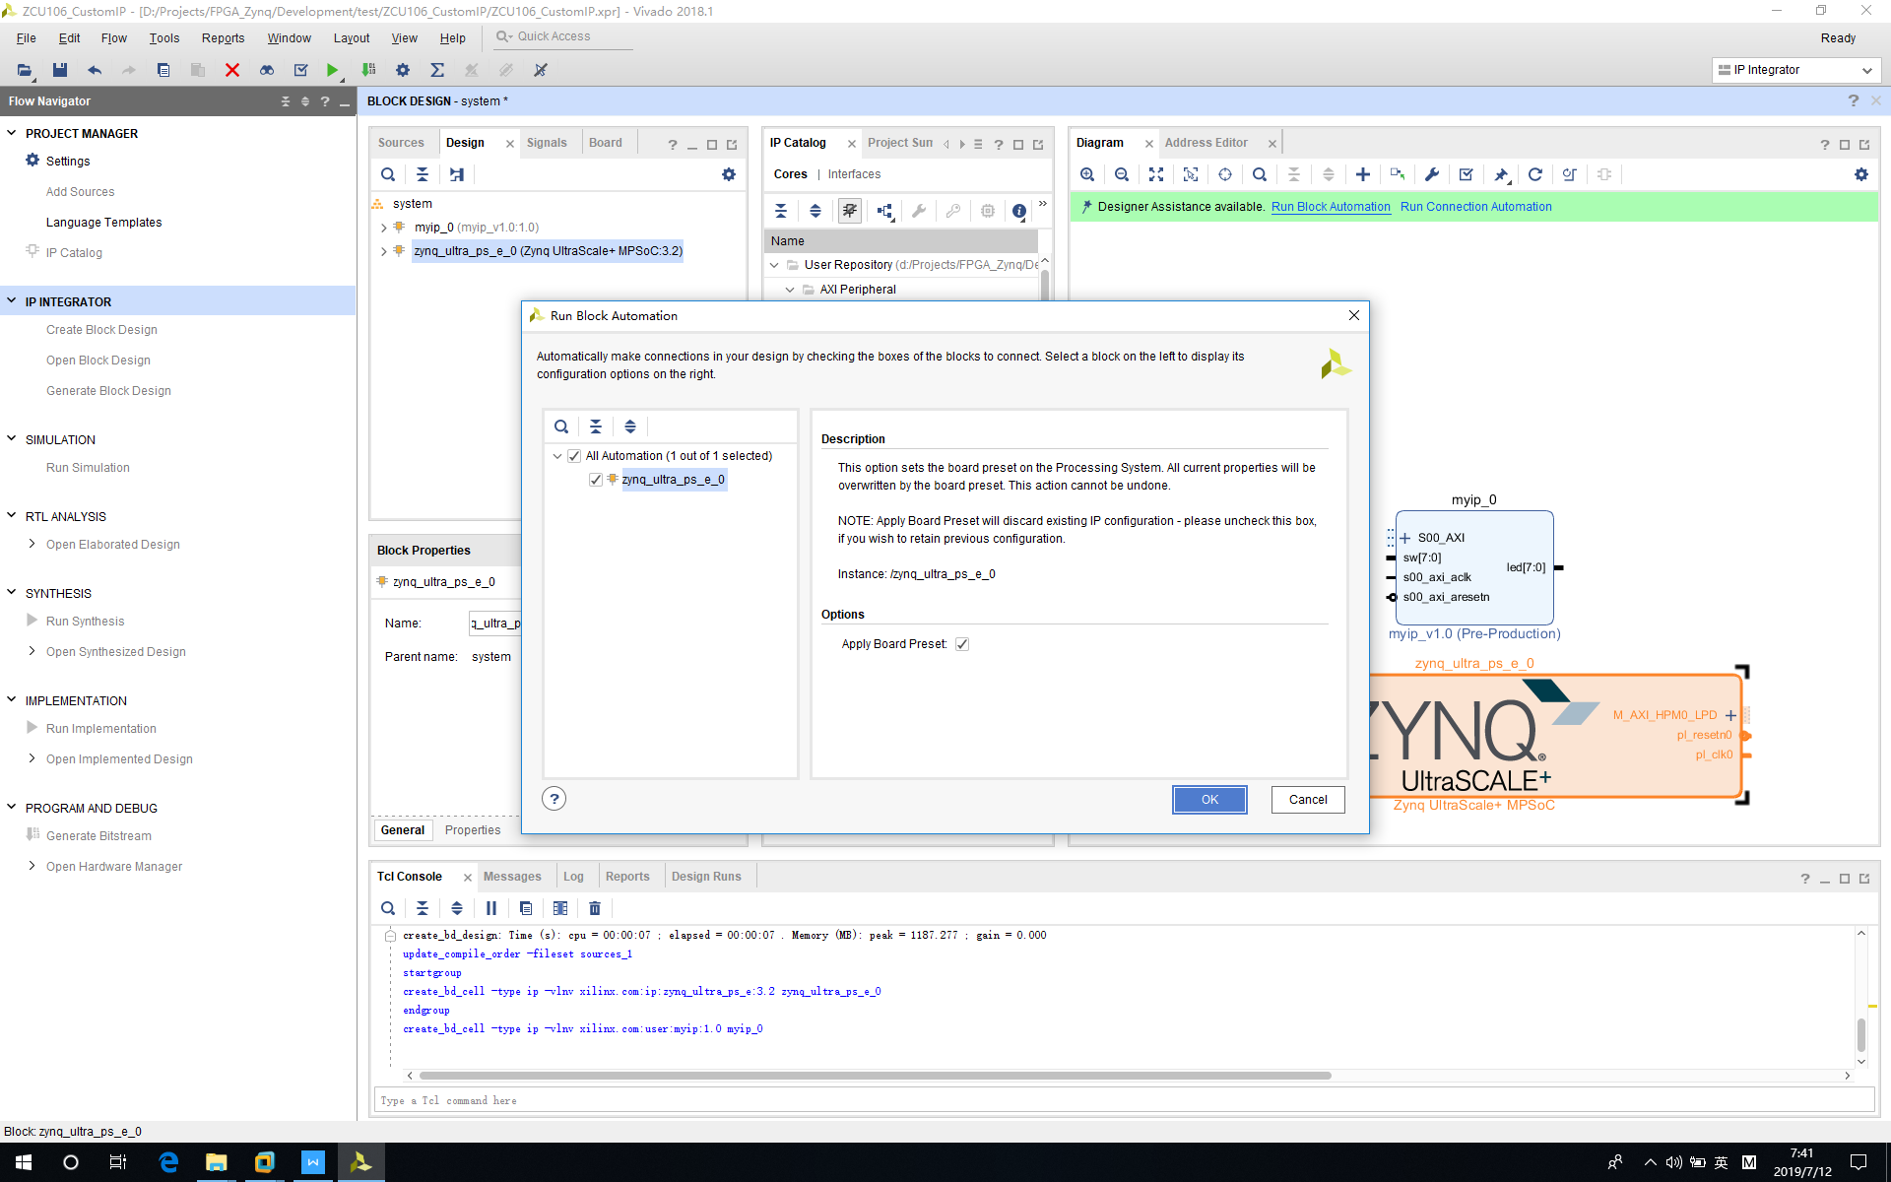

3‑27 Run Block Automation

Click “*Run Connection Automation*”.

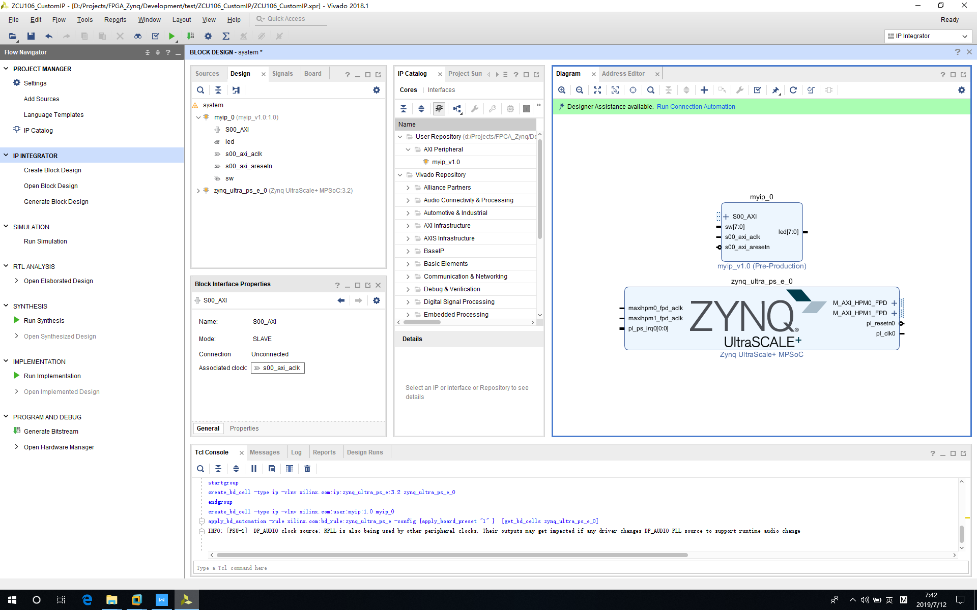

3‑28 Click Connection Automation

Click “*OK*” to run connection automation.

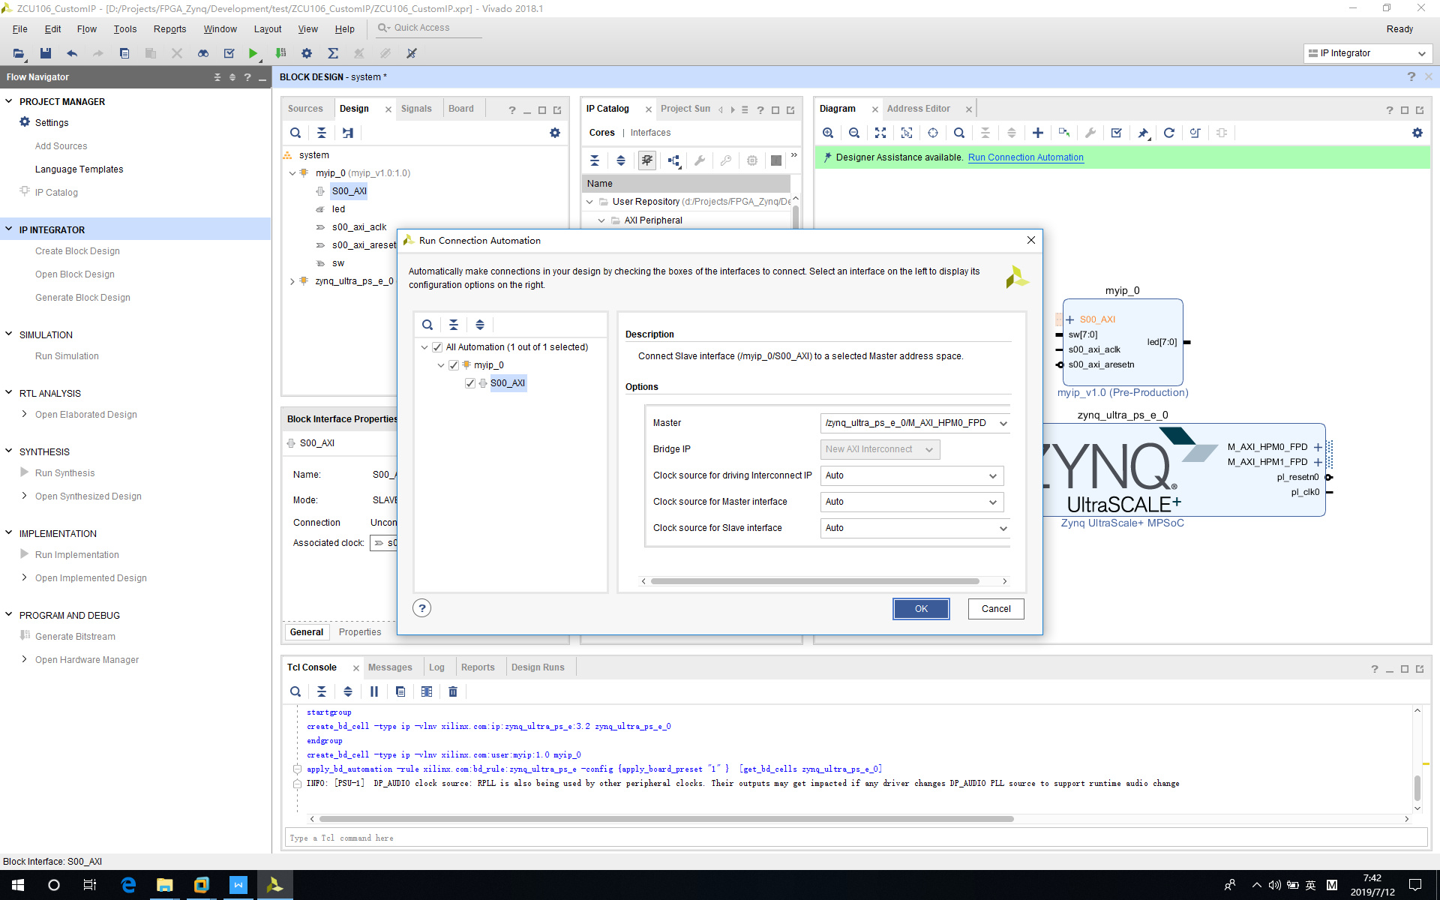

3‑29 Run Connection Automation

Block diagram will be updated like the following picture.

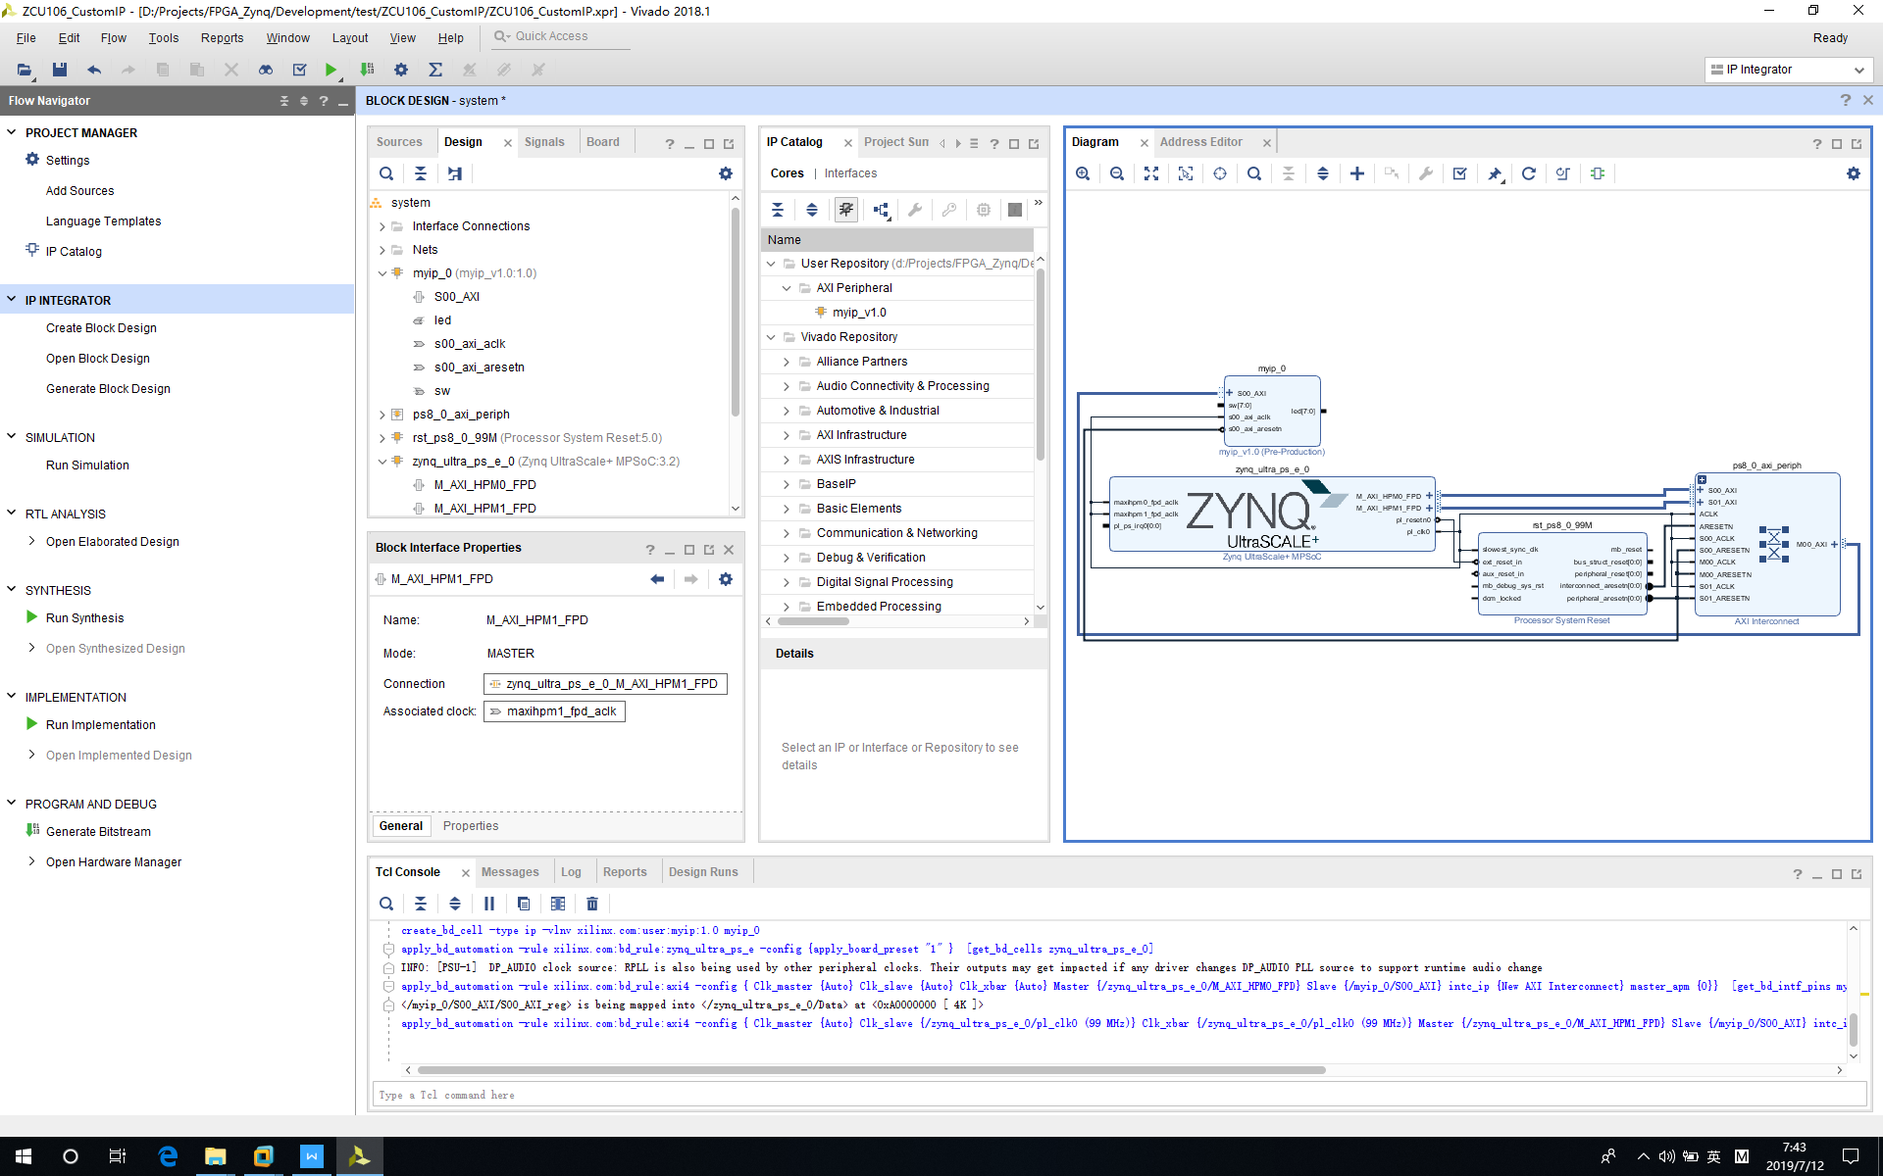

3‑30 Full Block Diagram

Click “*Regenerate Layout*” to display layout neatly.

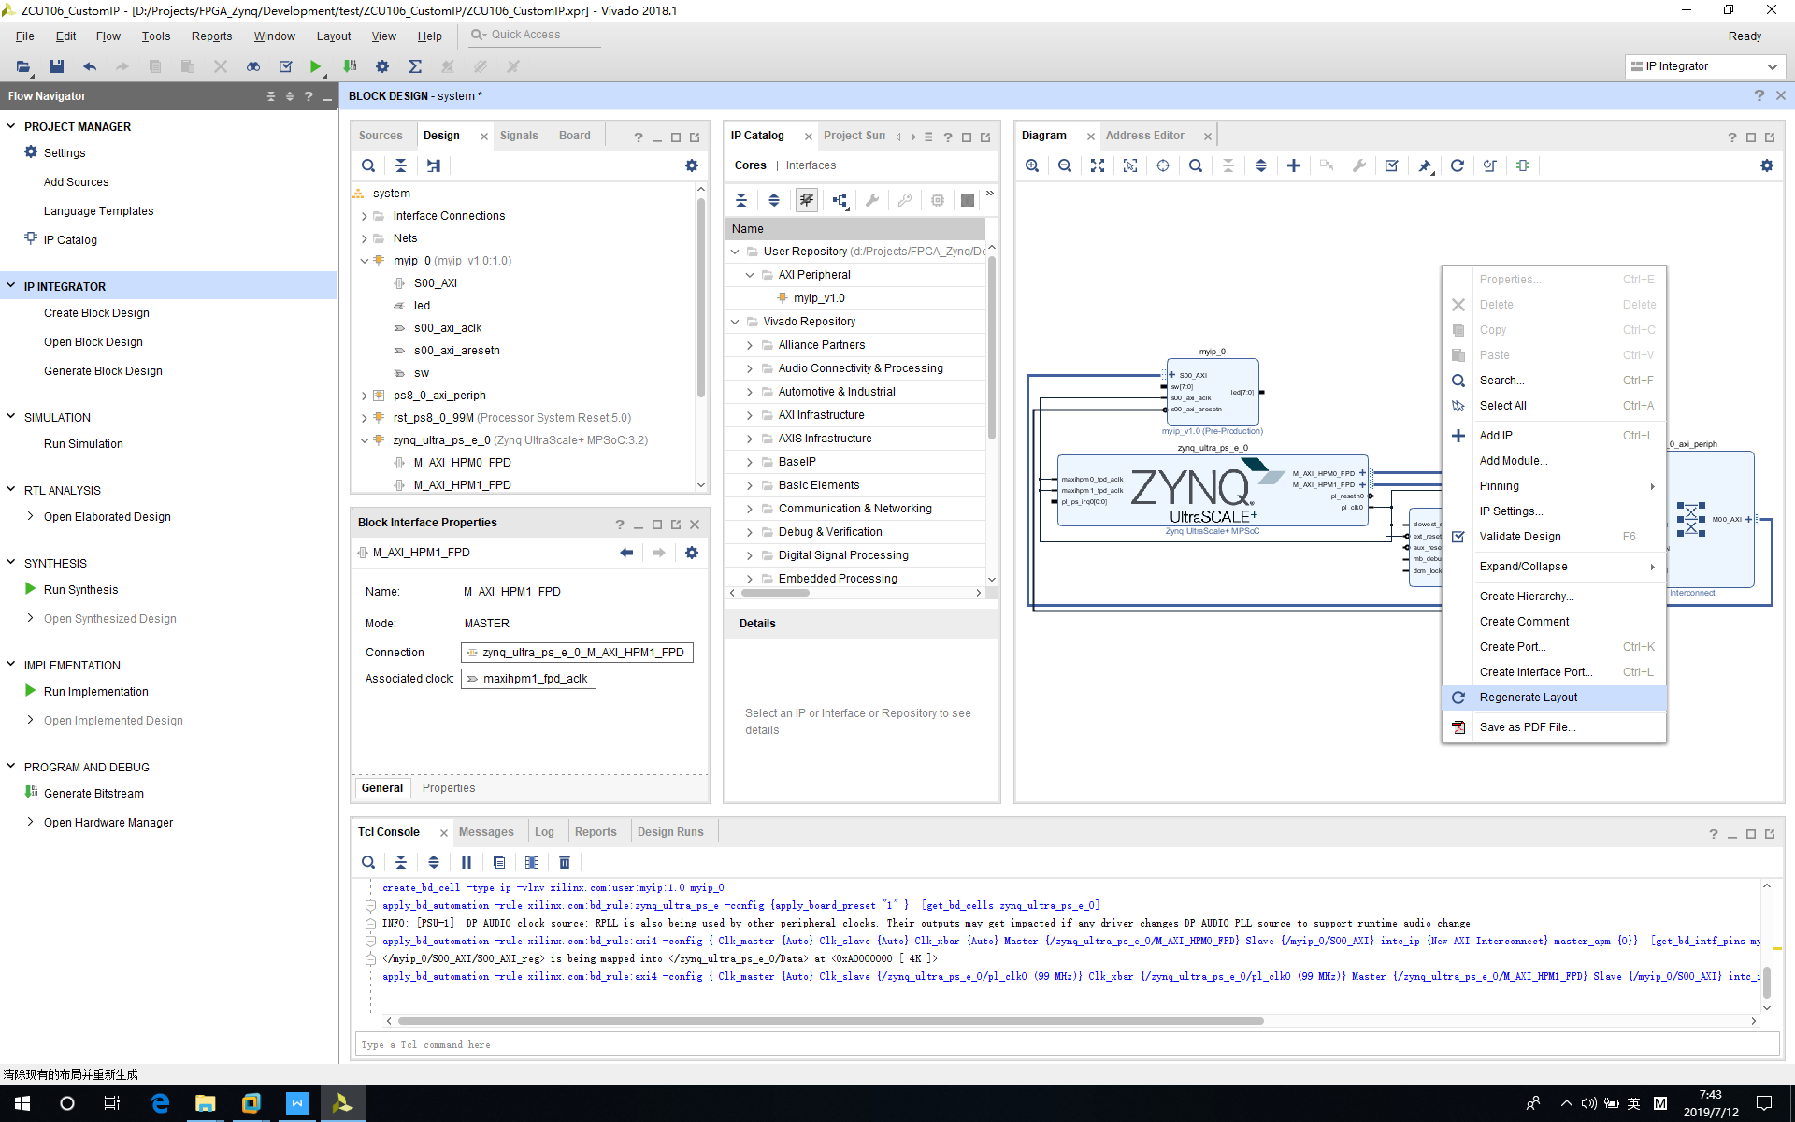

3‑31 Regenerate Layout

Regenerate Layout Results:

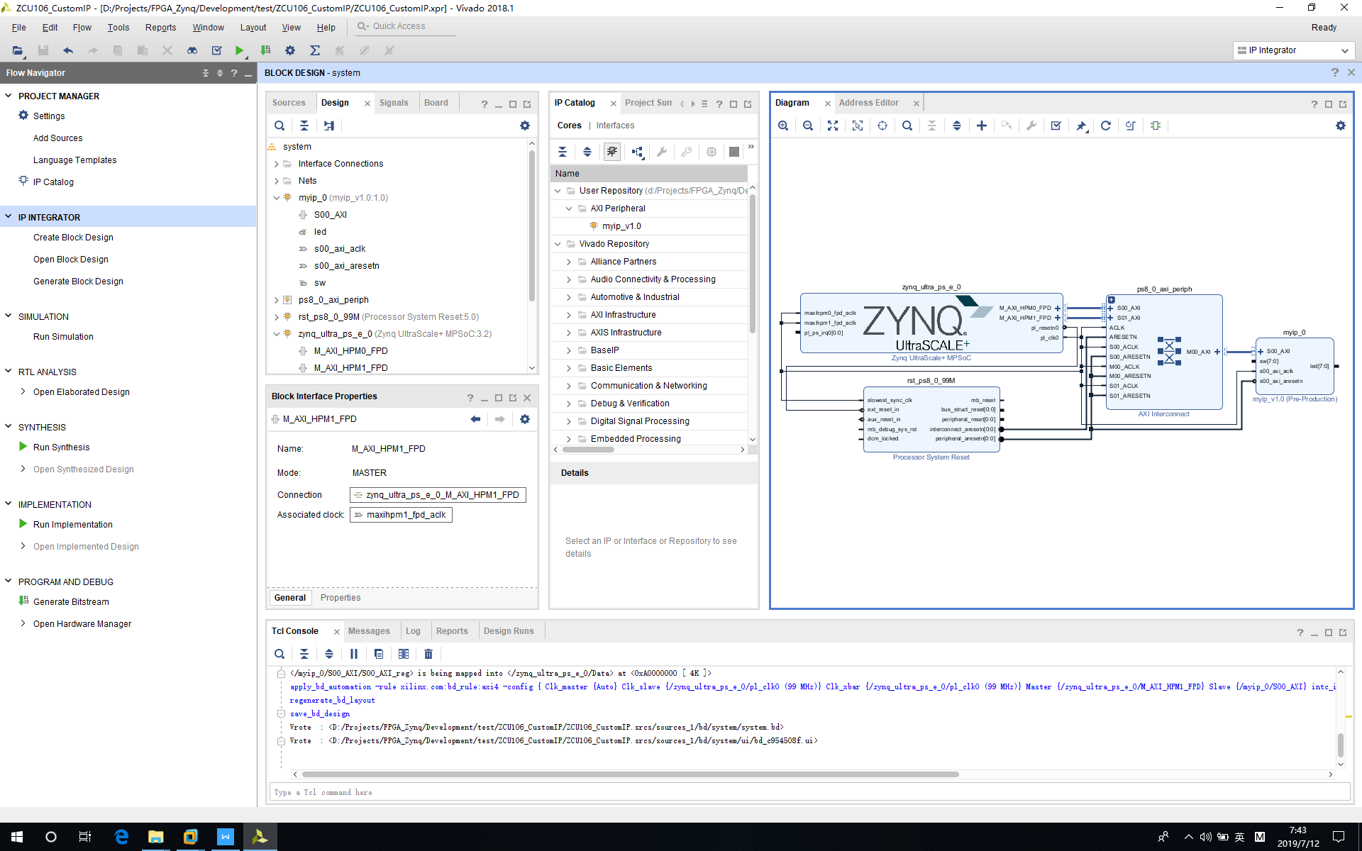

3‑32 Regenerated Results

After we have block diagram, we need to make LED/SW(Switch) pins external.

Left click “*led*” pin and right click.

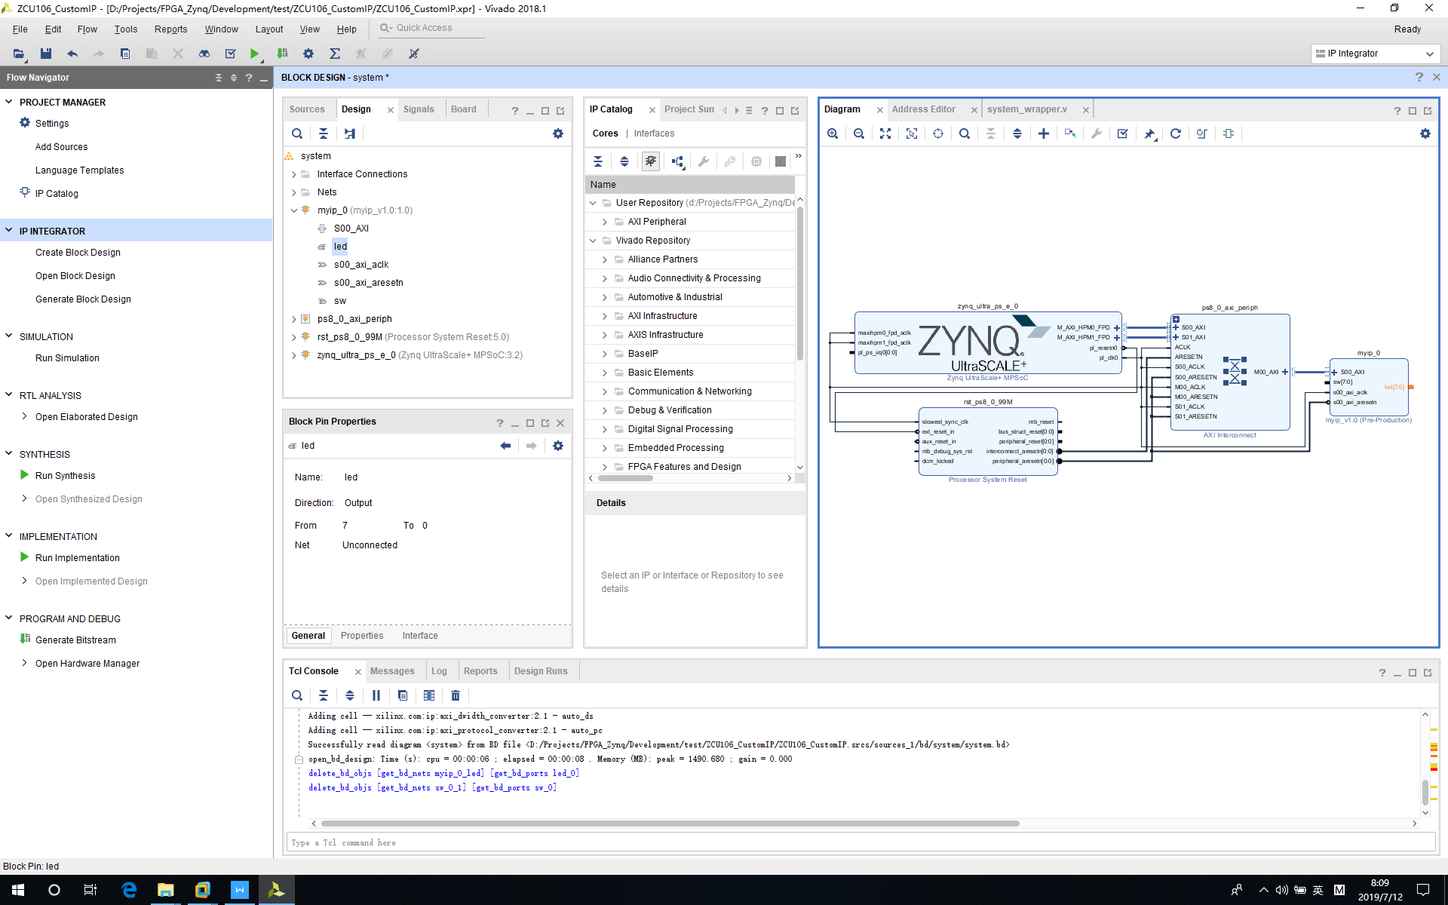

3‑33 Make LED External Step 1

Click “*Make External*”.

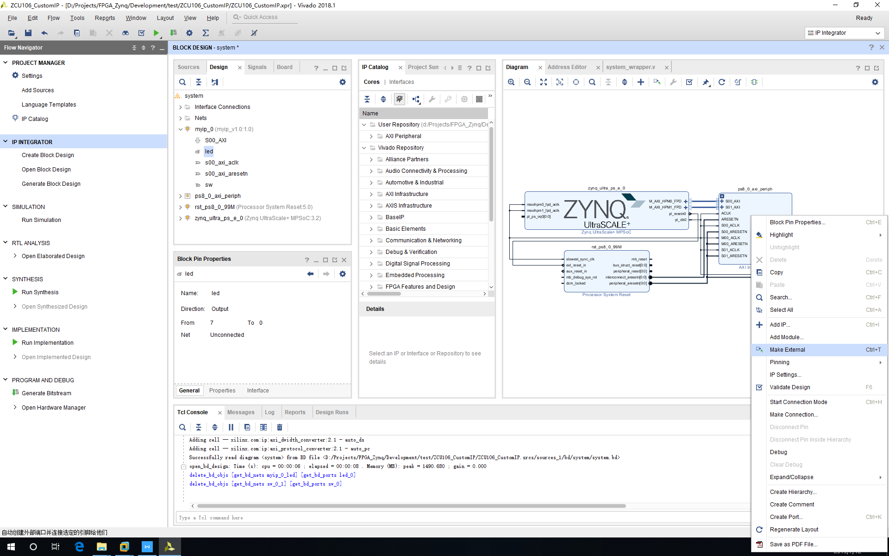

3‑34 Make LED External Step 2

Left click “*sw*” pin and right click.

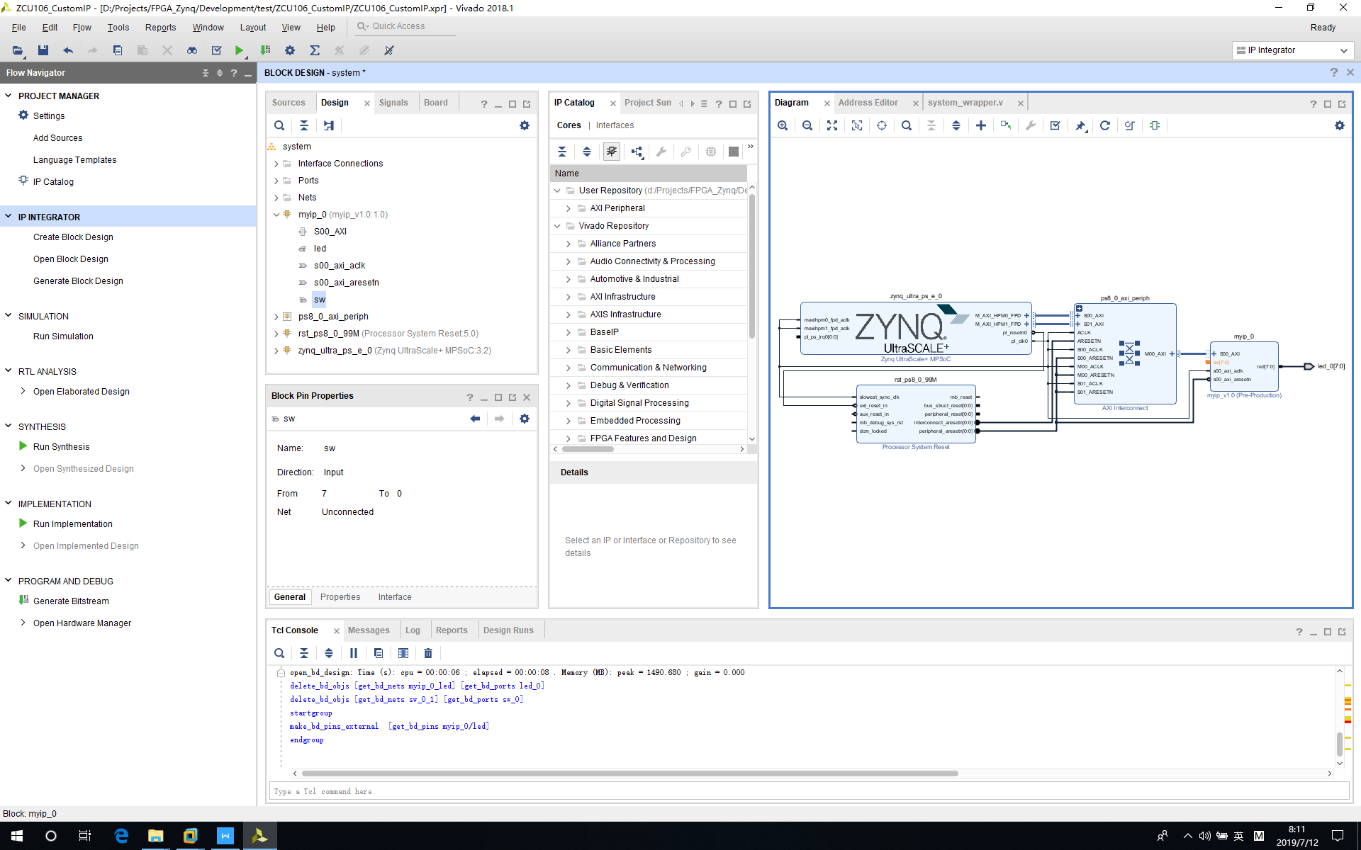

3‑35 Make SW External Step 1

Click “*Make External*”.

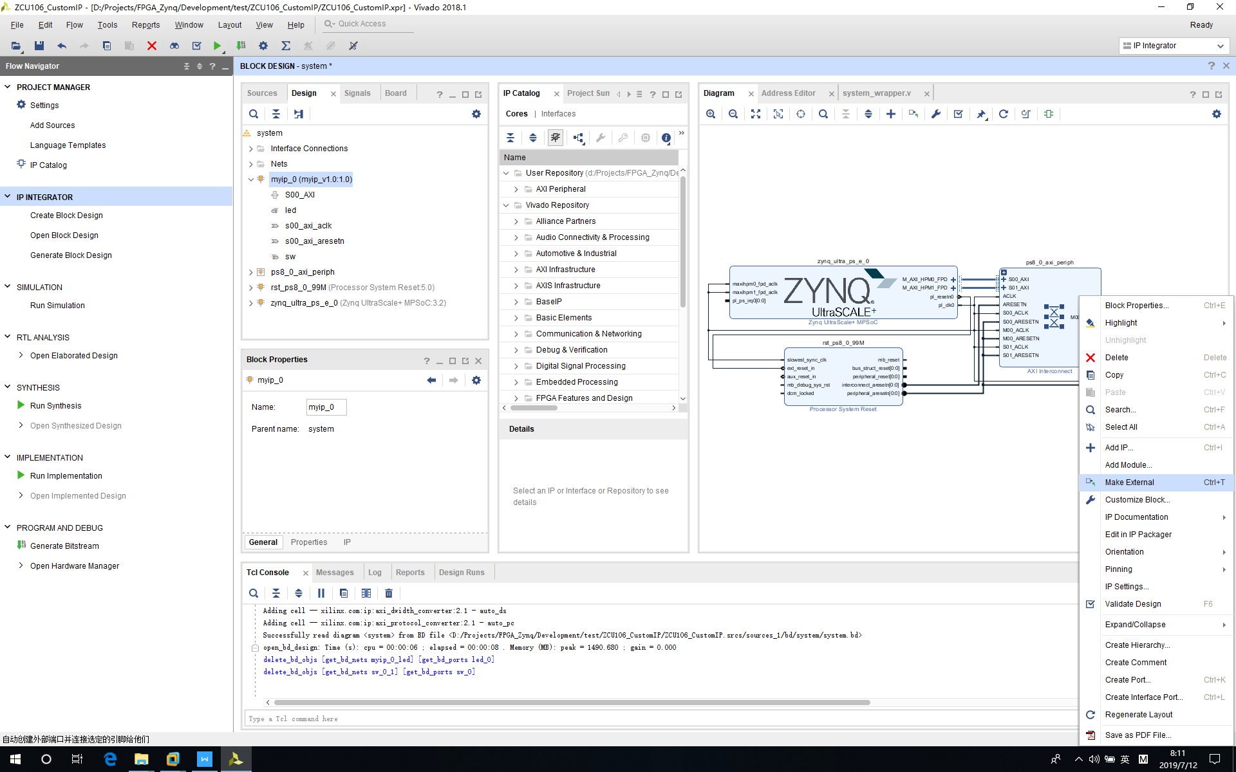

3‑36 Make SW External Step 2

Led and sw pins are external now.

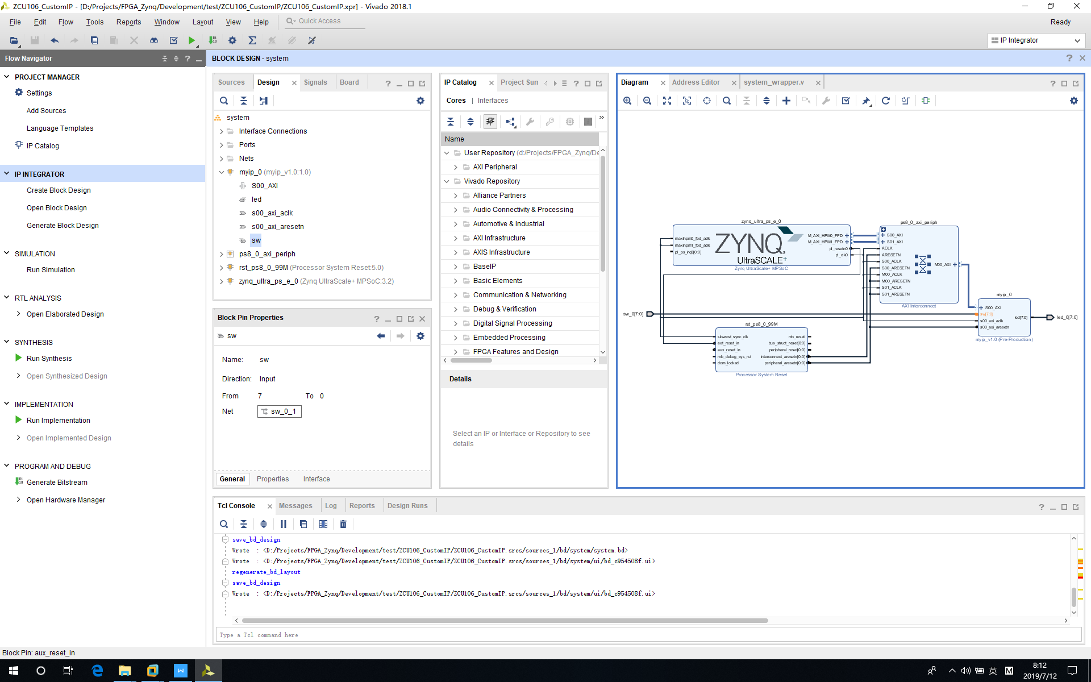

3‑37 Make Pin External Results

Click “*Validate Design*” button to validate system.

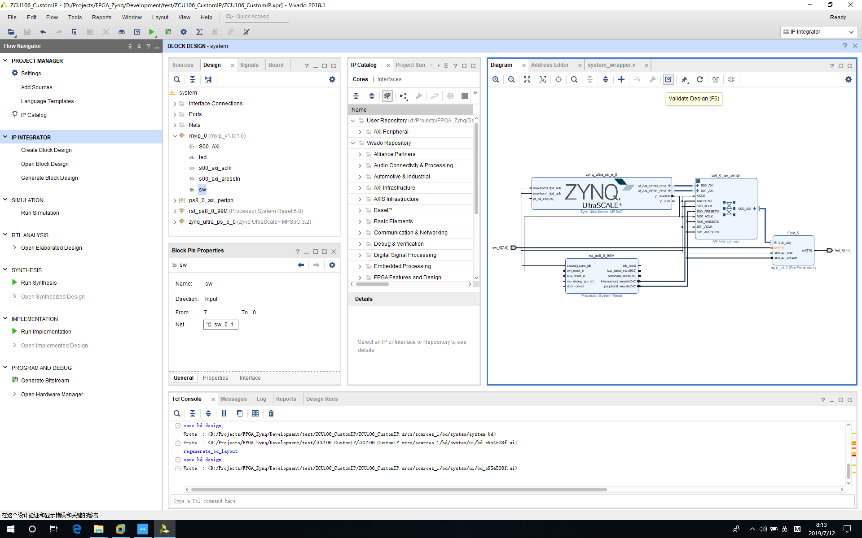

3‑38 Validate Design

If everything is correct, then one warning will jump out because of no pin assignment.

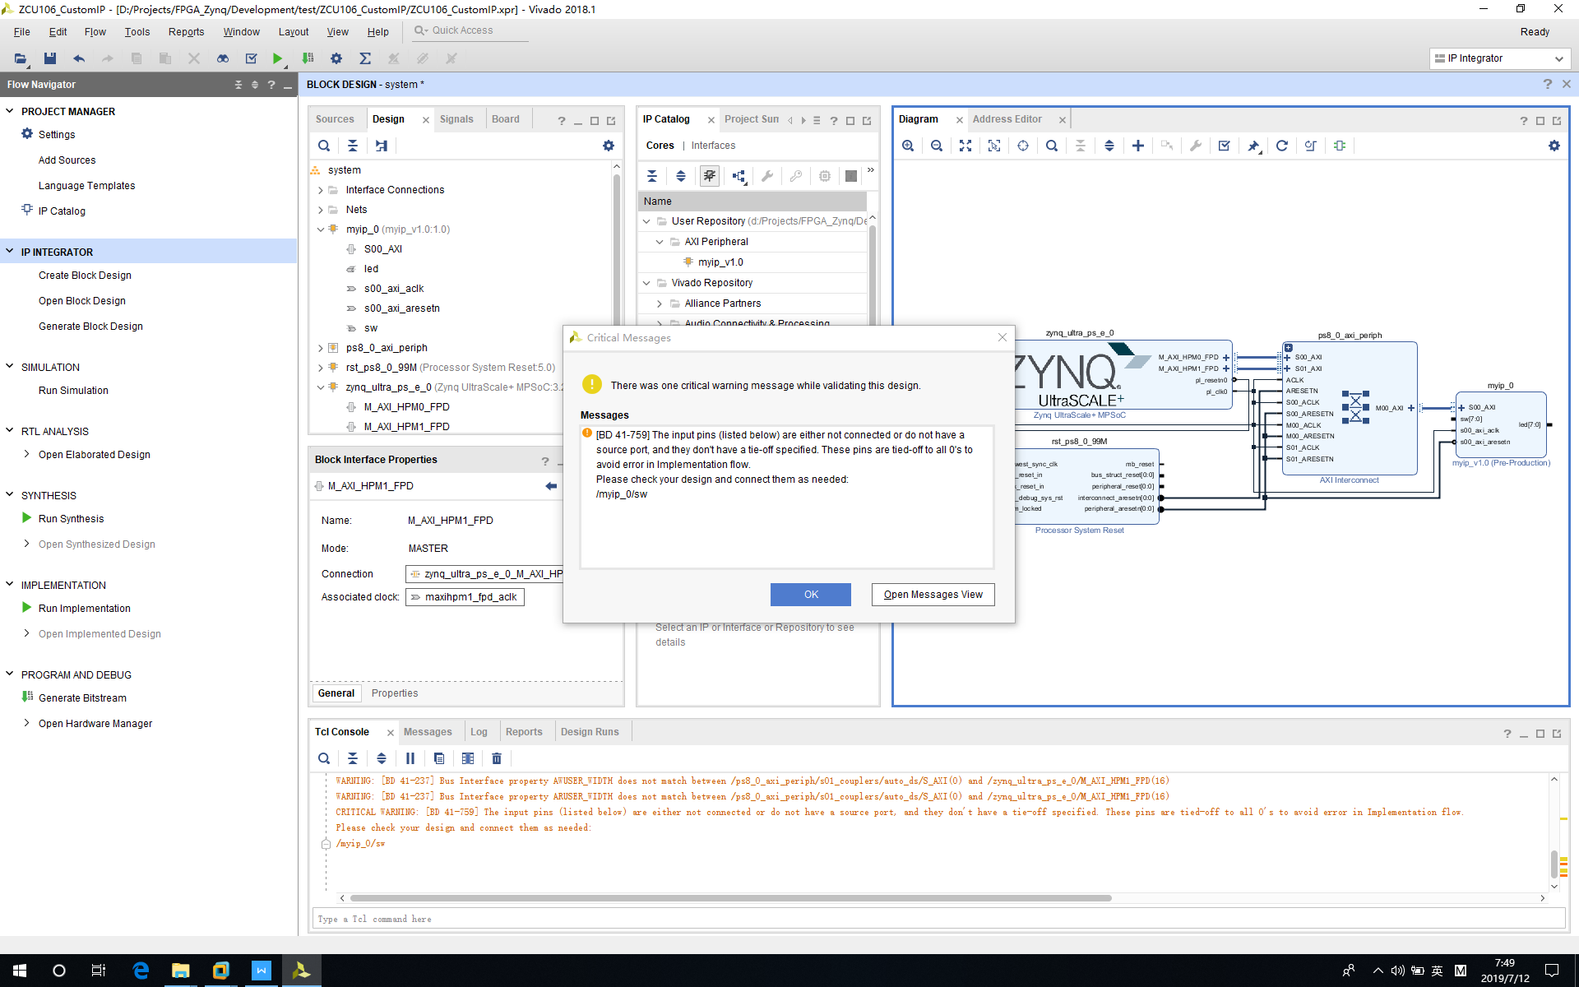

3‑39 Waring – No Pin Assignment

Now we need to create HDL wrapper. Otherwise, we could not compile this project.

Left click “*system*” and right click, select “*Create HDL Wrapper...*”.

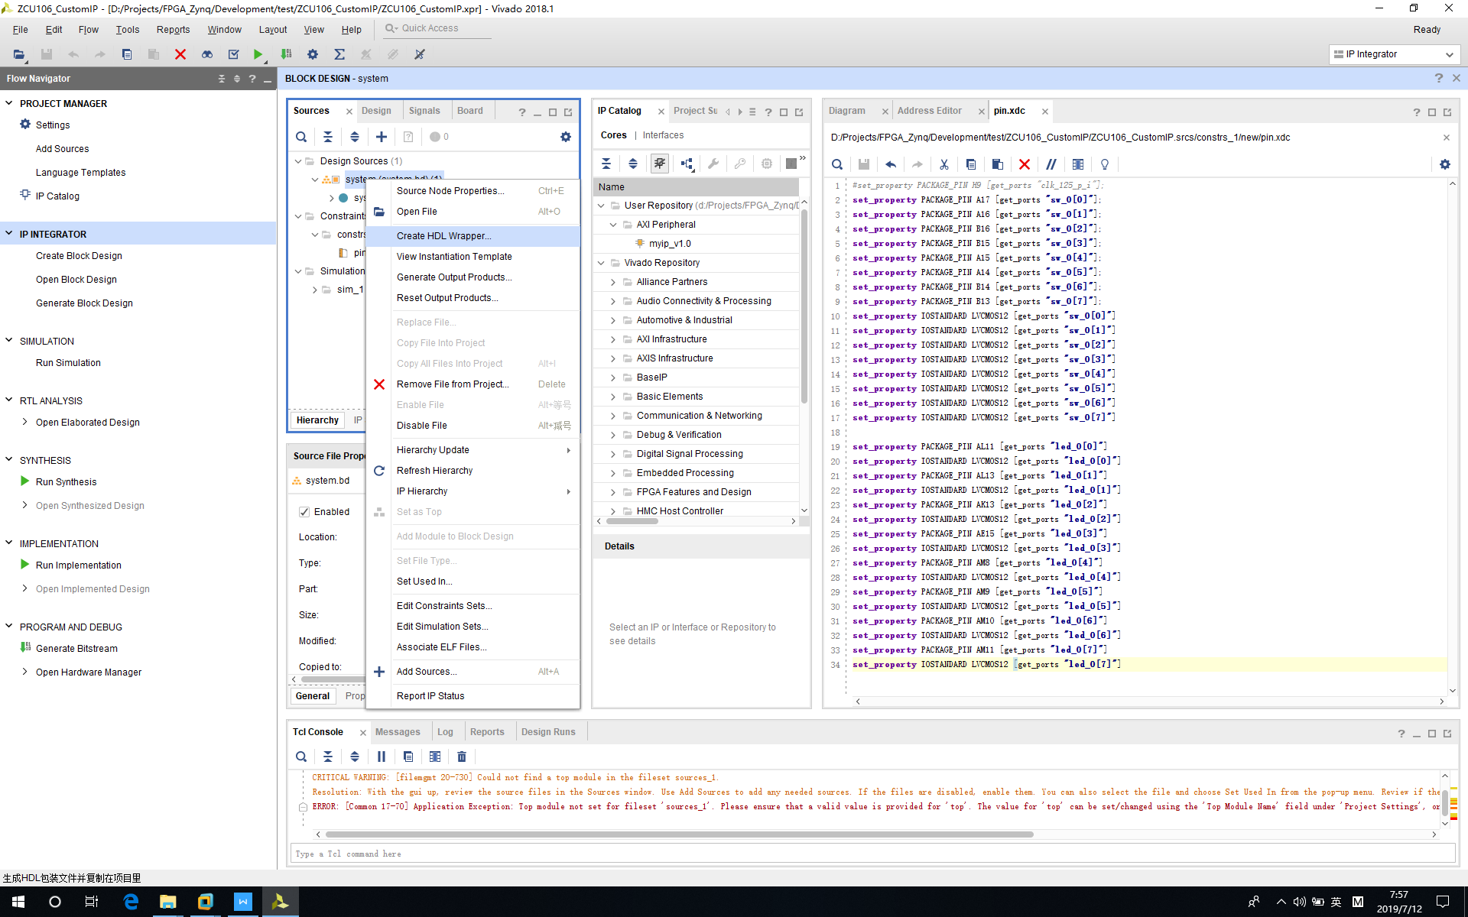

3‑40 Create HDL Wrapper

Click “*OK*” to continue.

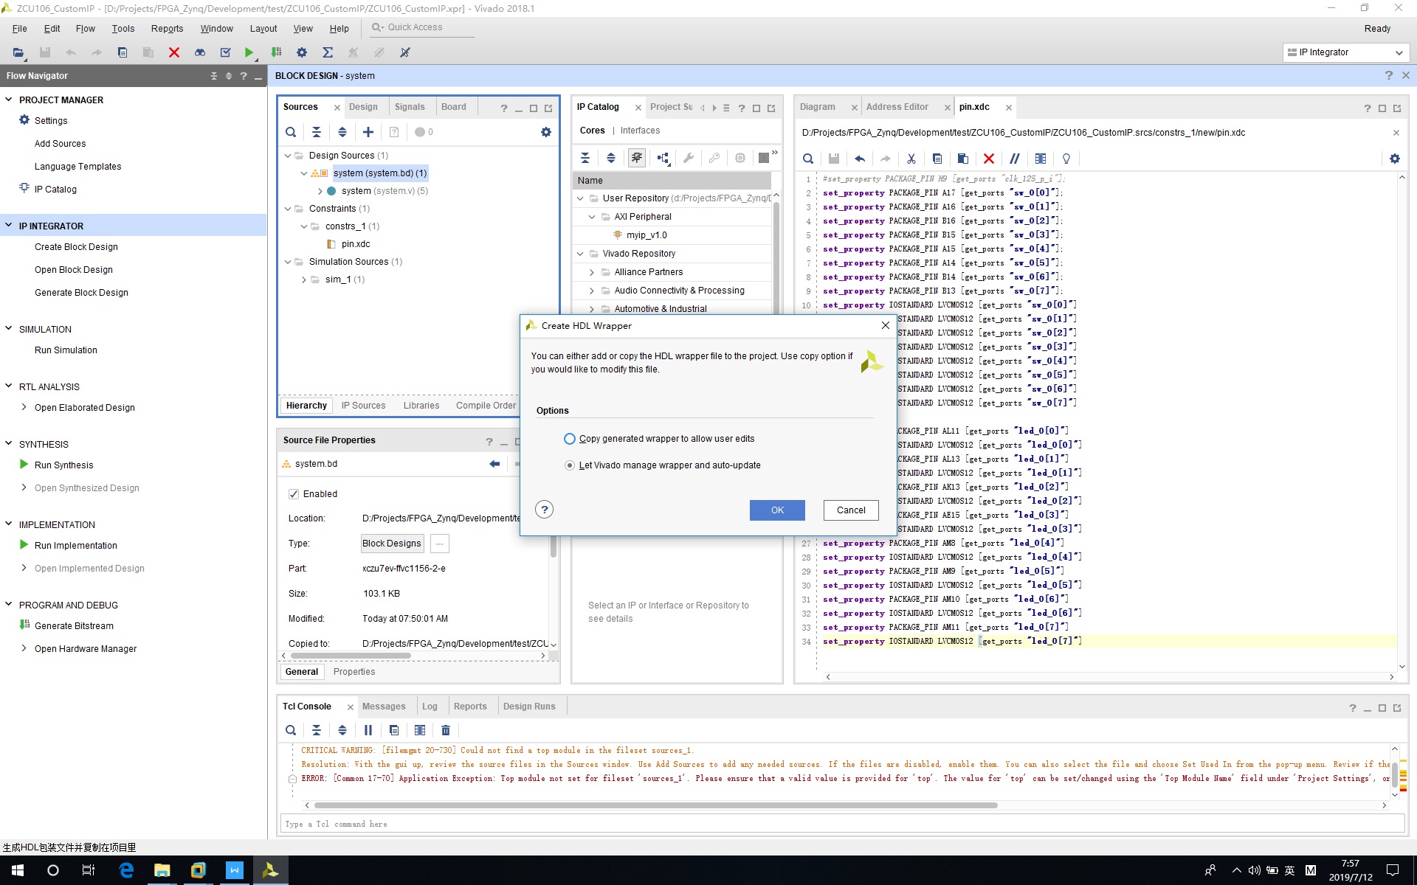

3‑41 Run HDL Wrapper

Then “*system_wrapper.v*” will be generated.

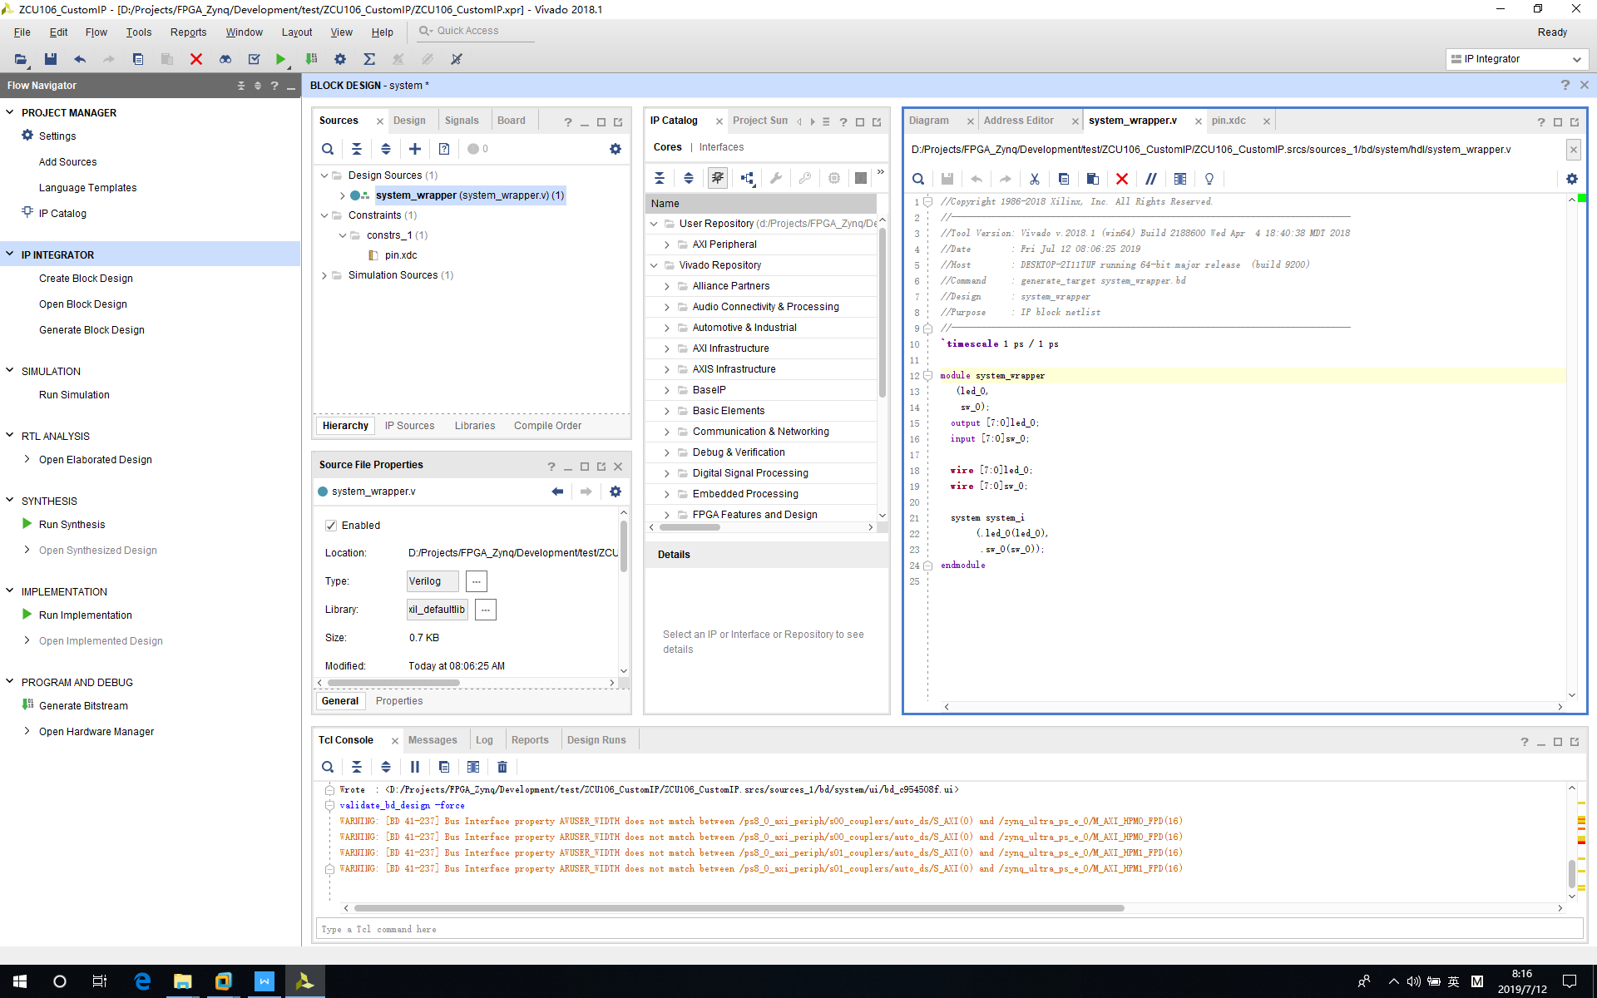

3‑42 Generated System Wrapper

*Next, we need to add constraint file for pin. Right click “constrs_1->Add Sources”.*

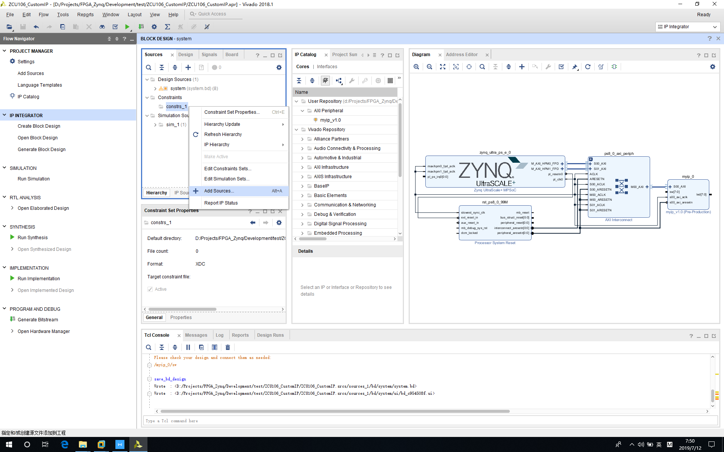

3‑43 Add Sources

Click “*OK*” to continue.

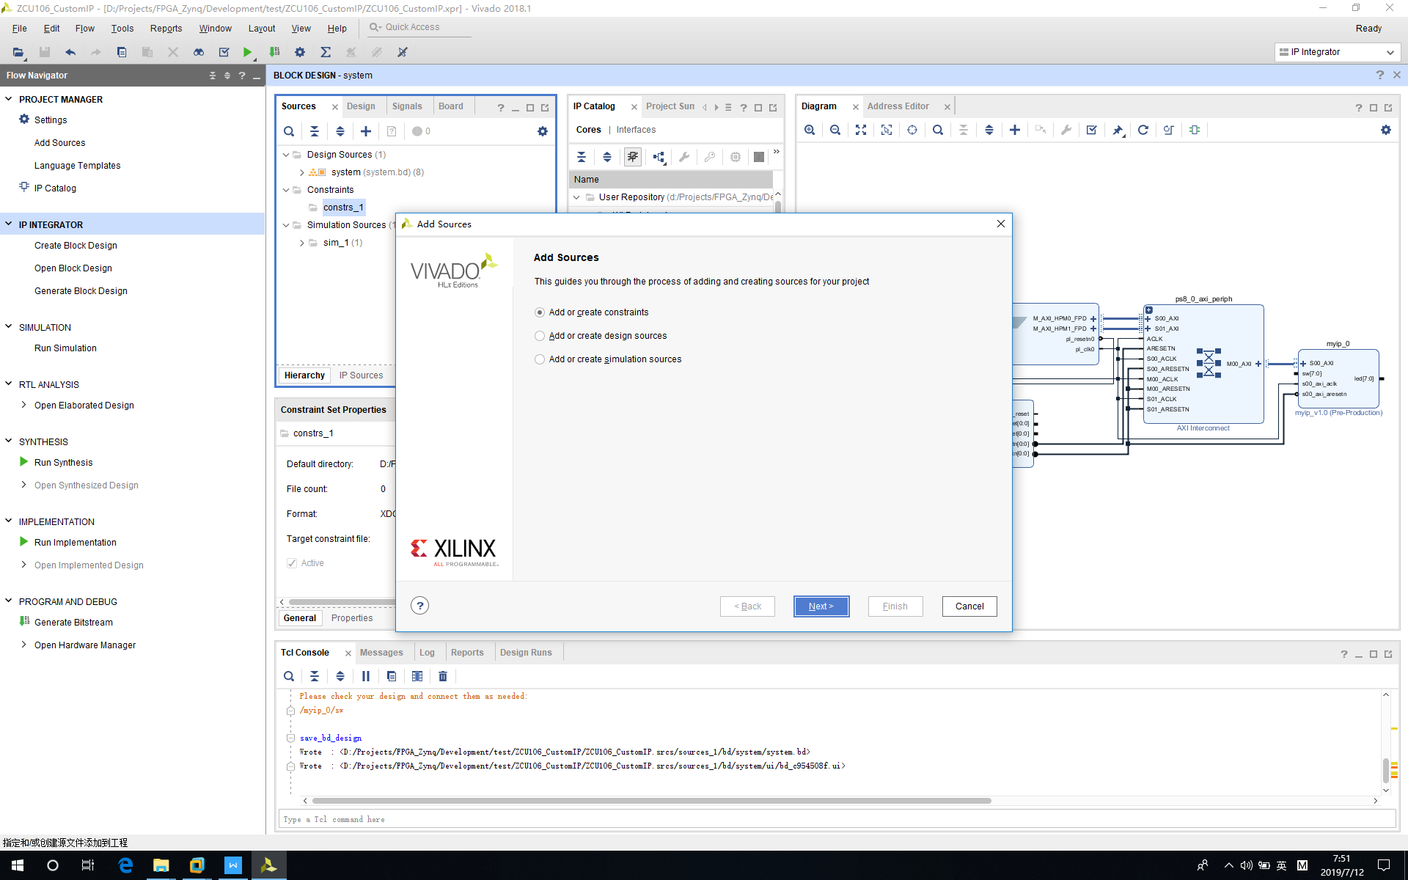

3‑44 Add or Generate Constraints

Click “*Create File*”.

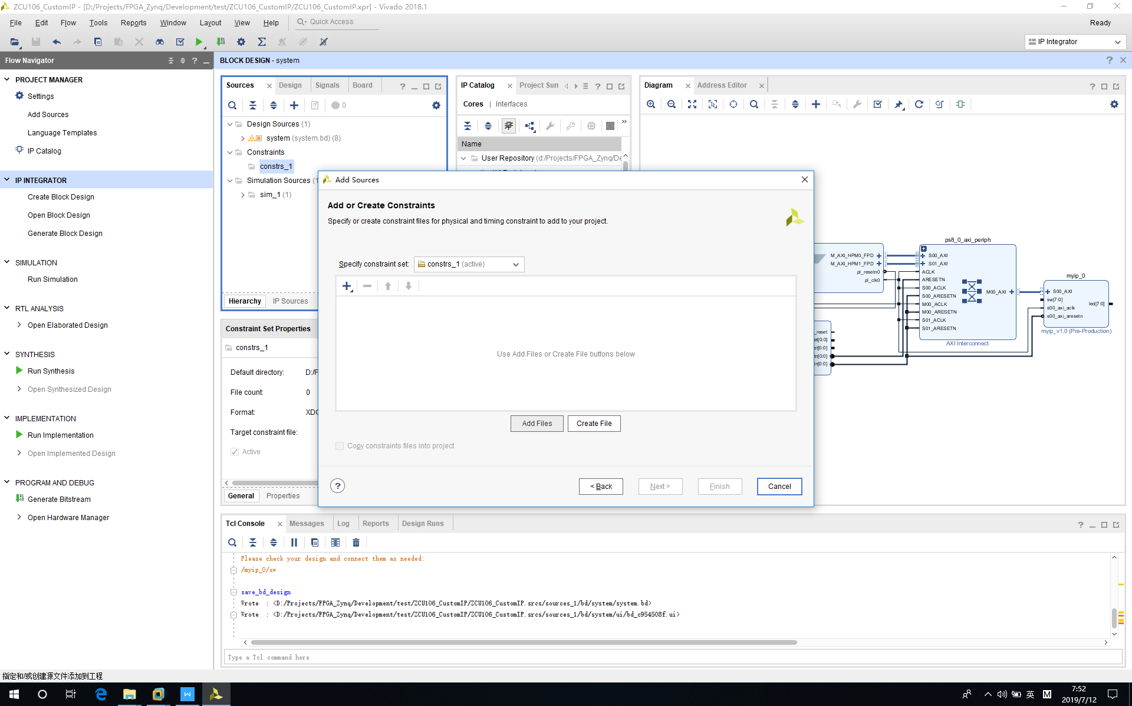

3‑45 Add or Create Constraints

Name file as “pin”.

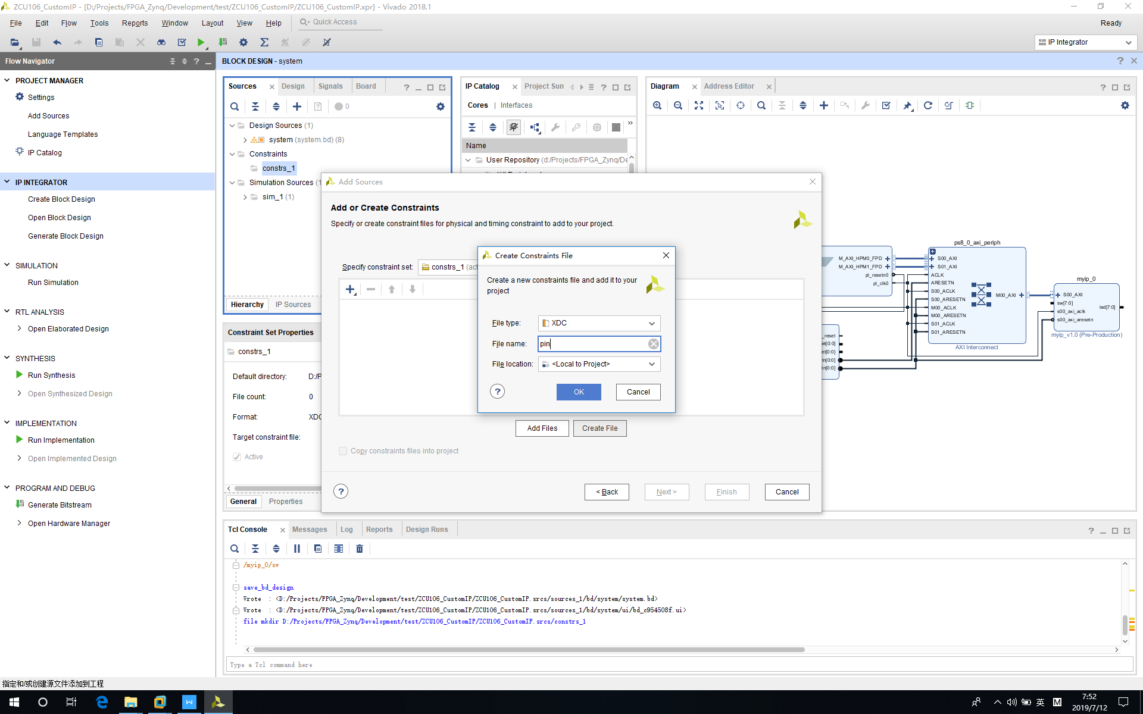

3‑46 Set Up Constraint File Name

File “pin.xdc” is generated.

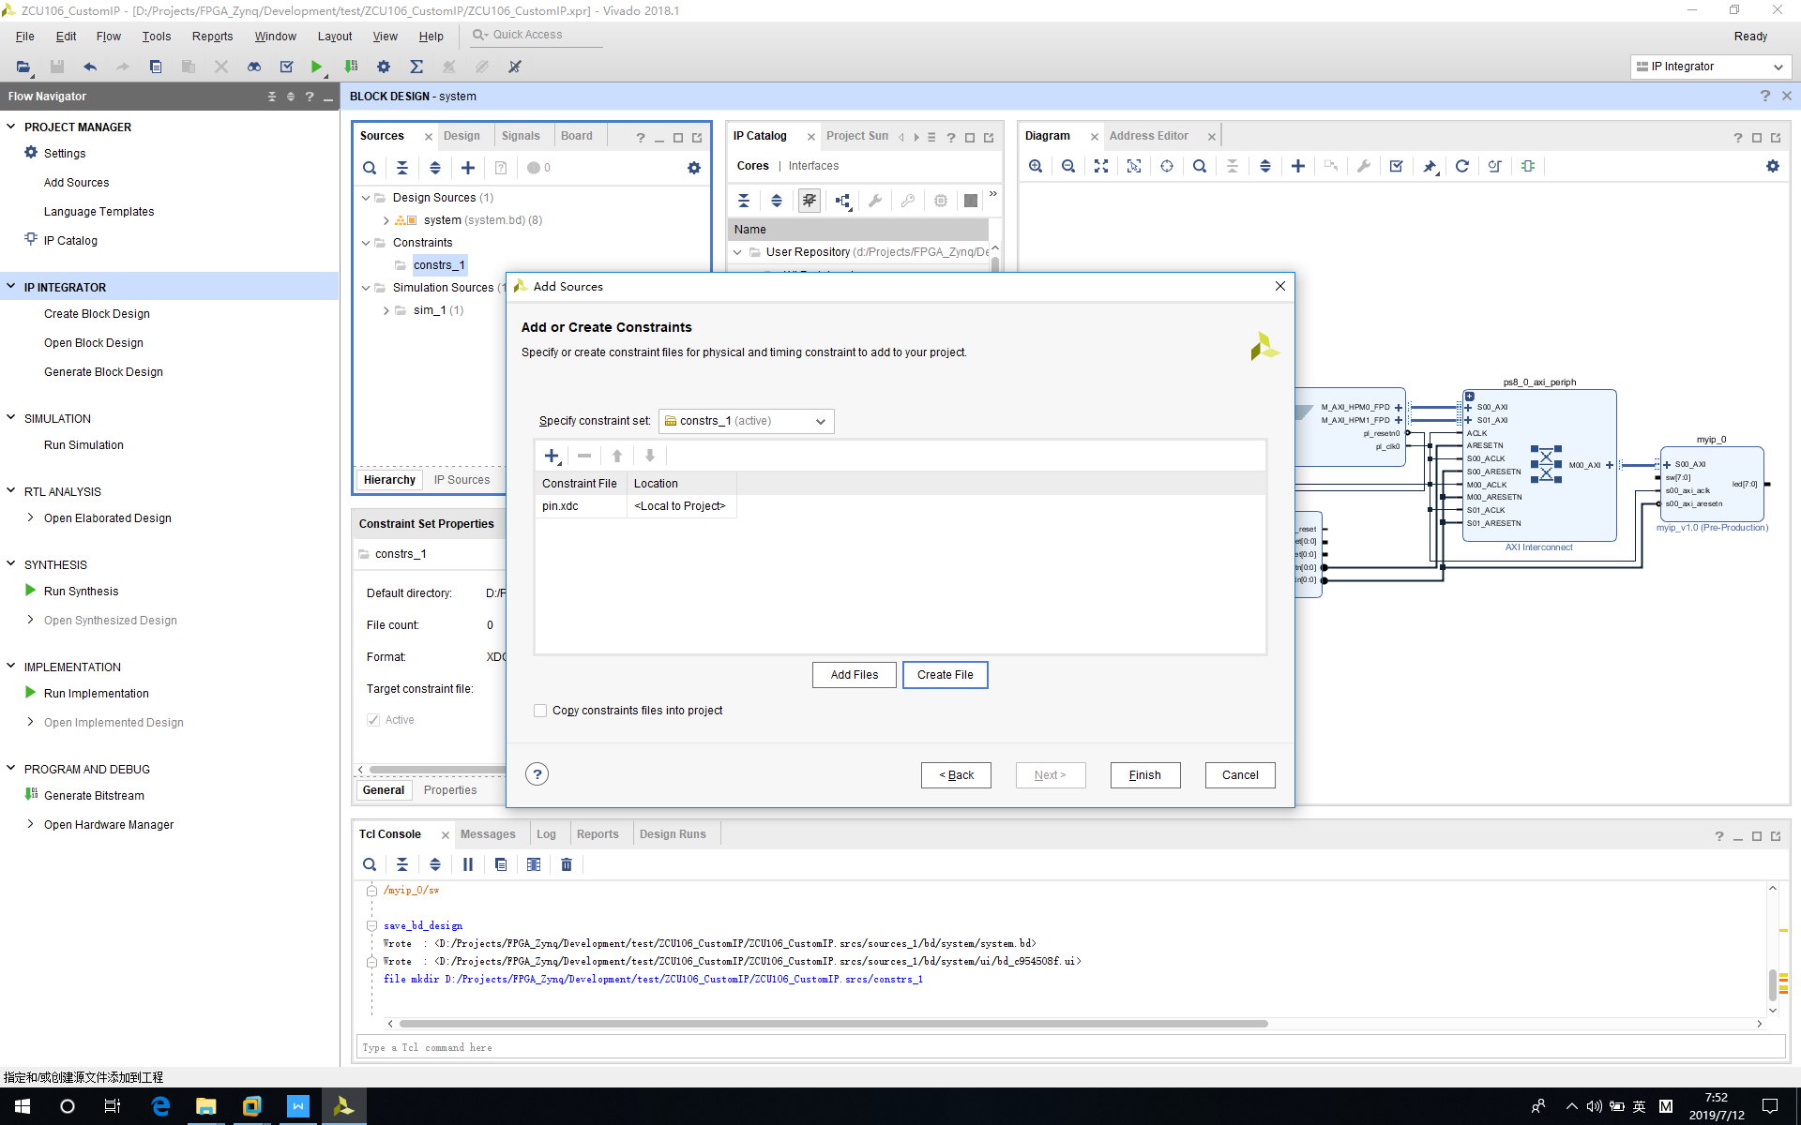

3‑47 Create Constraint File

Add following content to pin.xdc file. You can also find this file in github.

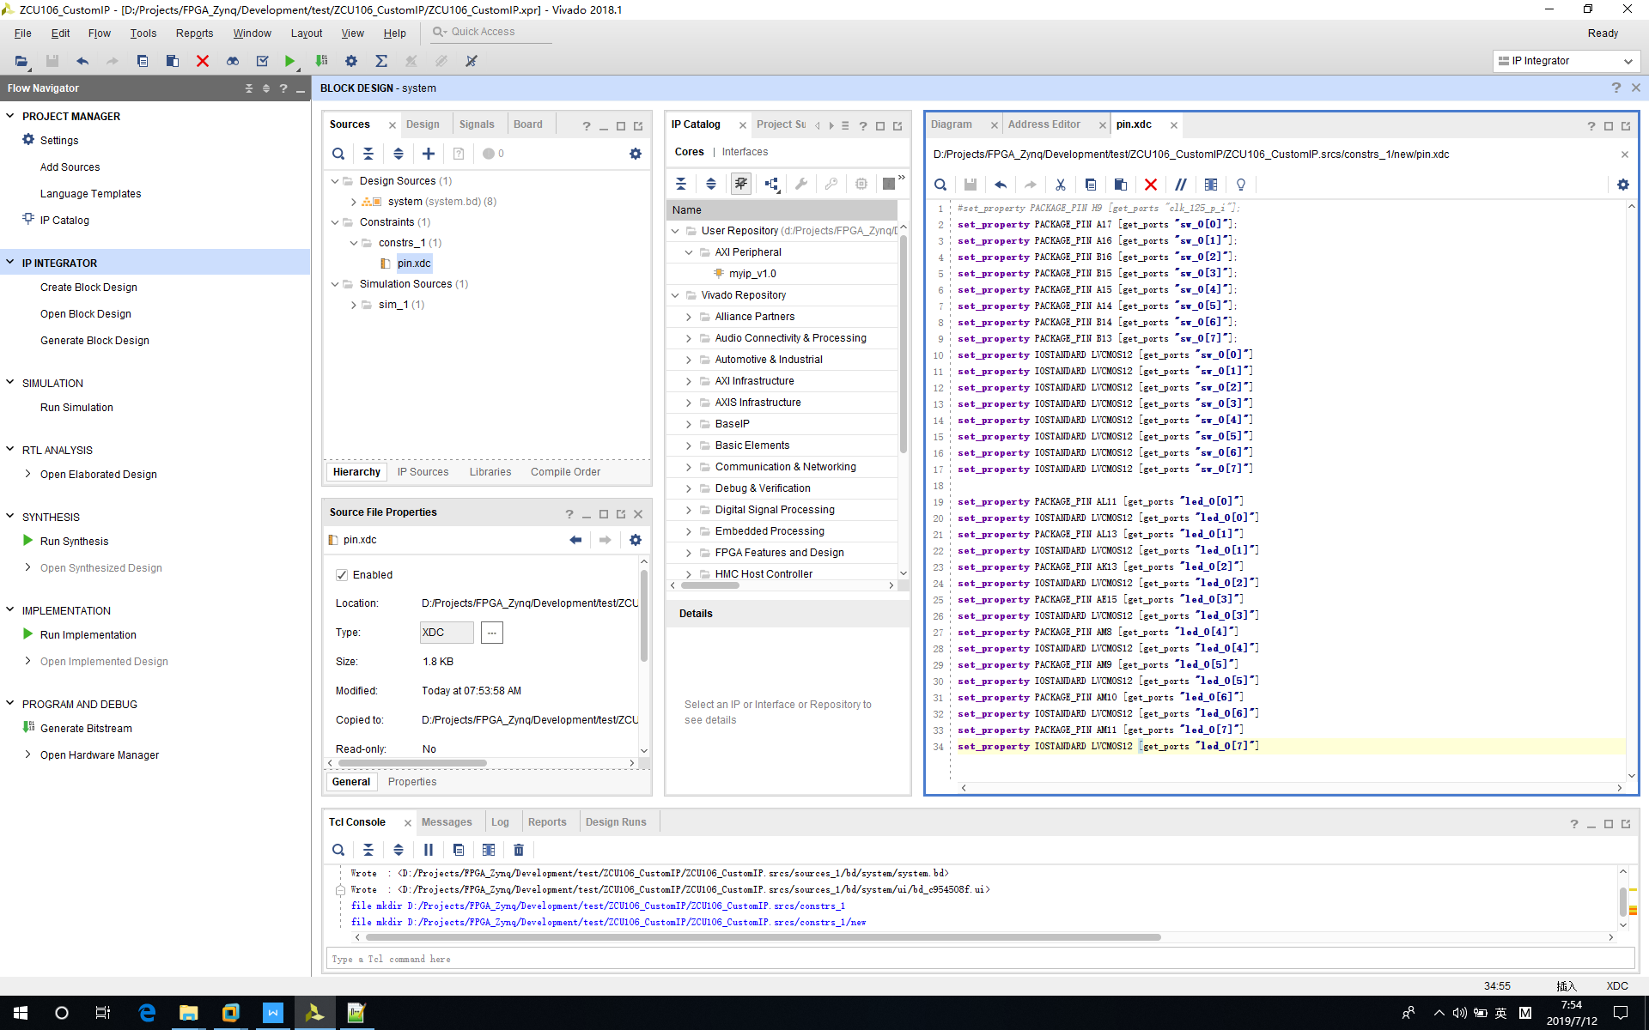

3‑48 Edit Constraint File

Now, click “Generate bitstream” to compile project.

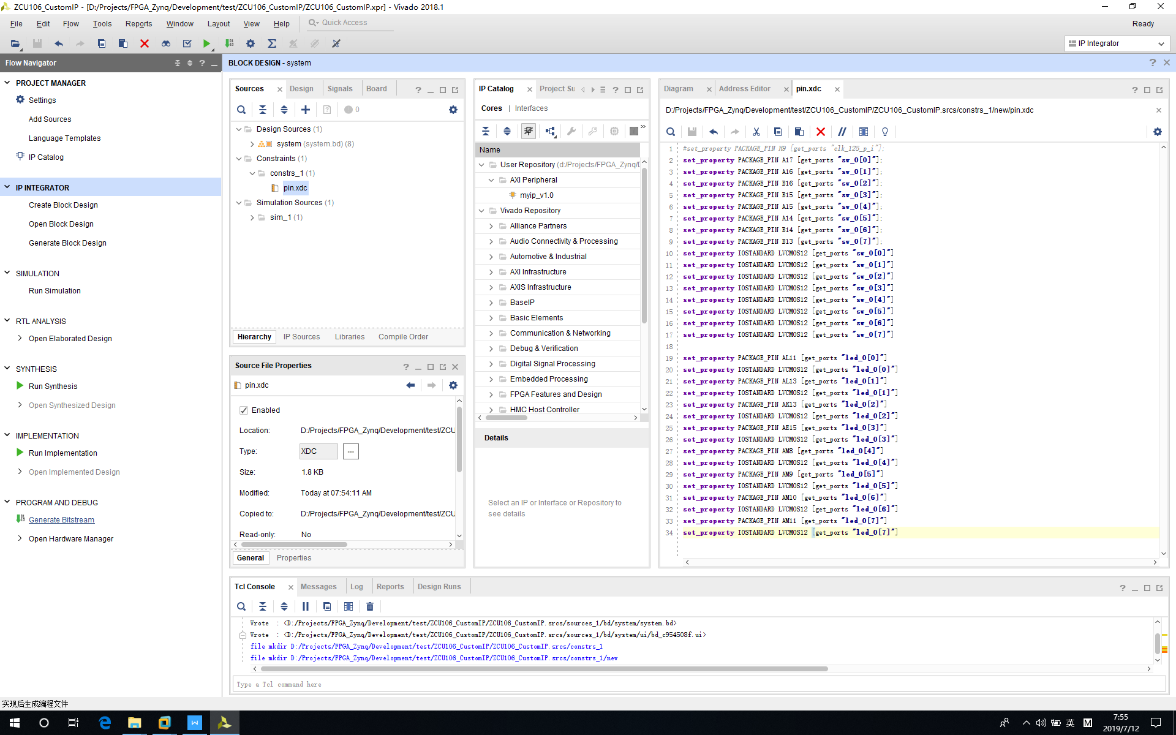

3‑49 Generate Bitstream

After compilation is finished, click “File->Export->Export Hardware”.

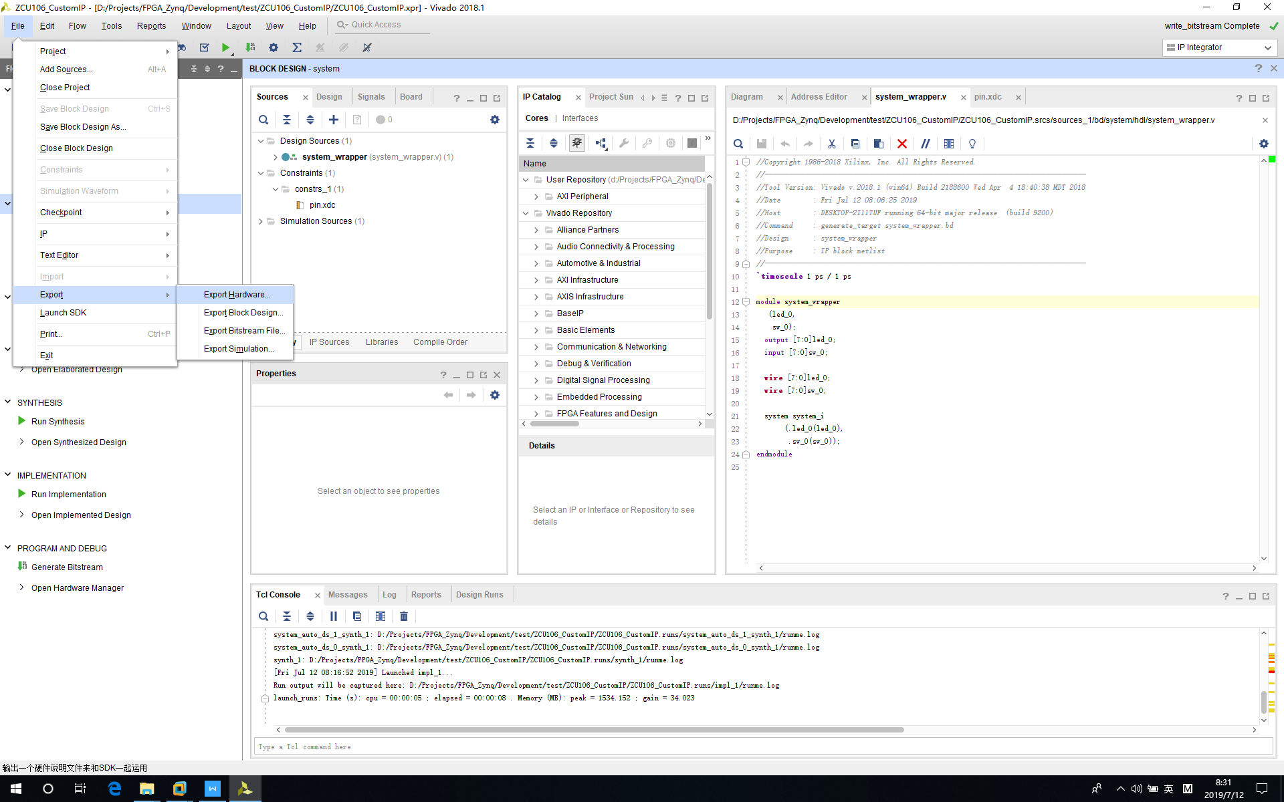

3‑50 Export Hardware

Click “*Include bitstream*” and click “*OK*”.

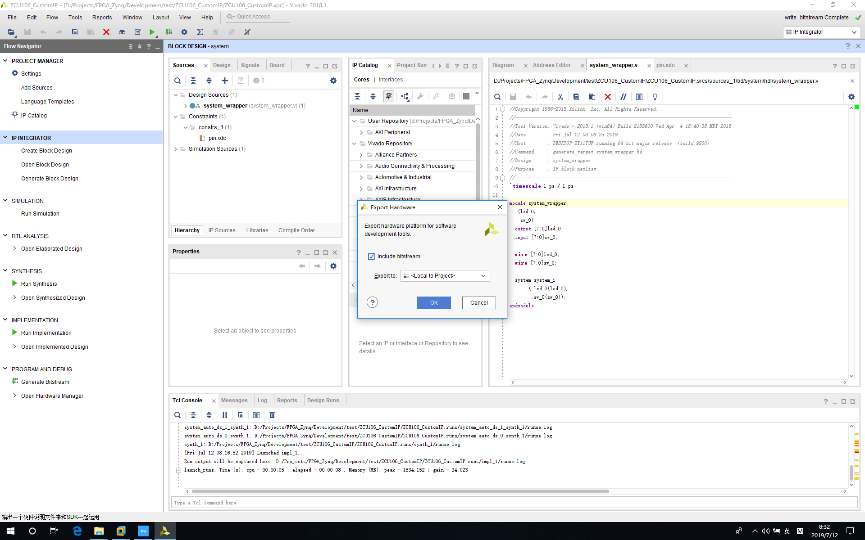

3‑51 Export Hardware – Include Bitstream

After we have the hardware file exported, we need to launch SDK for future firmware development.

Click “*File->Launch SDK*”.

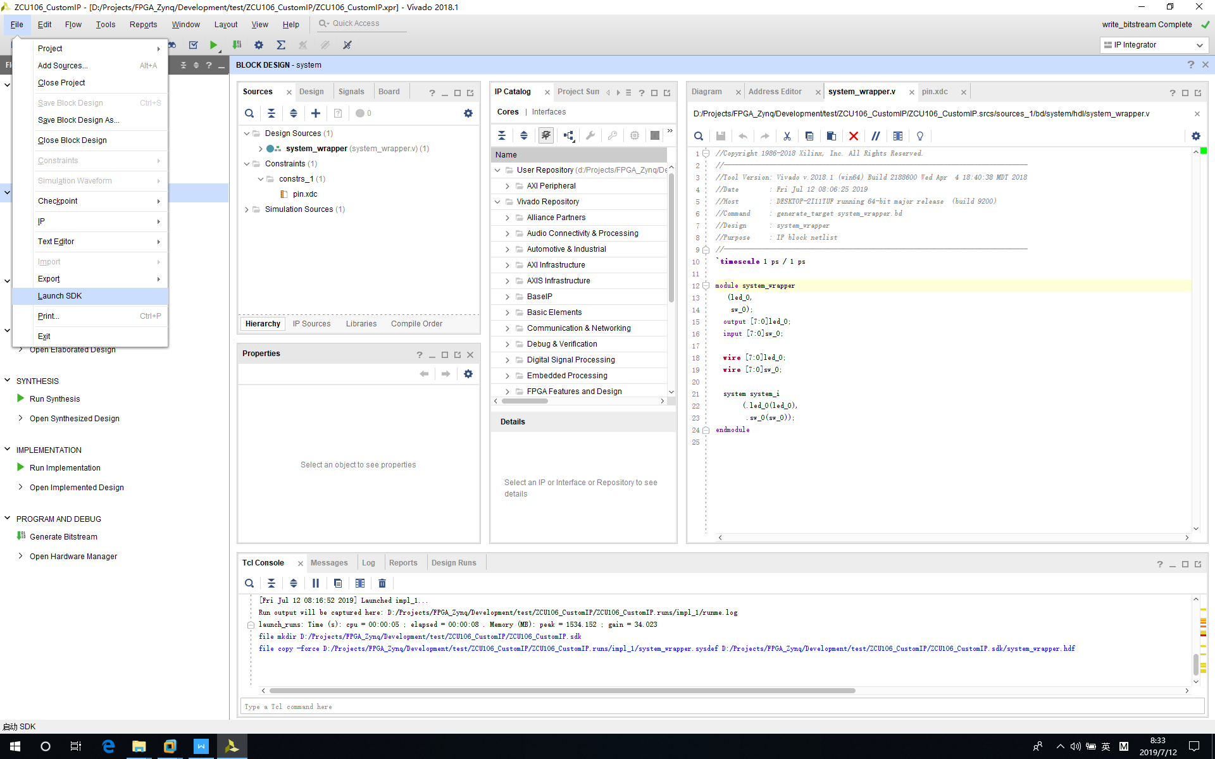

3‑52 Click “Launch SDK”

Click “*OK*” to continue.

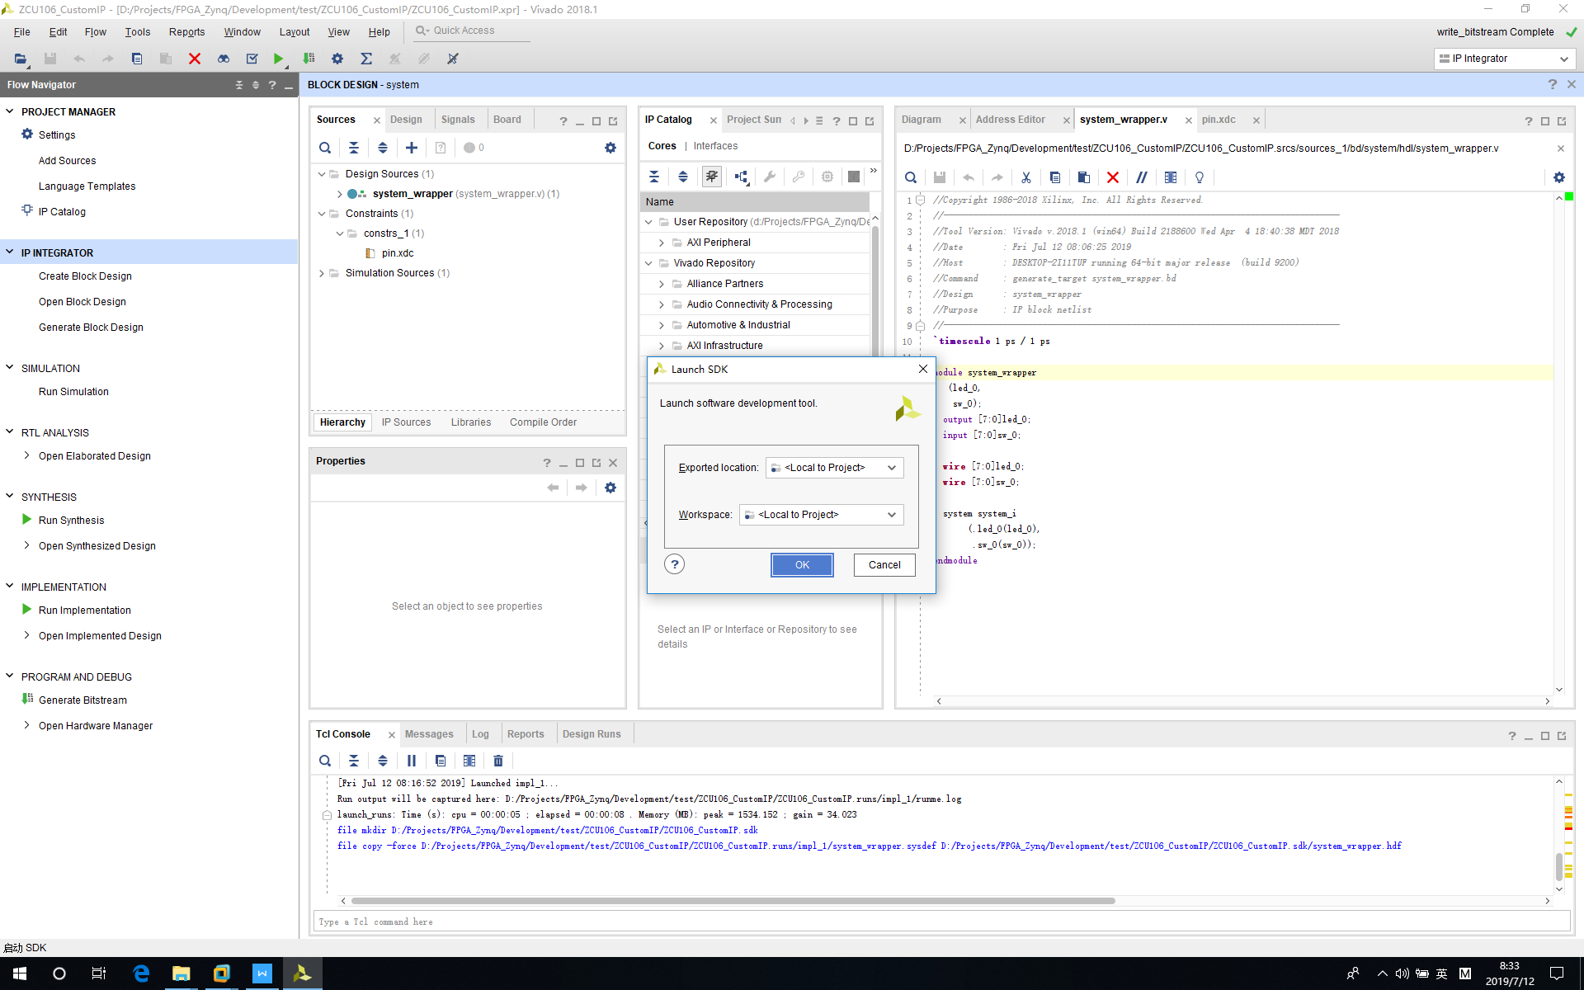

3‑53 Launch SDK

SDK is launched here. Now we will create Petalinux project and will come back to develop firmware in this SDK after Petalinux image is ready.

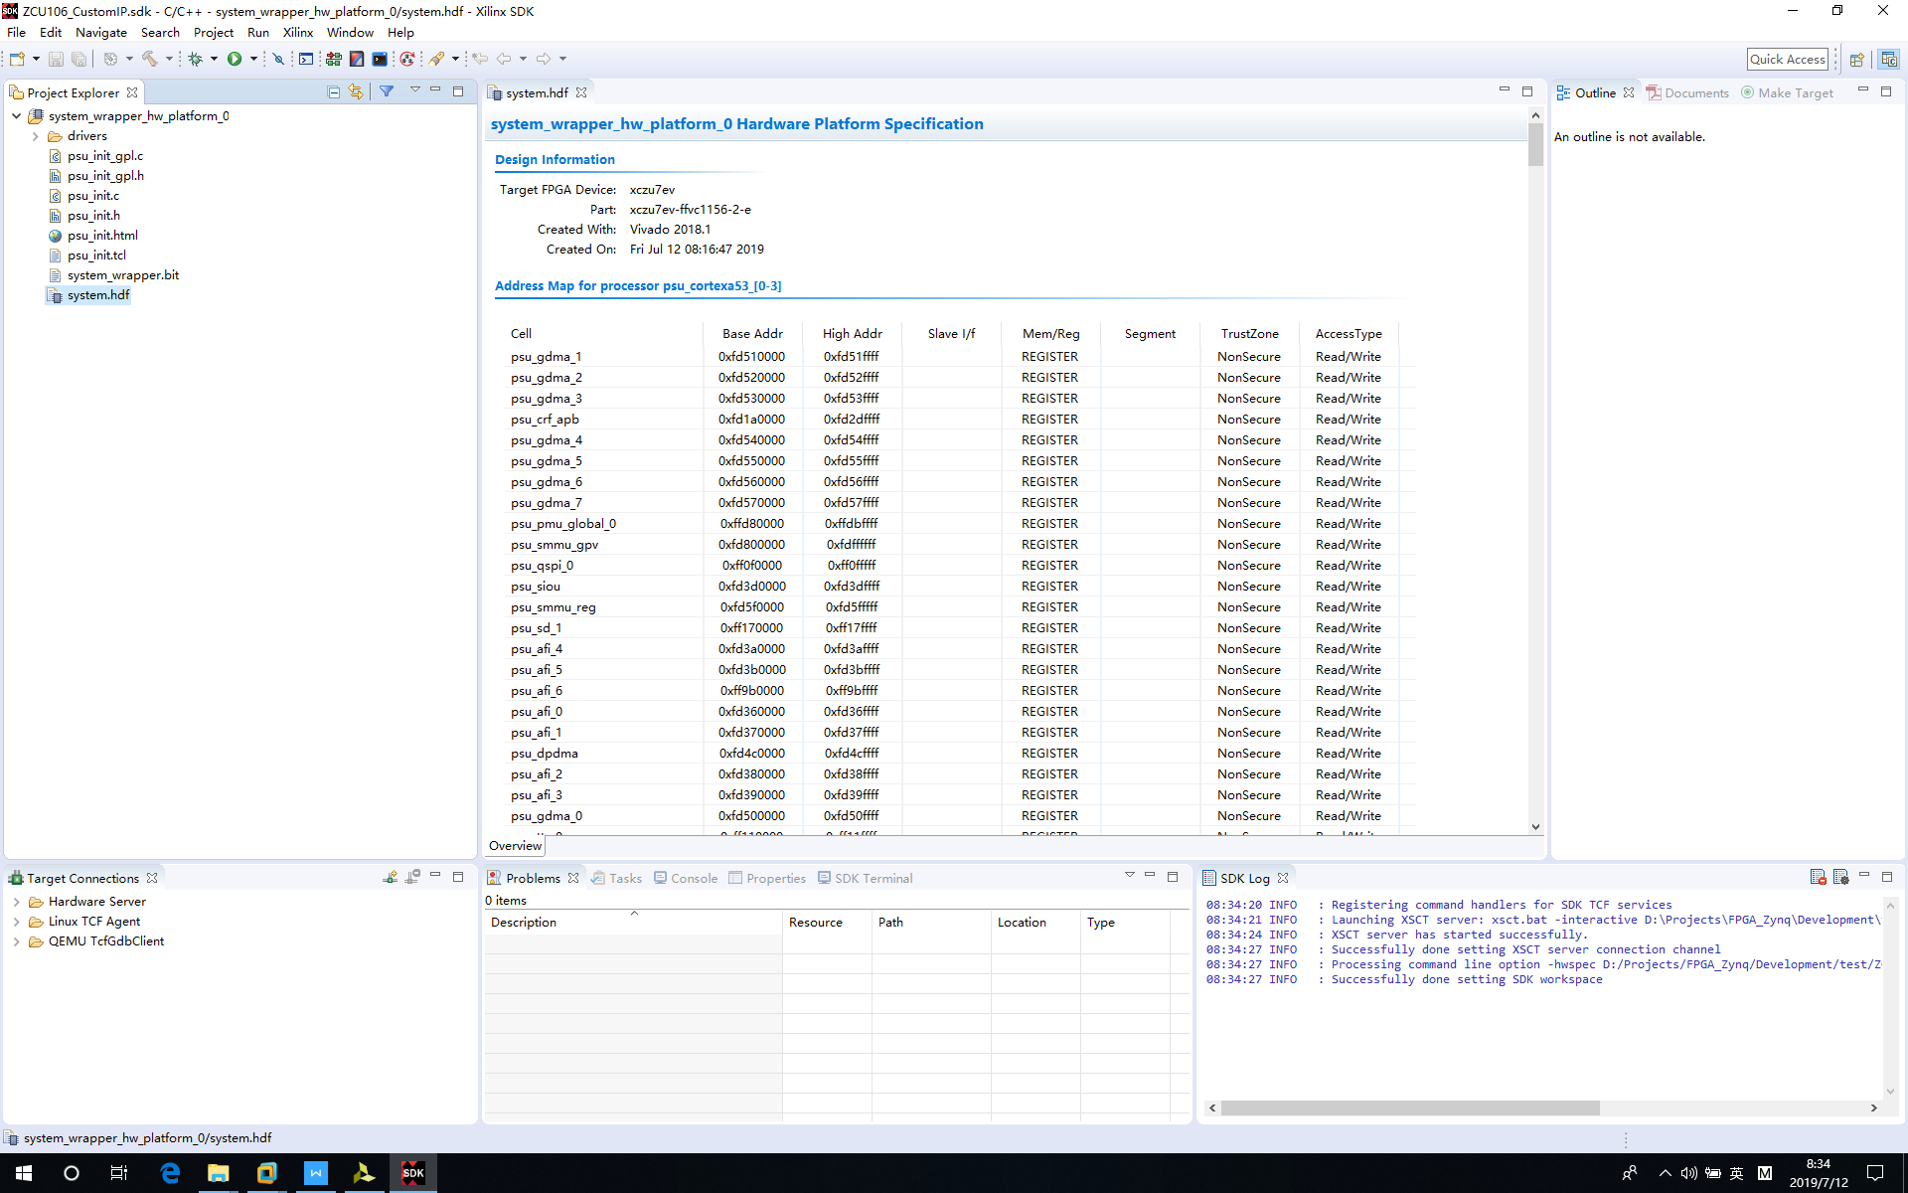

3‑54 Xilinx SDK

# Petalinux Project

The PetaLinux Tools offers everything necessary to customize, build and deploy Embedded Linux solutions on Xilinx processing systems. Tailored to accelerate design productivity, the solution works with the Xilinx hardware design tools to ease the development of Linux systems for Zynq® UltraScale+™ MPSoC, Zynq®-7000 SoCs, and MicroBlaze™. This document shows detailed steps on how to create this project.

## Step 1 - Create Petalinux Project

*Run command:*

*petalinux-create --type project --template zynqMP --name ZCU106_CustomIP_Petalinux*

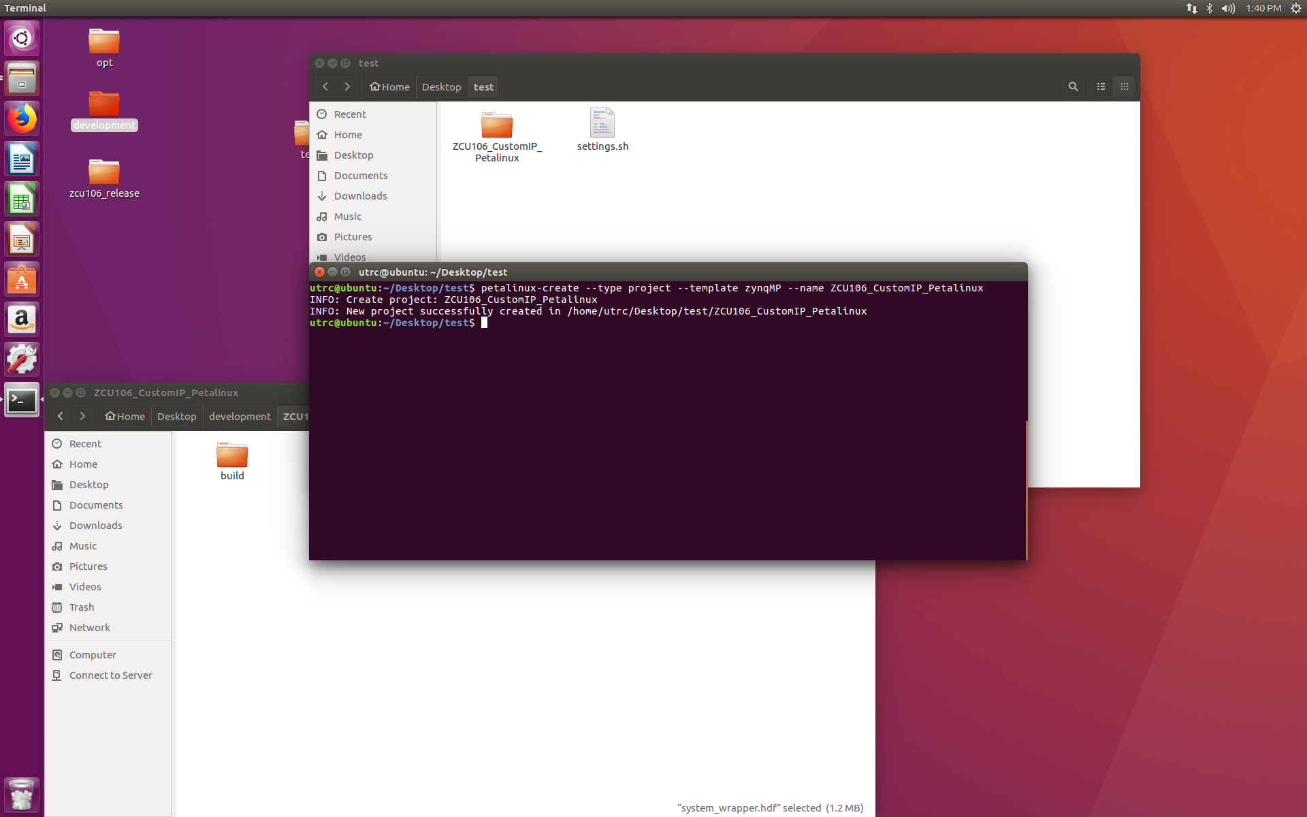

4‑1 Create Petalinux Project

## Step 2 - Config Petalinux Project

Copy system_wrapper.hdf (Windows machine) in following folder to Ubuntu Petalinux project folder.

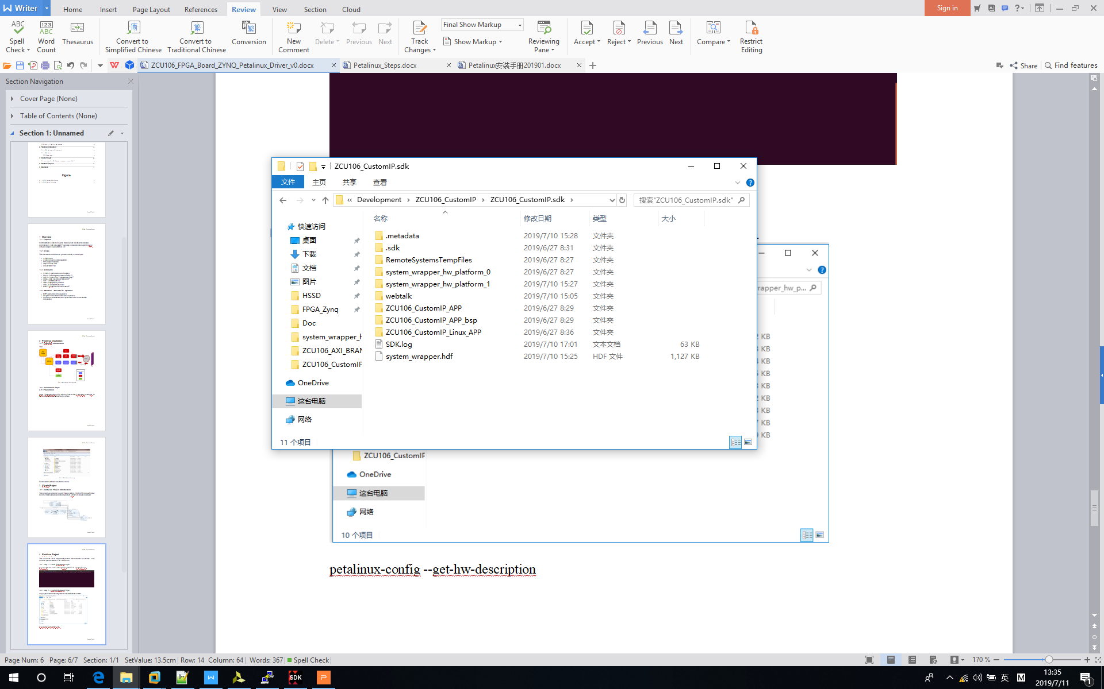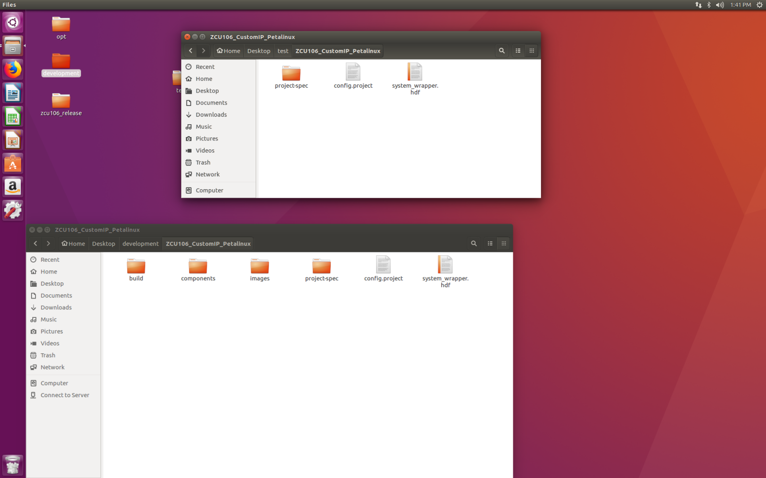

4‑2 Copy hdf file to Virtual Machine

*Run command: petalinux-config --get-hw-description*

1. *Wait for config page to pop up;*
2. *Set DTG Settings -> MACHINE_NAME to zcu106-reva;*
3. *Save and return, this will take some time to compile hardware;*

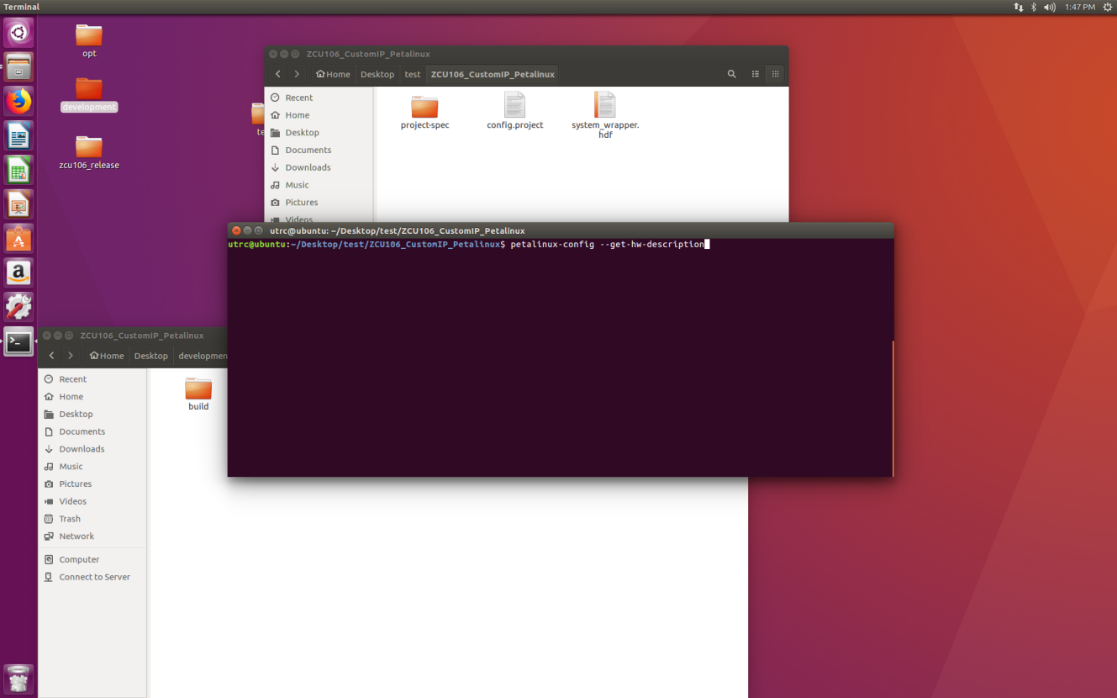

4‑3 Config Petalinux Project

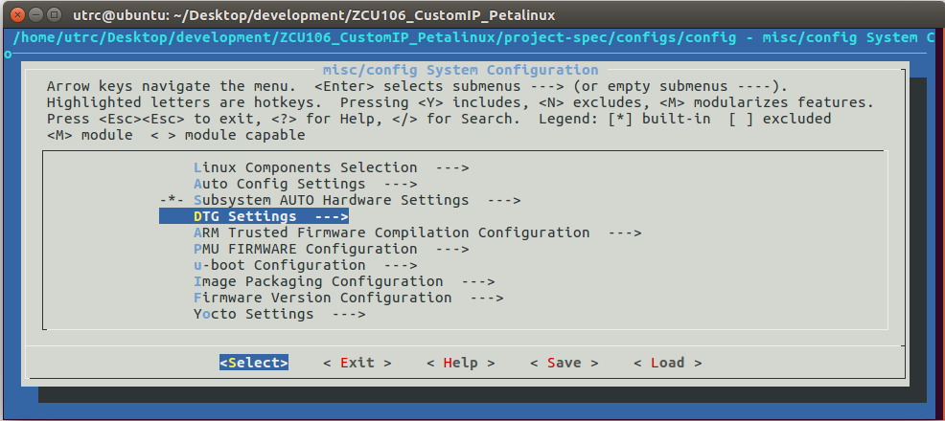

4‑4 Move to “DTG Seetings”

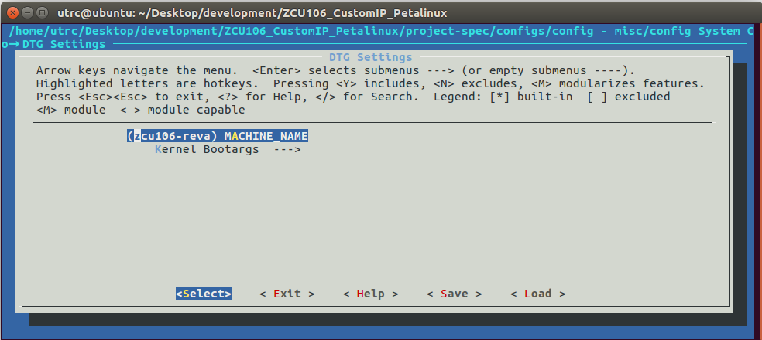

4‑5 Change Machine Name

## Step 3 - Build Petalinux Project

*Run command: petalinux-build*

1. *This will compile code;*
2. *It will take long time;*
3. *This step will generate device tree, which will be useful for custom IP; As to details, go to next step;*
4. *If you do not have custom IP, just go to step 7 which will help you to package files;*

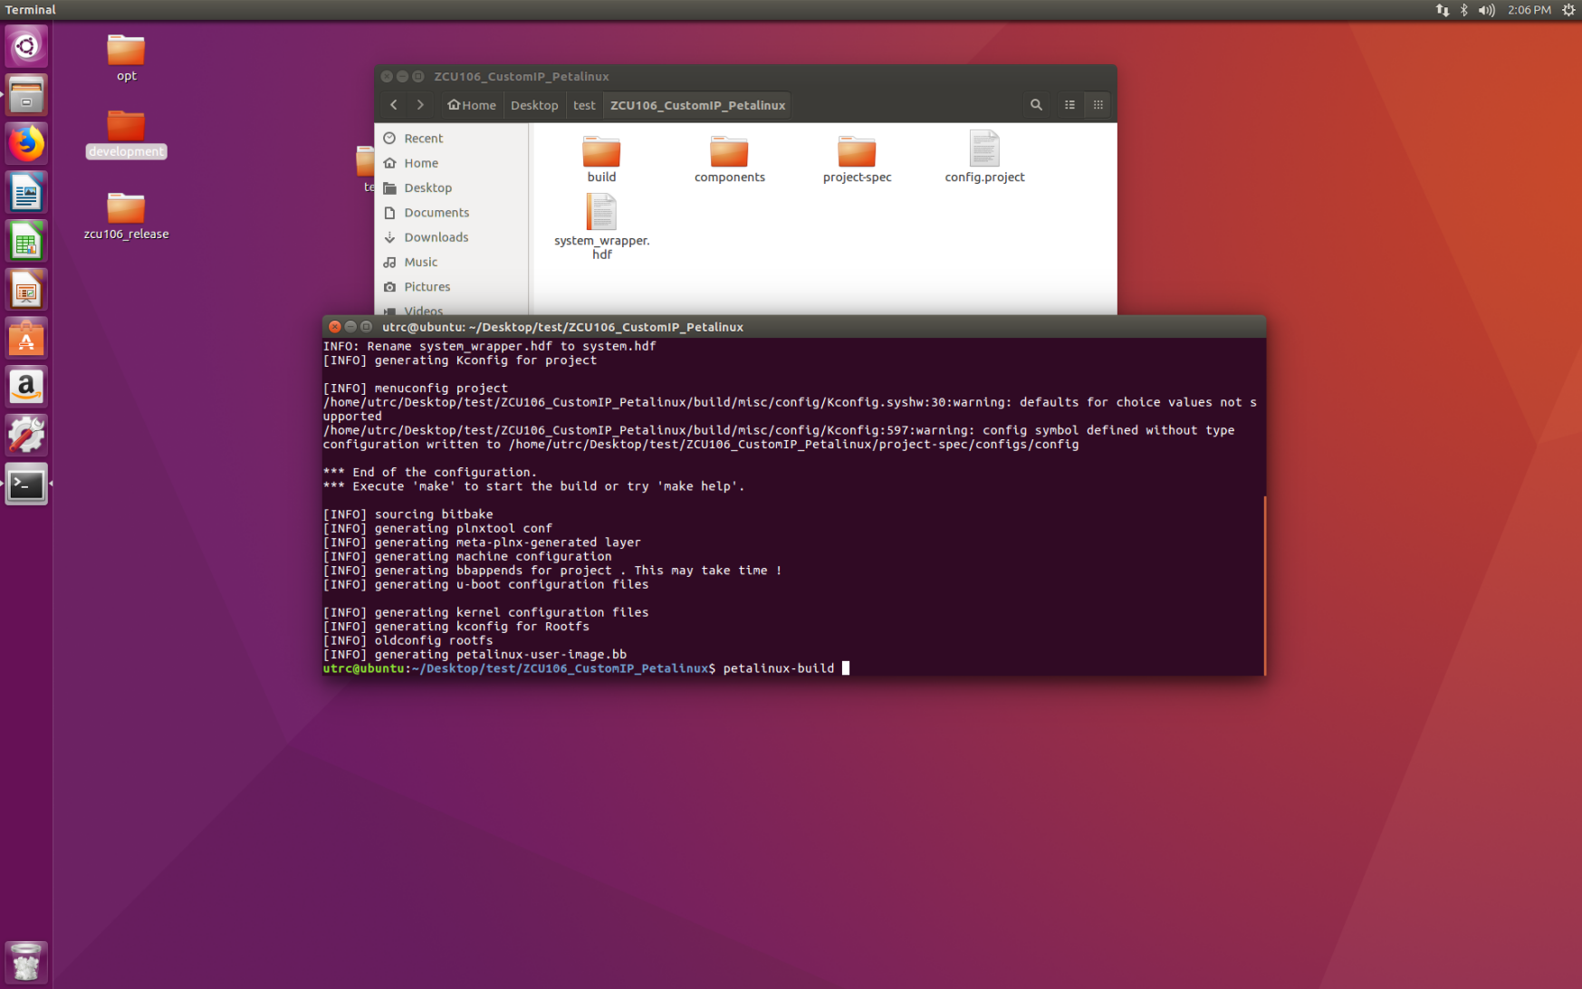

4‑6 Build Petalinux Project

After this command, device tree file will be generated under the following folder

1. <project folder>/components/plnx_workspace/device-tree/device-tree;
2. File “pl.dtsi” is the pl (program logic) side device tree, it contains myip information;

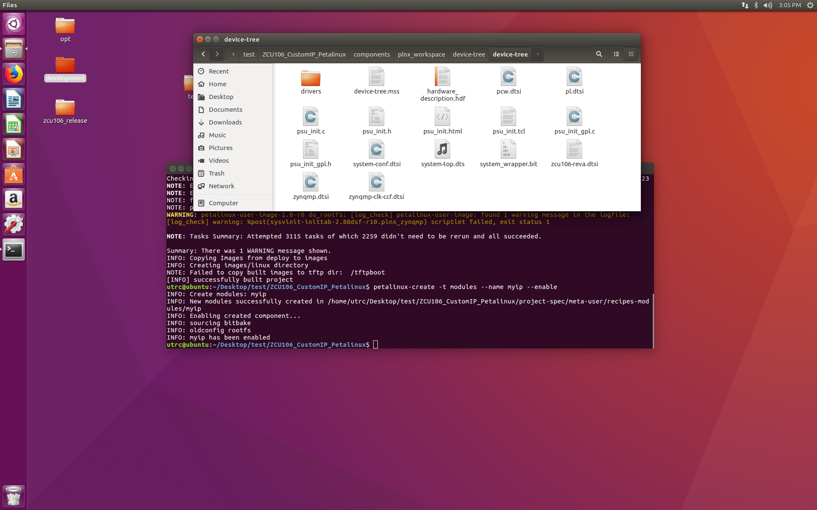

4‑7 Generated Files by Build Command

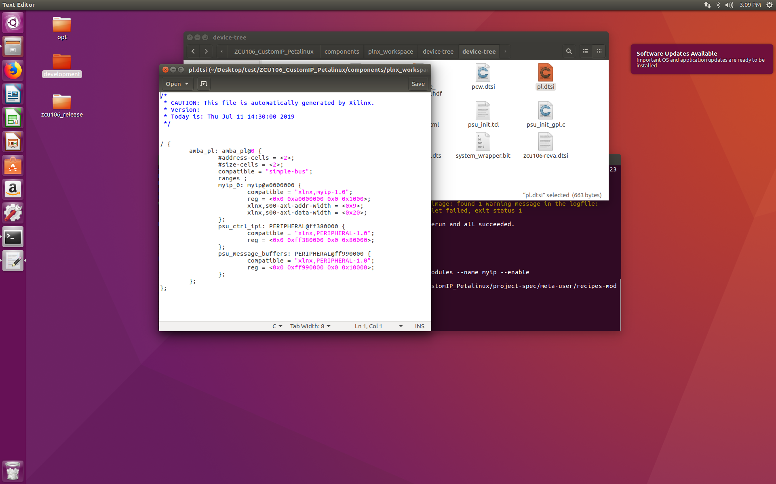

4‑8 Content in “pl.dsti” File

## Step 4 - Create Custom Modules

*Run command: petalinux-create -t modules --name myip --enable*

1. *This step will create myip modules*

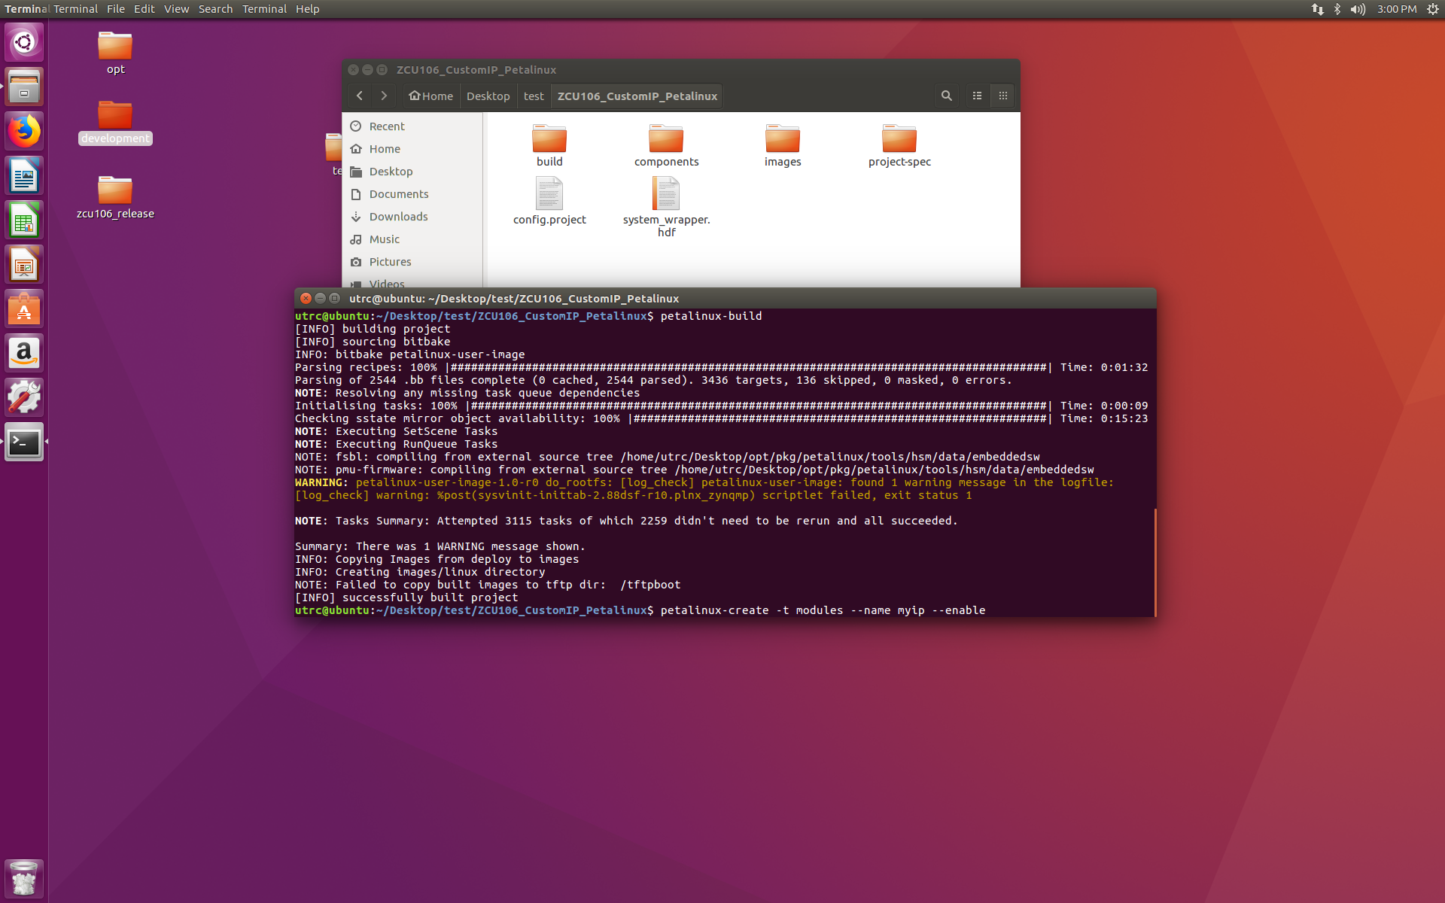

4‑9 Create Custom Modules

After this command, myip module will be crated under following folder.

1. <project folder>/project-spec/meta-user/recipes-modules/myip
2. Replace auto-generated myip.c in myip folder with updated myip.c in this github project.

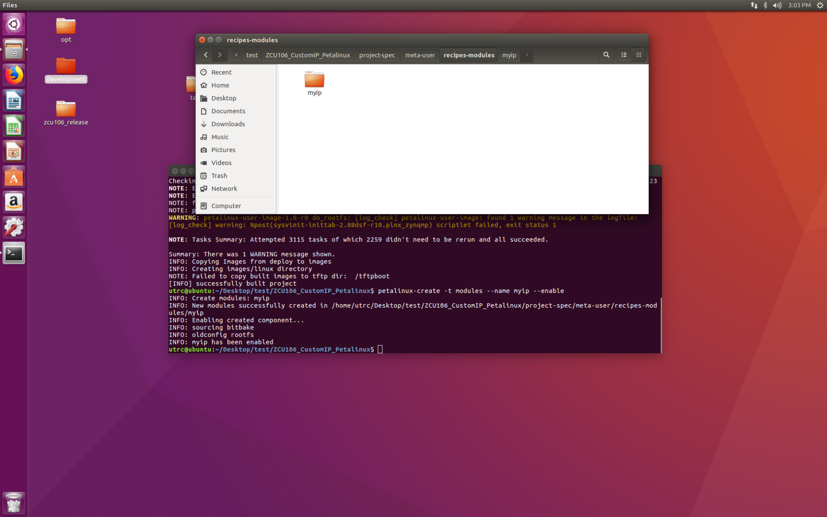

4‑10 Custom Modules Direction

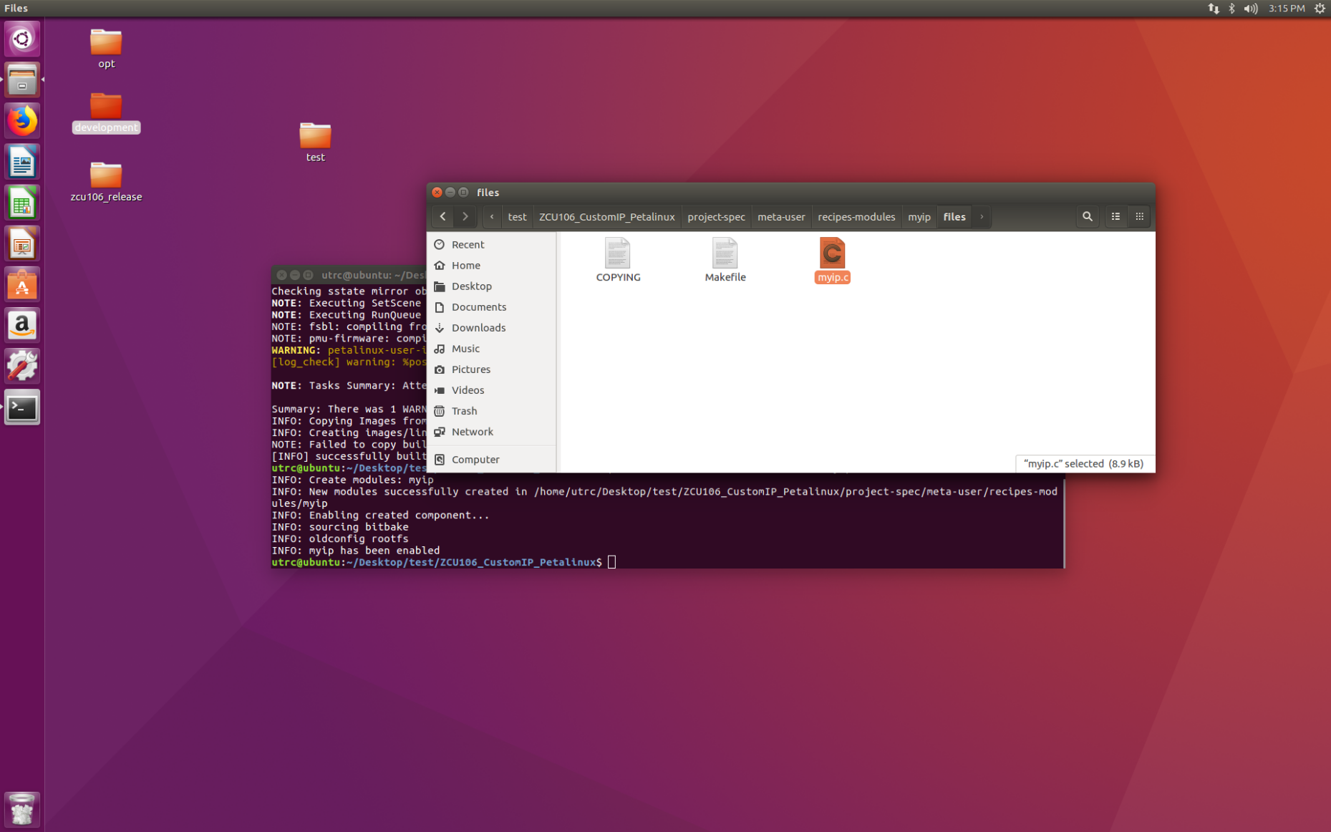

4‑11 Custom Modules Default Driver

Open myip.c file in myip folder, this file implements the basic functions for Linux Devices. But it needs user to implement functions like “write”, “read”, “open”, “release”. The updated myip.c is located in this github project, please do some comparison between updated version and original version.

## Step 5 - Build Petalinux Project

Since we added myip module to project, please build project again.

*Run command: petalinux-build*

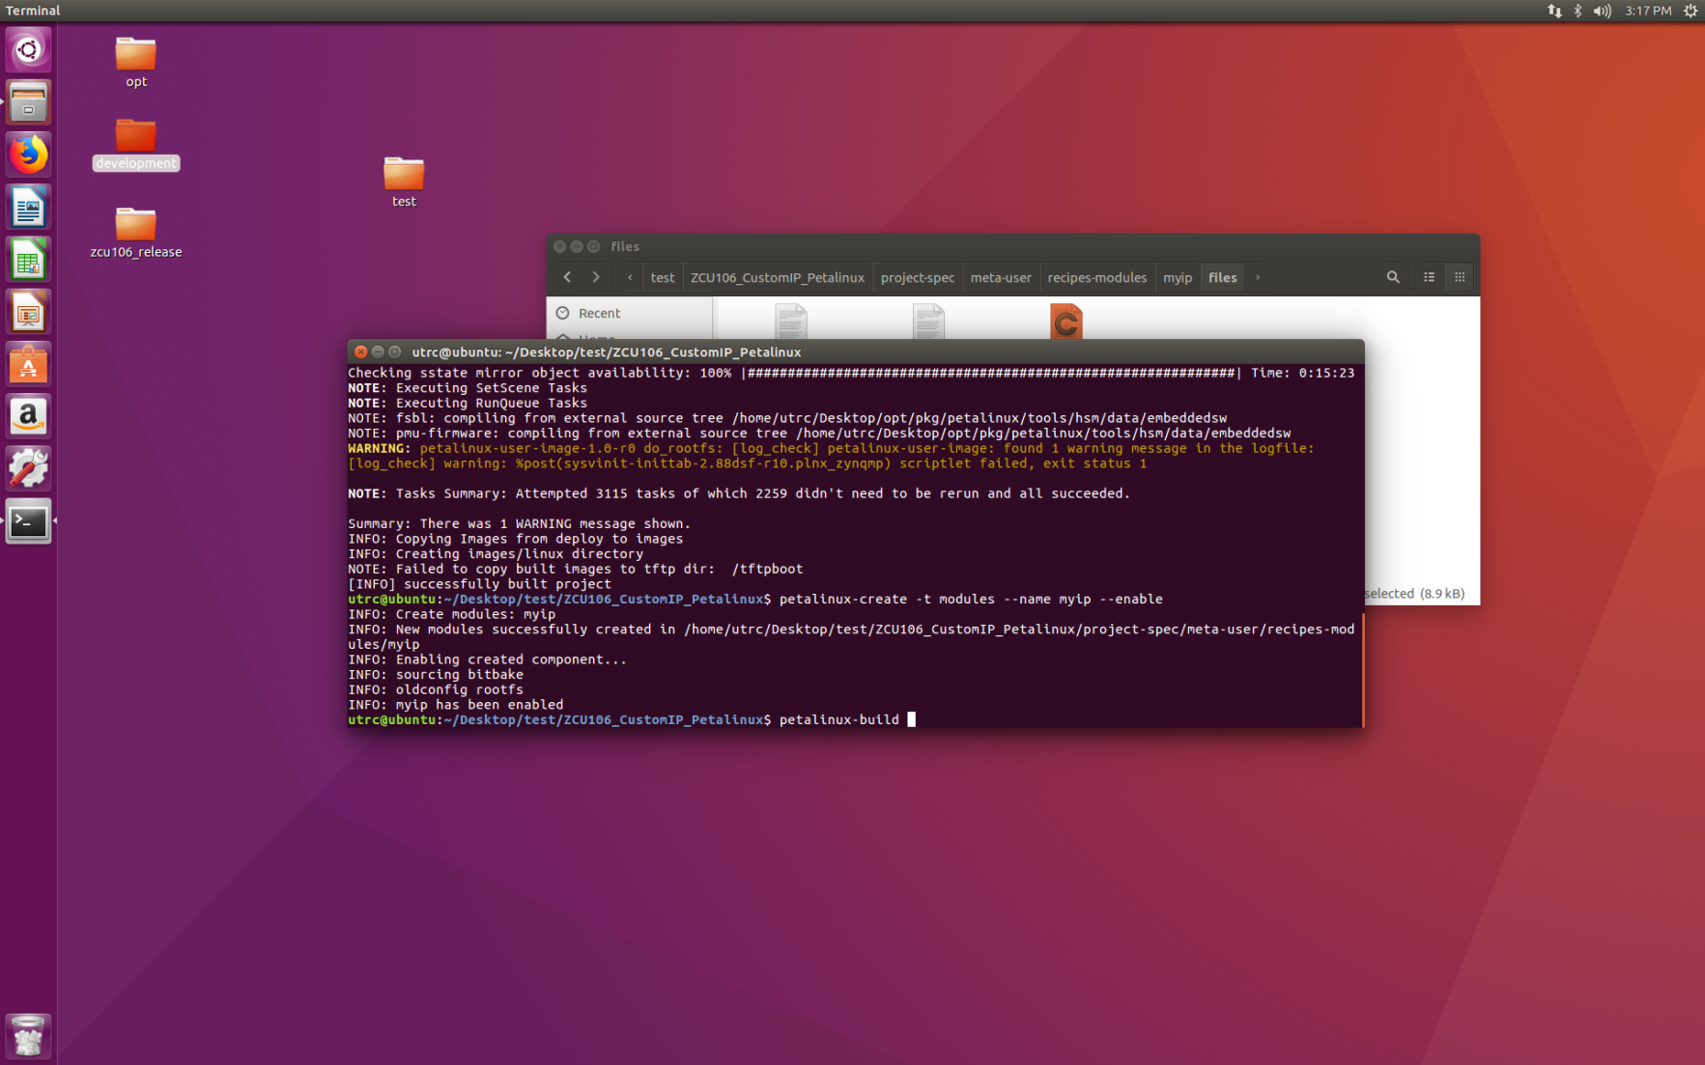

4‑12 Build Petalinux Project

## Step 6 - Package Petalinux Project

*Go images/linux folder, run command:*

*petalinux-package --boot --fsbl zynqmp_fsbl.elf --fpga system.bit --pmufw pmufw.elf --u-boot*

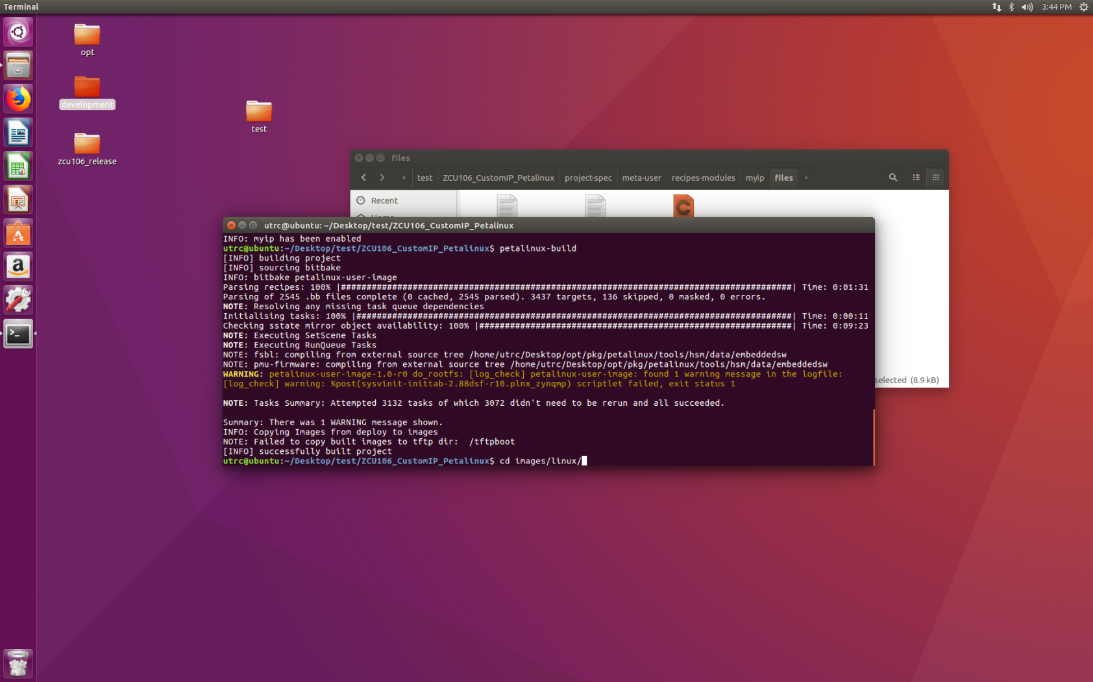

4‑13 Move to Package Folder

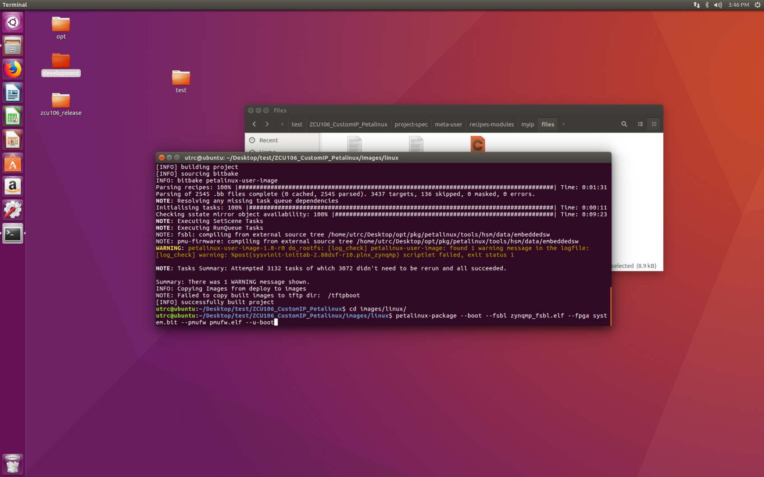

4‑14 Package Petalinux Files

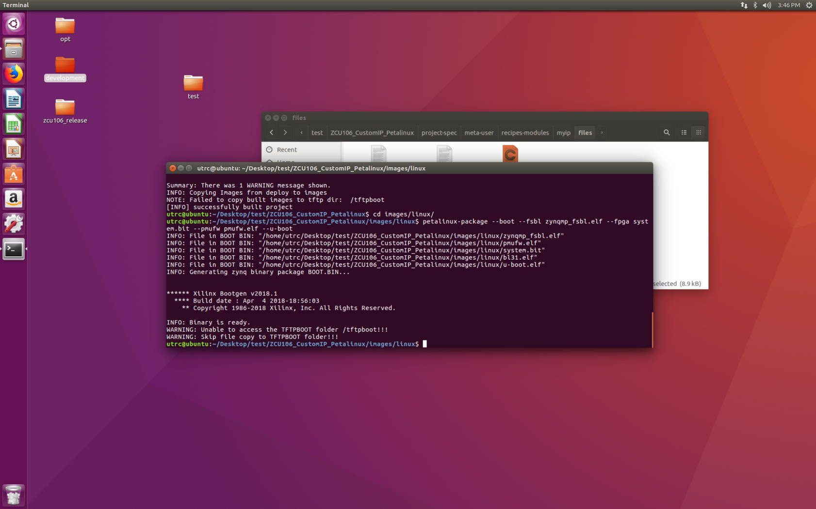

4‑15 Package Results

# Linux Application Development

## Step 1 – Board Setup

Copy all files in images/linux to SD card with FAT32 format.

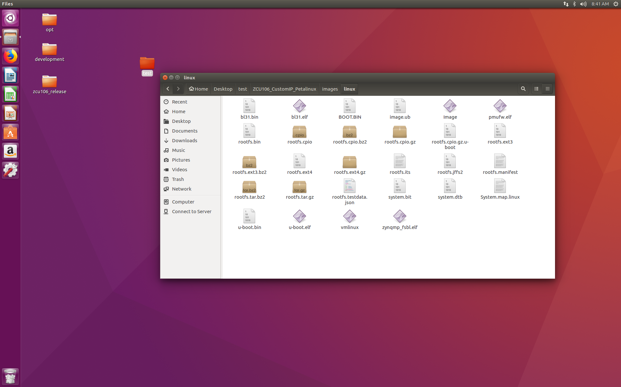

5‑1 Petalinux Files for SD Card

Insert SD card(1), set to SD card boot mode(2), turn on power(3);

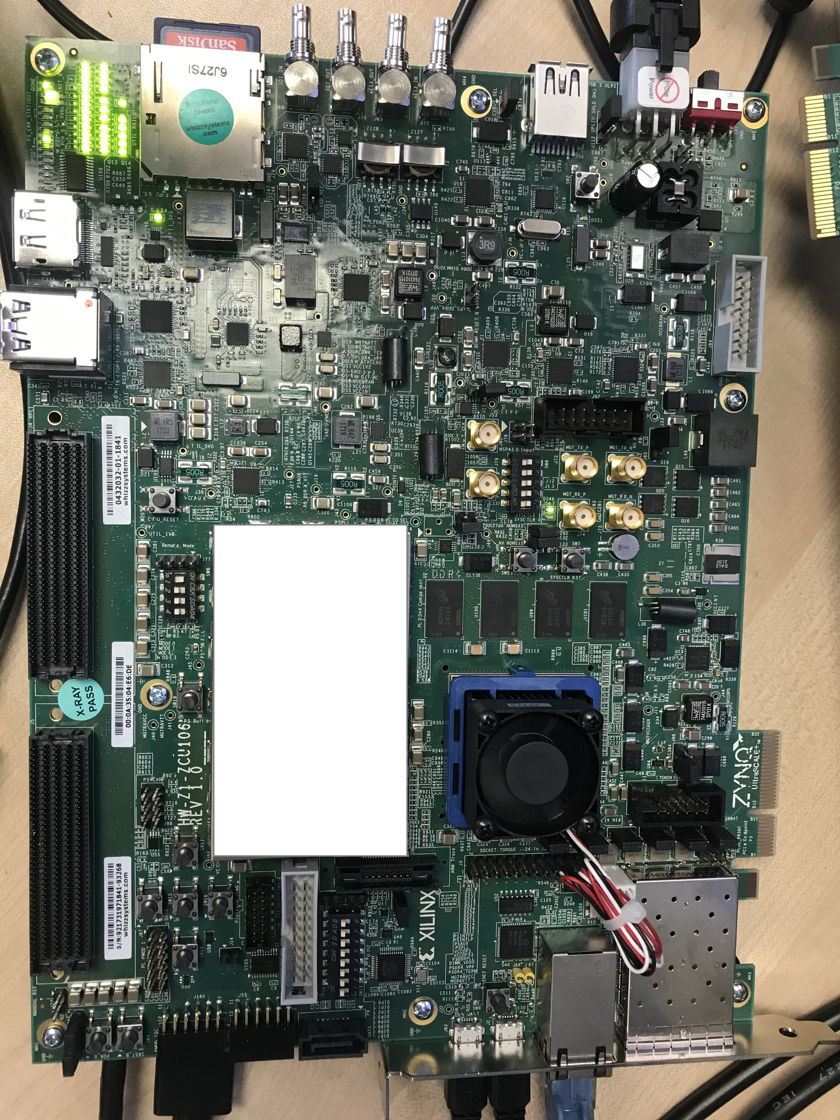

5‑2 Board Running Configuration

## Step 2 – Tera Term Setup

Open Teraterm.

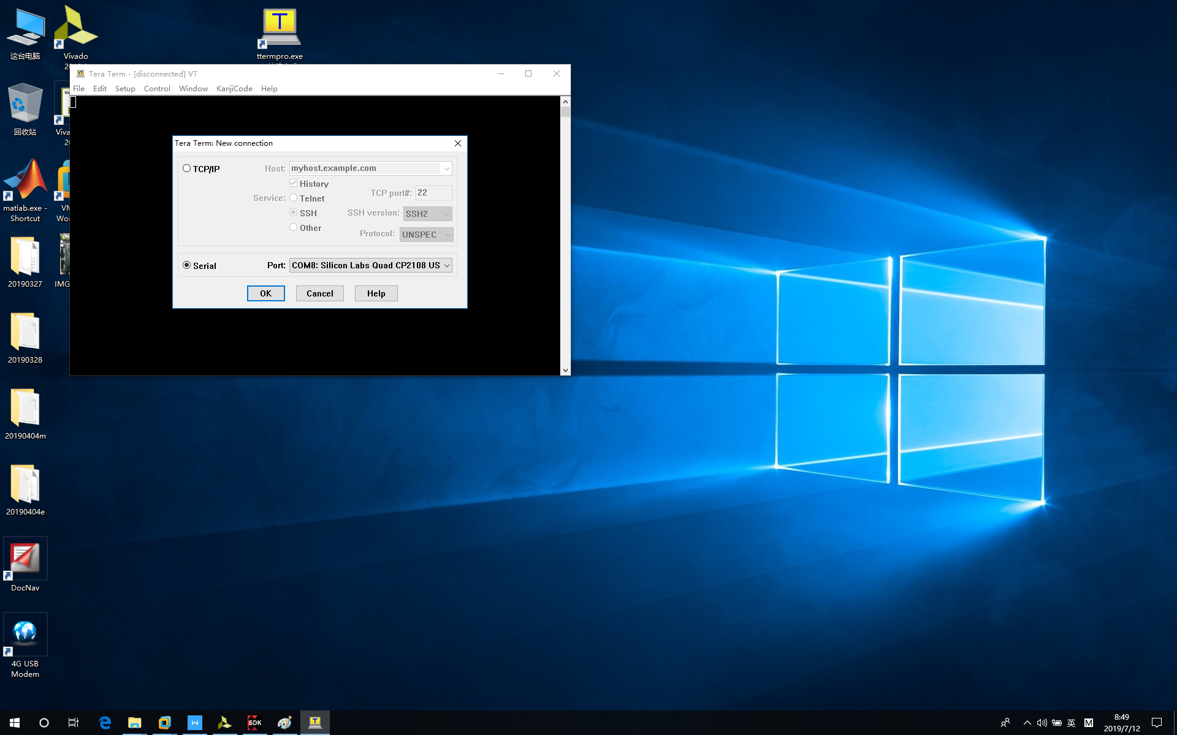

5‑3 Open Tera Term

Setup baud rate to 115200.

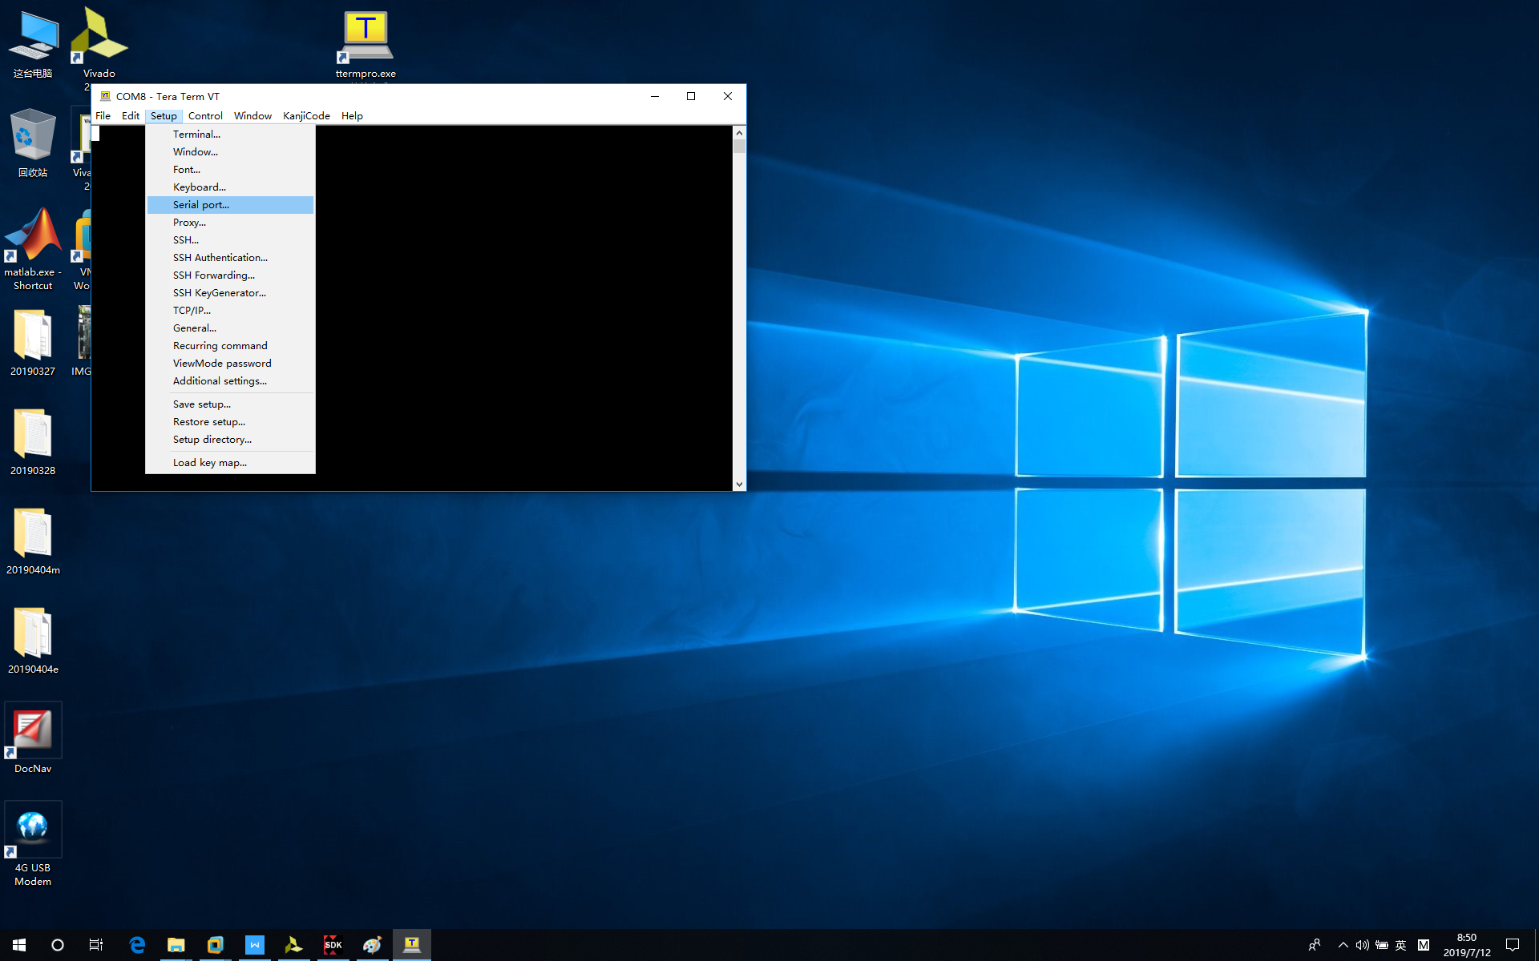

5‑4 Open Teraterm “Serial Port...”

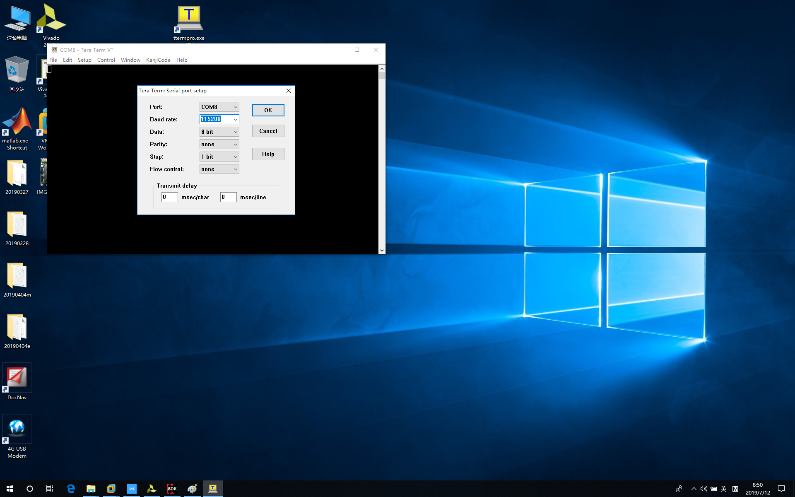

5‑5 Set Teraterm “Serial Port...”

Then we can see message which shows Linux is running on the board, we can user root@root to login.

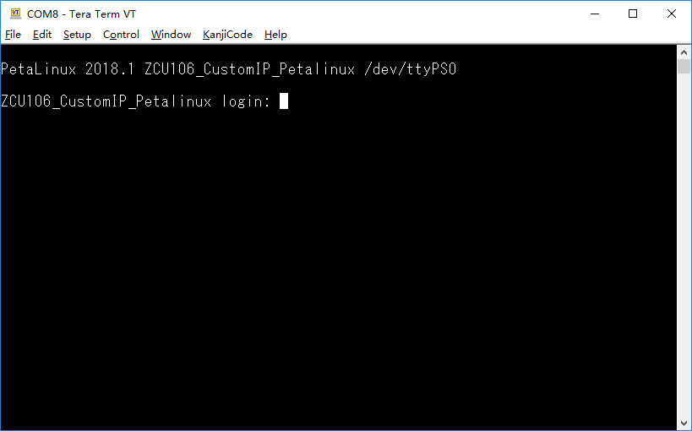

5‑6 Login to Board

## Step 3 – Linux Setup

Input user name and password, root and root;

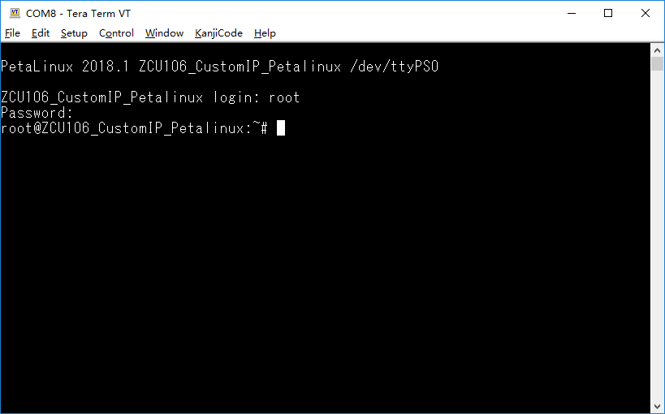

5‑7 Login Status

cd /lib/modules/4.14.0-xilinx-v2018.1/extra/ folder, myip.ko which is linux device driver is there.

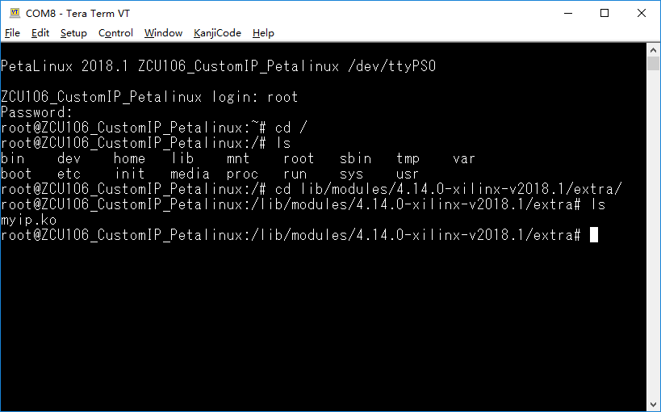

5‑8 Move to Extra Folder

Input “dmesg” command to show Linux driver loading status.

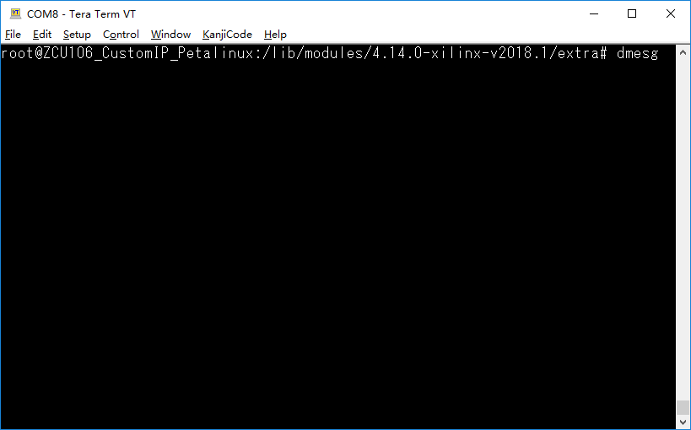

5‑9 Input “dmesg” Command

myip driver is installed successfully.

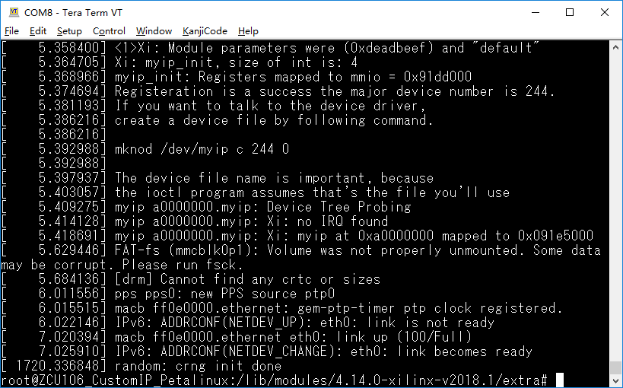

5‑10 Display Driver Status

“myip” device driver is installed successfully, but we still have not instance one “myip” node in dev folder.

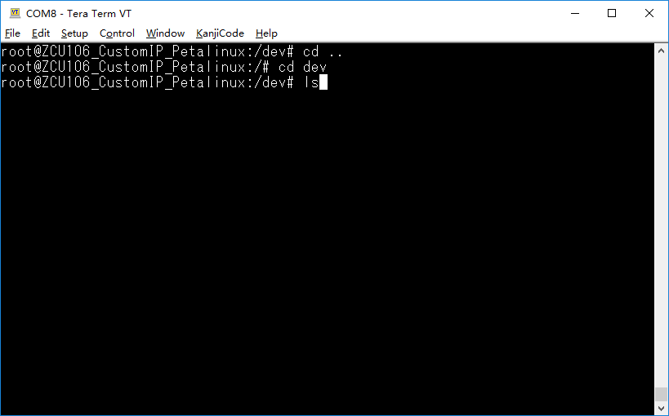

5‑11 Display Devices

There is no “myip” module in list.

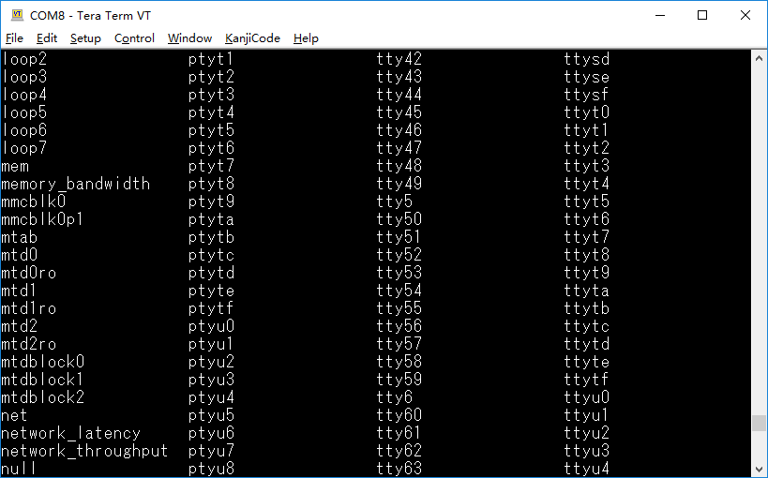

5‑12 Default Devices

Input “*mknod myip c 244 0*” to create that device

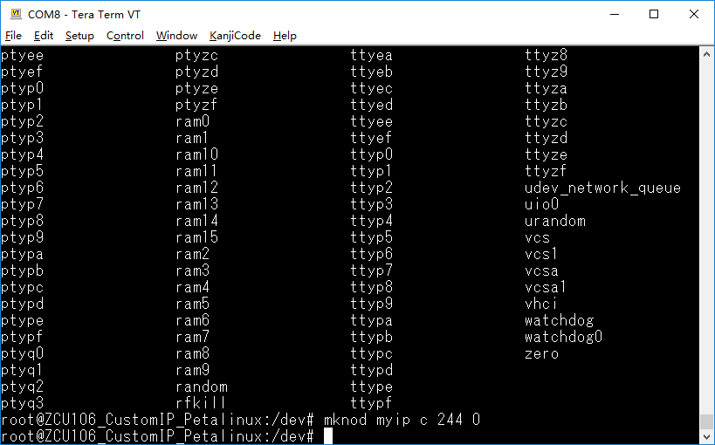

5‑13 Make Custom Module Device

Input “ls” command to have a check.

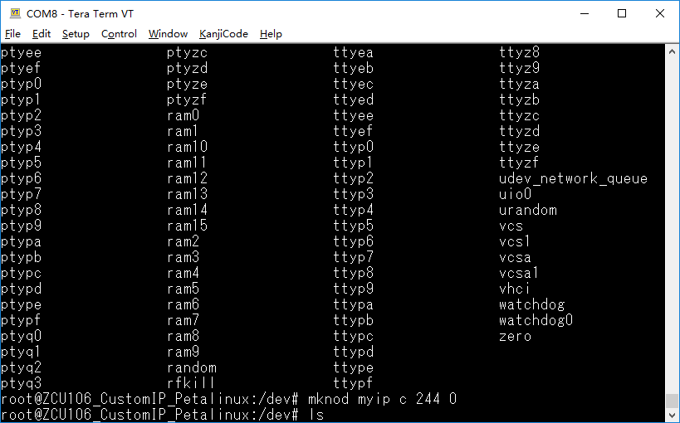

5‑14 Display Devices

“myip” is there now.

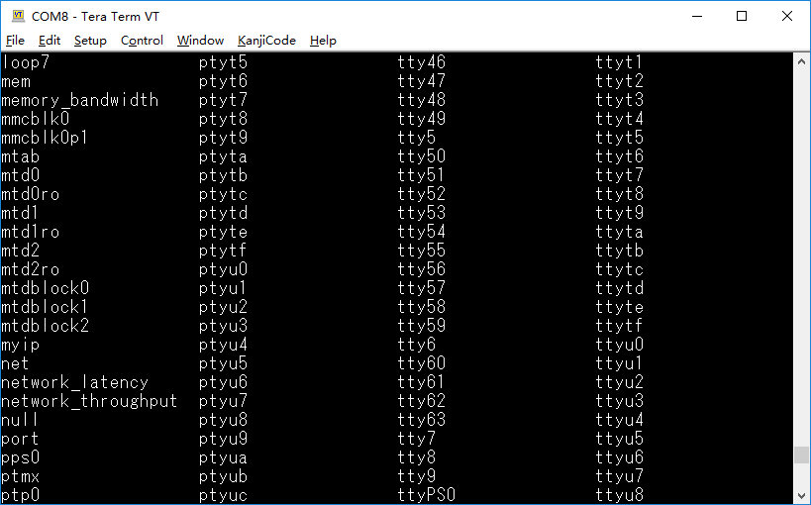

5‑15 Updated Devices with Custom Device

## Step 4 – Linux Application

After “myip” node is created on Linux, then we can develop Linux application.

In Xilinx SDK, click “New -> Application Project”.

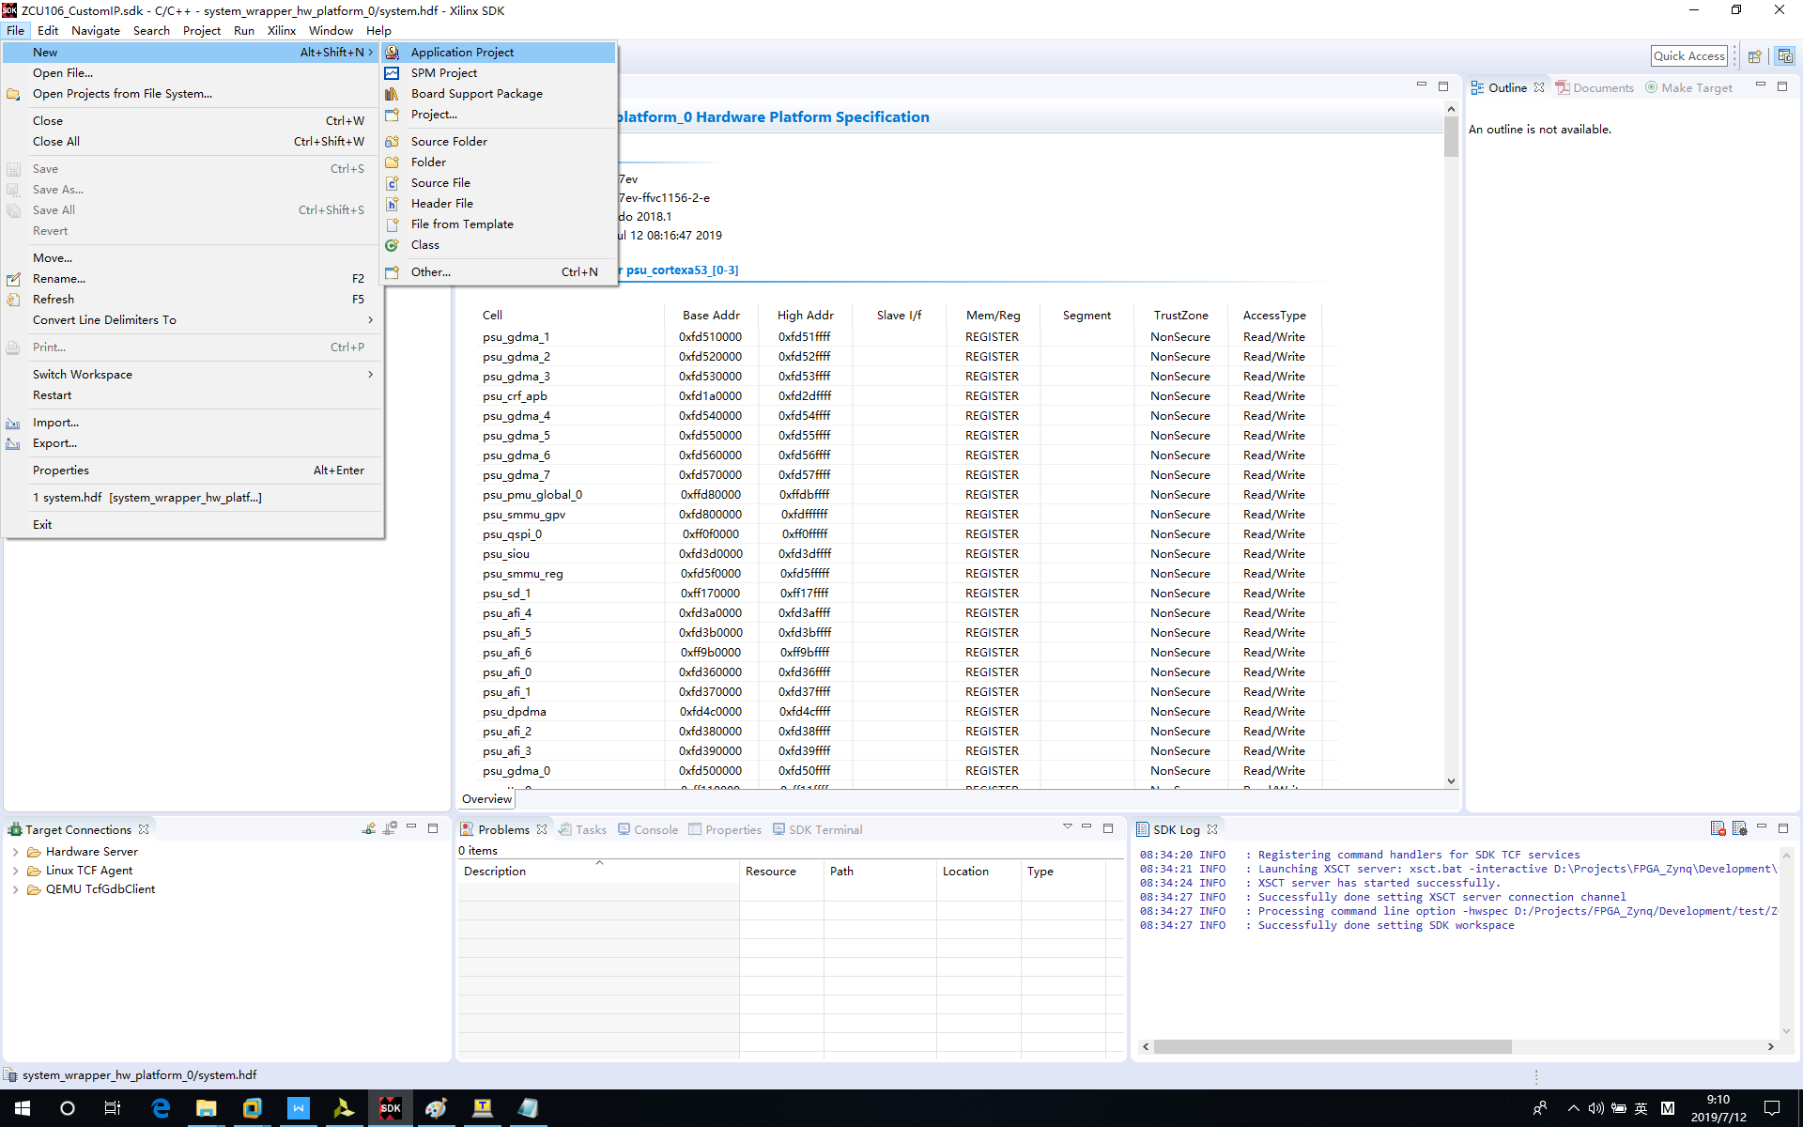

5‑16 Create Linux Application Project

Setup the project like the following.

* Project name - ZCU106_CustomIP_Linux
* OS Platform - linux
* Processor Type: psu_cortexa53

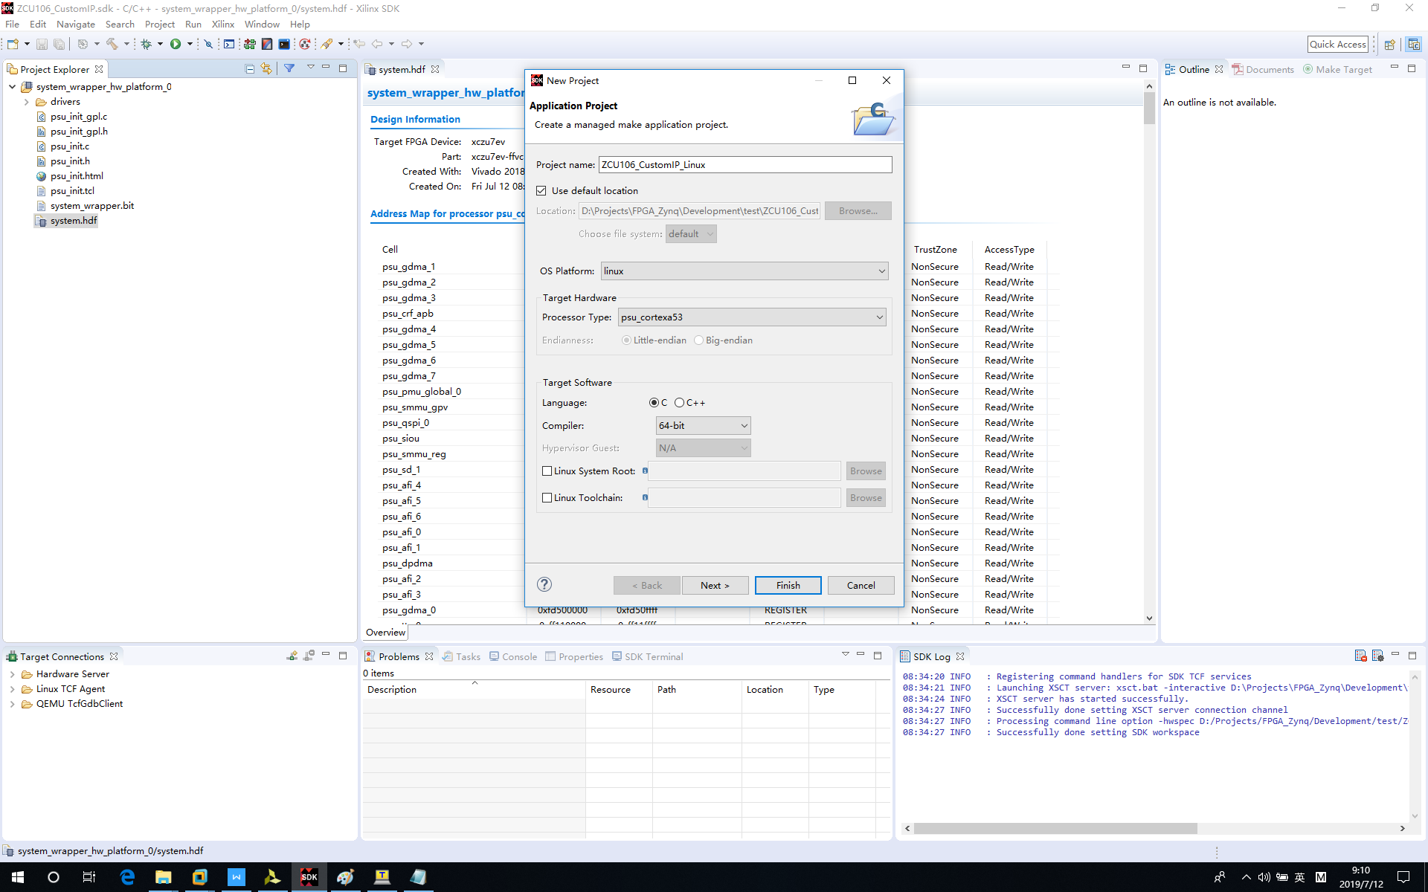

5‑17 Linux Project Configuration

Select “Linux Hello World” template.

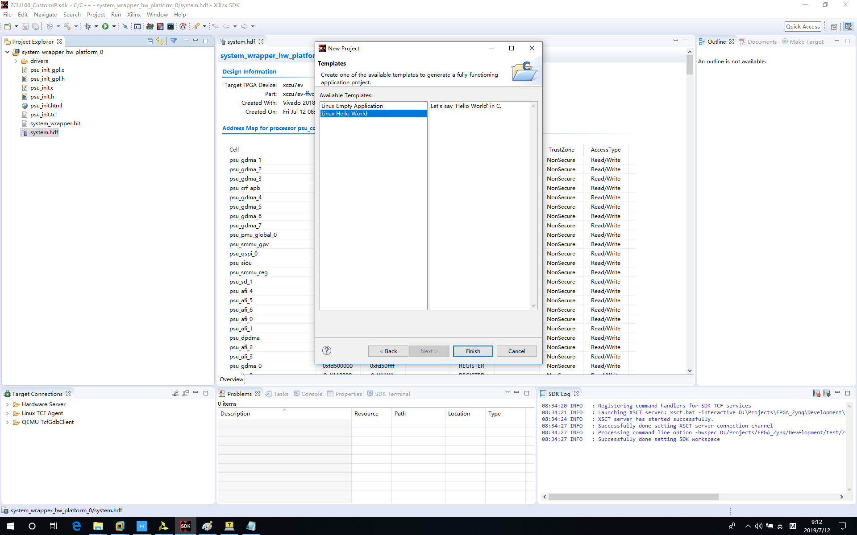

5‑18 Select Linux Project Template

Update helloworld.c with following content. You can find it in github.

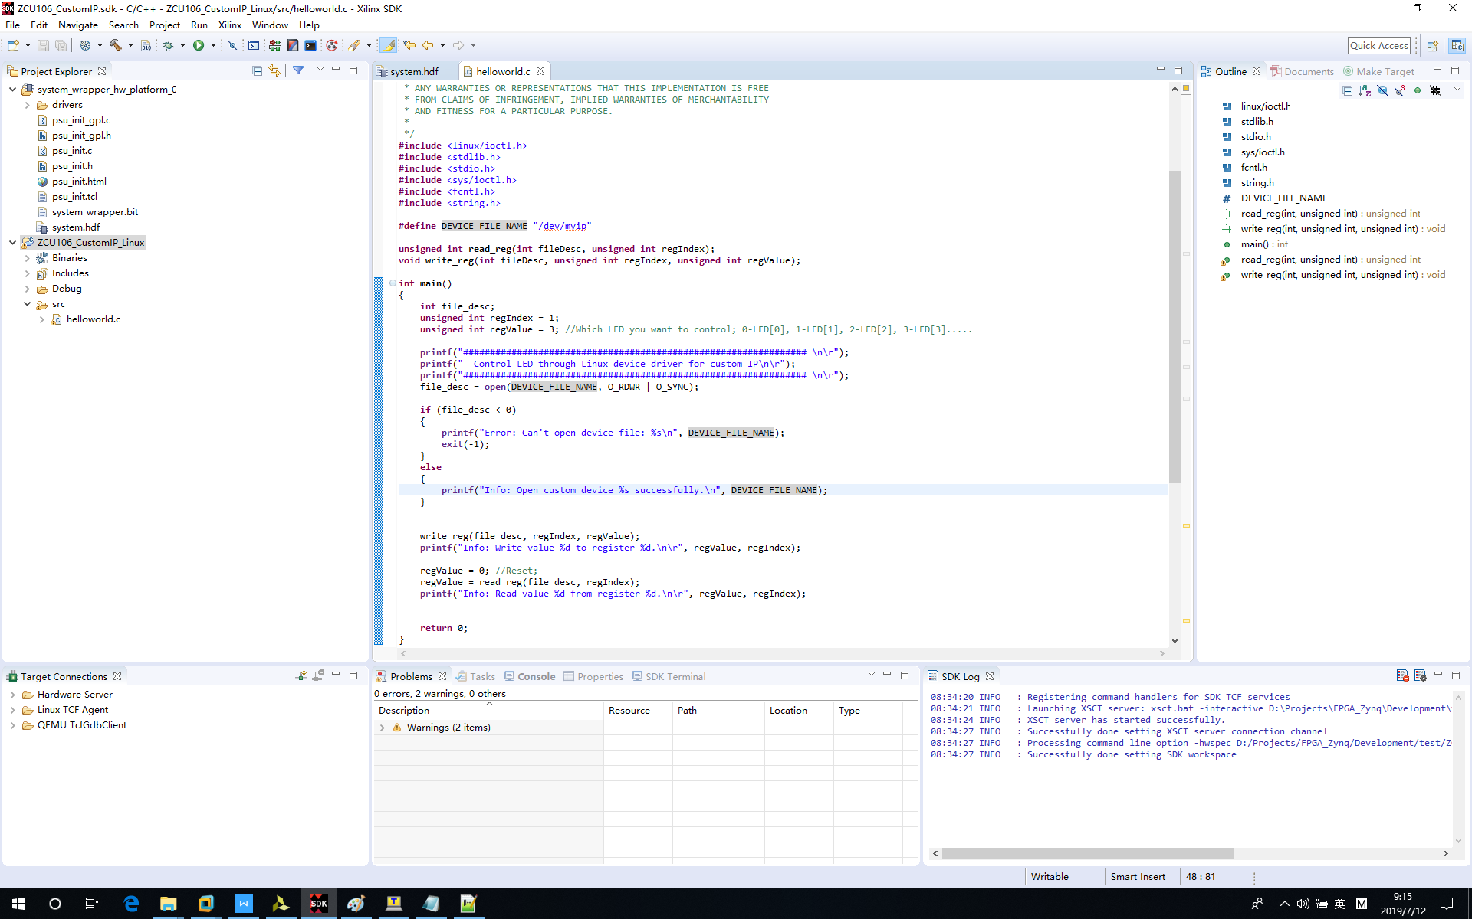

5‑19 Update Helloworld.c

Right click “project name -> Run As -> Run Configurations...”

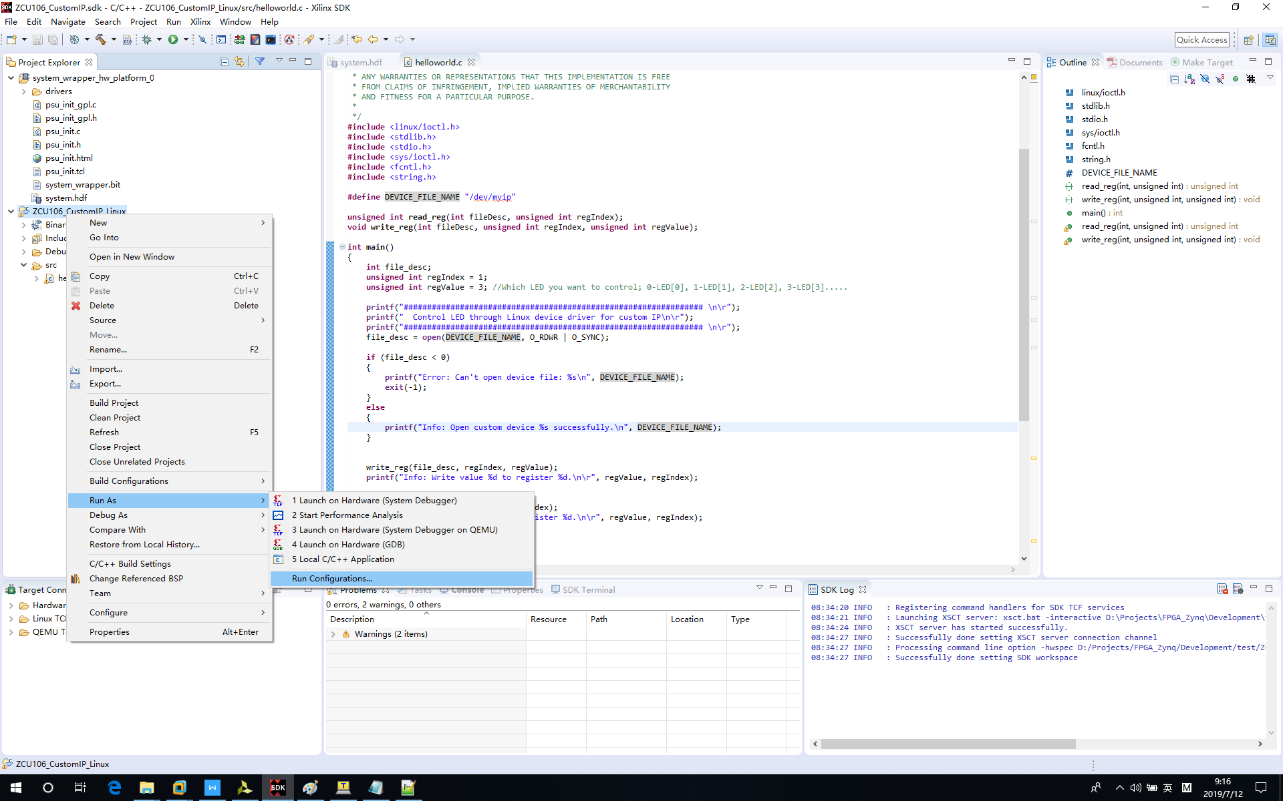

5‑20 Open “Run Configurations…”

Double click *“Xilinx C/C++ application (System Debugger)”*

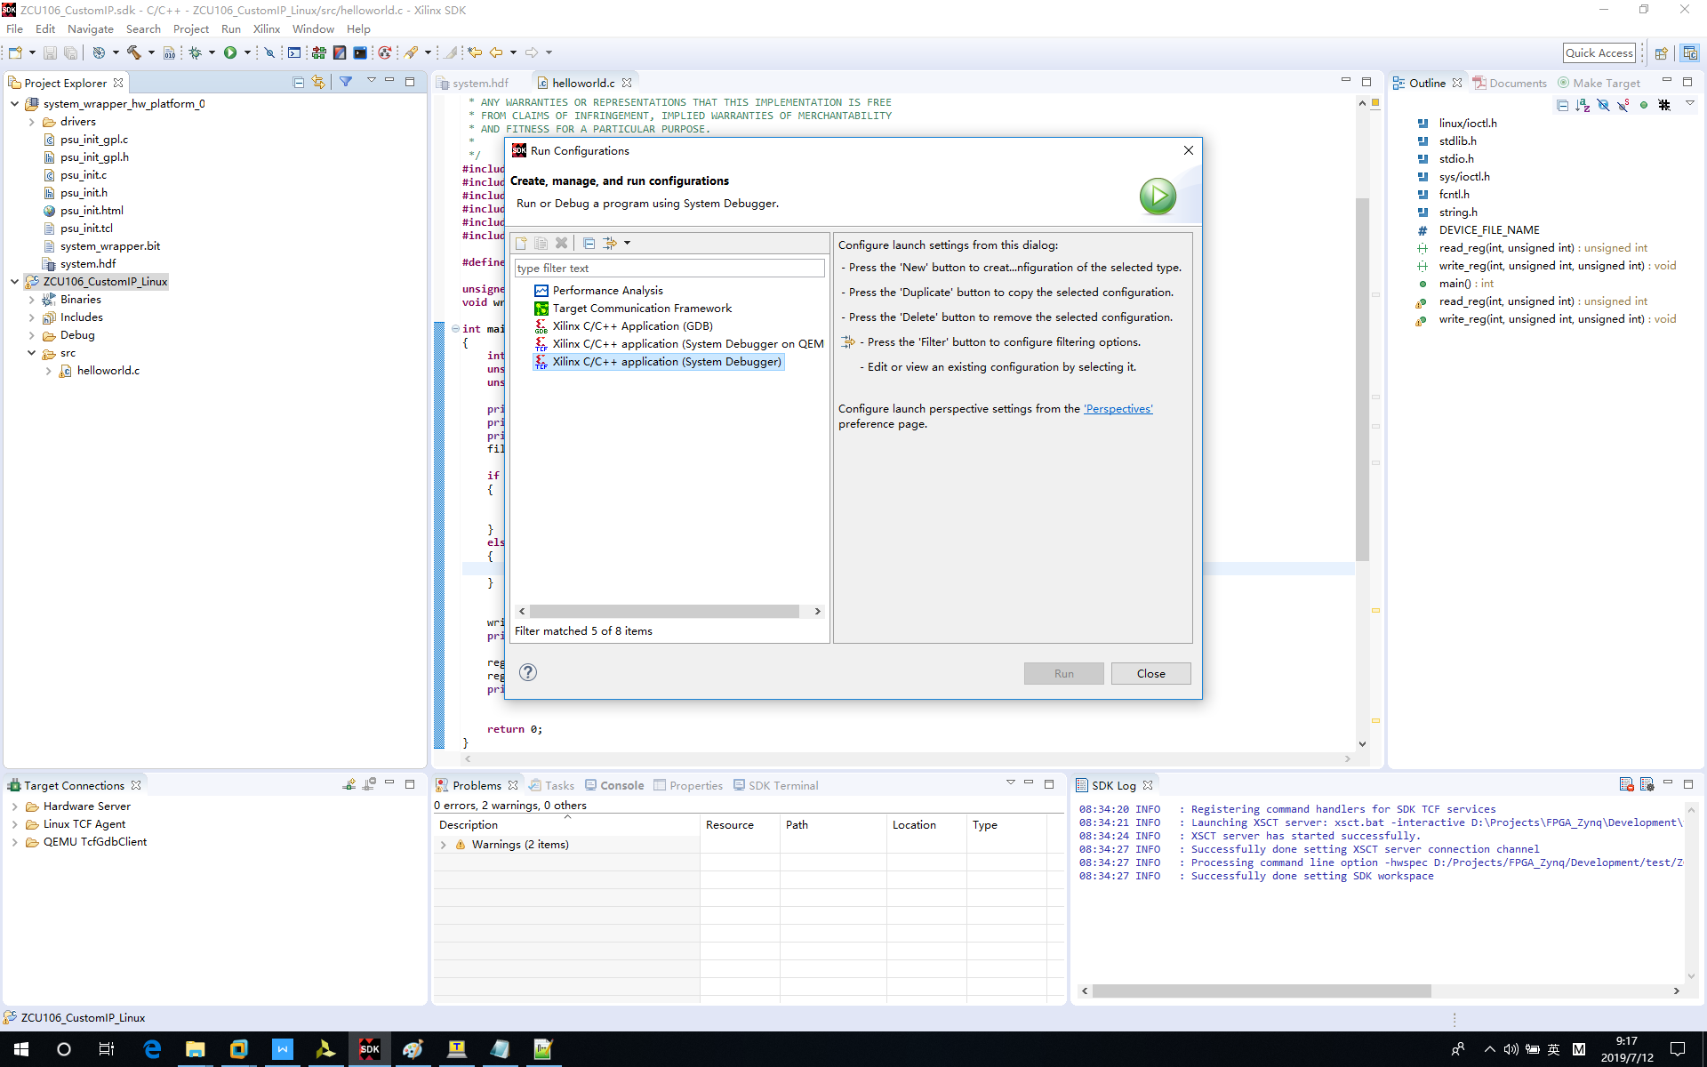

5‑21 Create “Xilinx C/C++ application (System Debugger)”

Go back to Tera Term and use ifconfig to get board IP address.

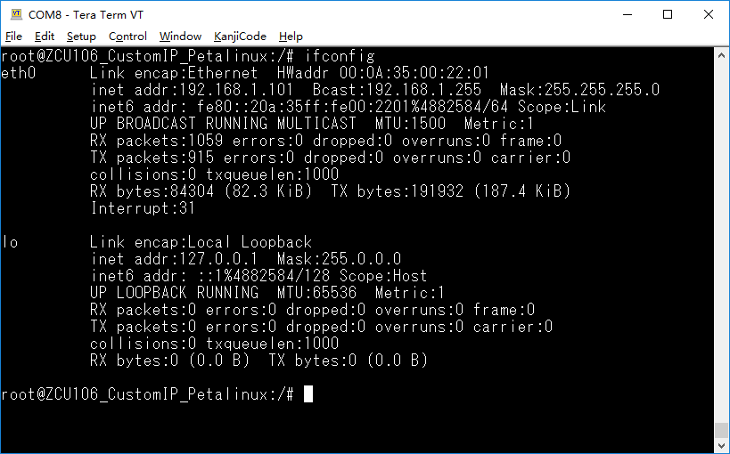

5‑22 Get Board IP

Click “New” to create new Linux Agent.

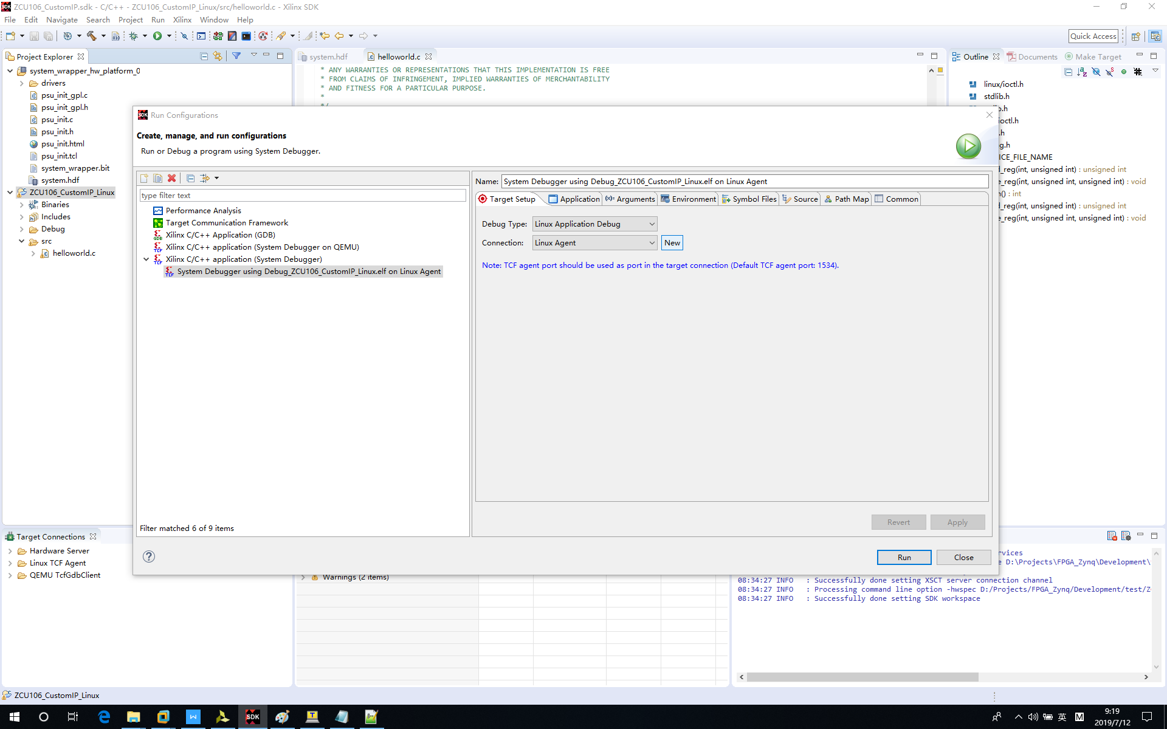

5‑23 Create Linux Agent

Input Target Name, Host IP, Check “Set as default target”.

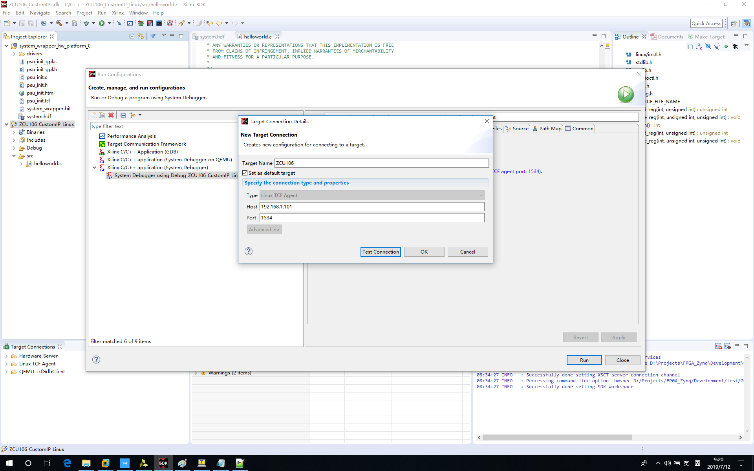

5‑24 Linux Agent Configuration

Click “Run” to run “helloworld.c”.

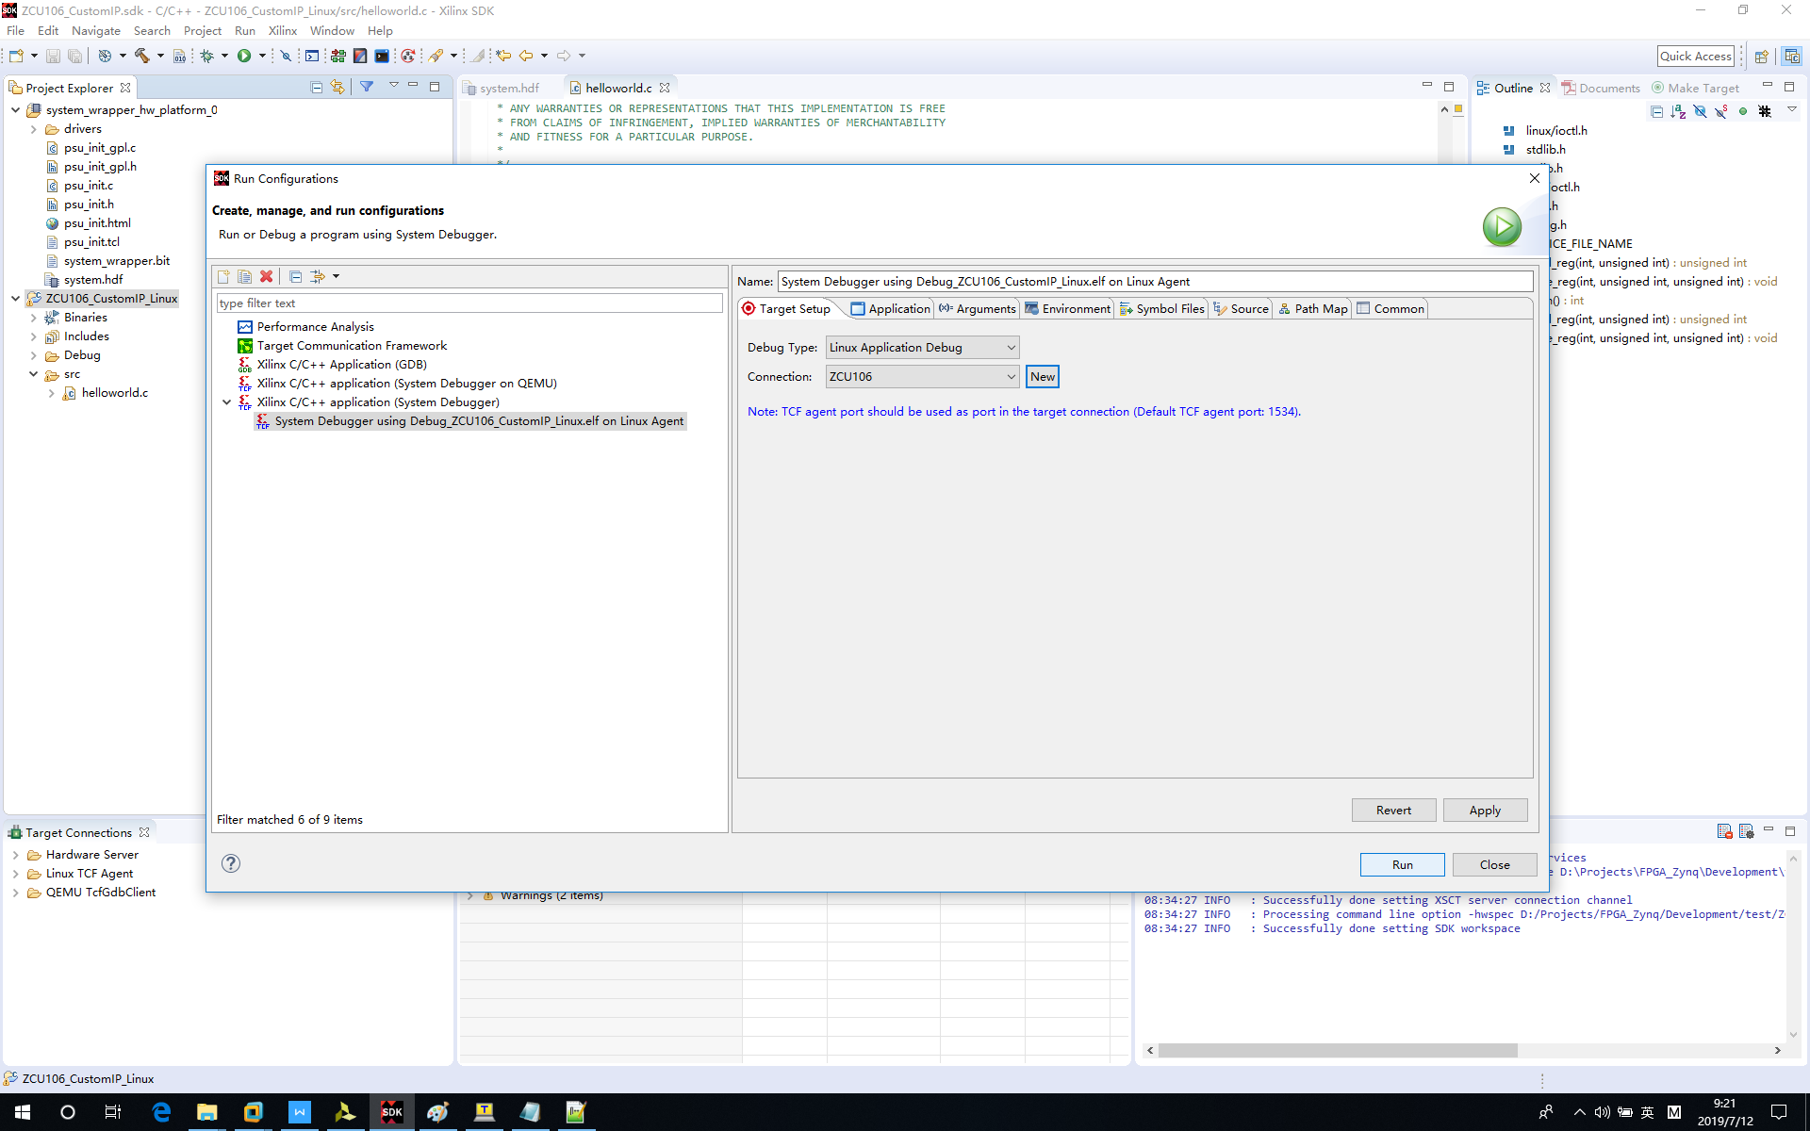

5‑25 Run Linux Application

Message is out and LED is ON. By default LED3 is ON. You can change it through updating “regValue” variable in helloworld.c.

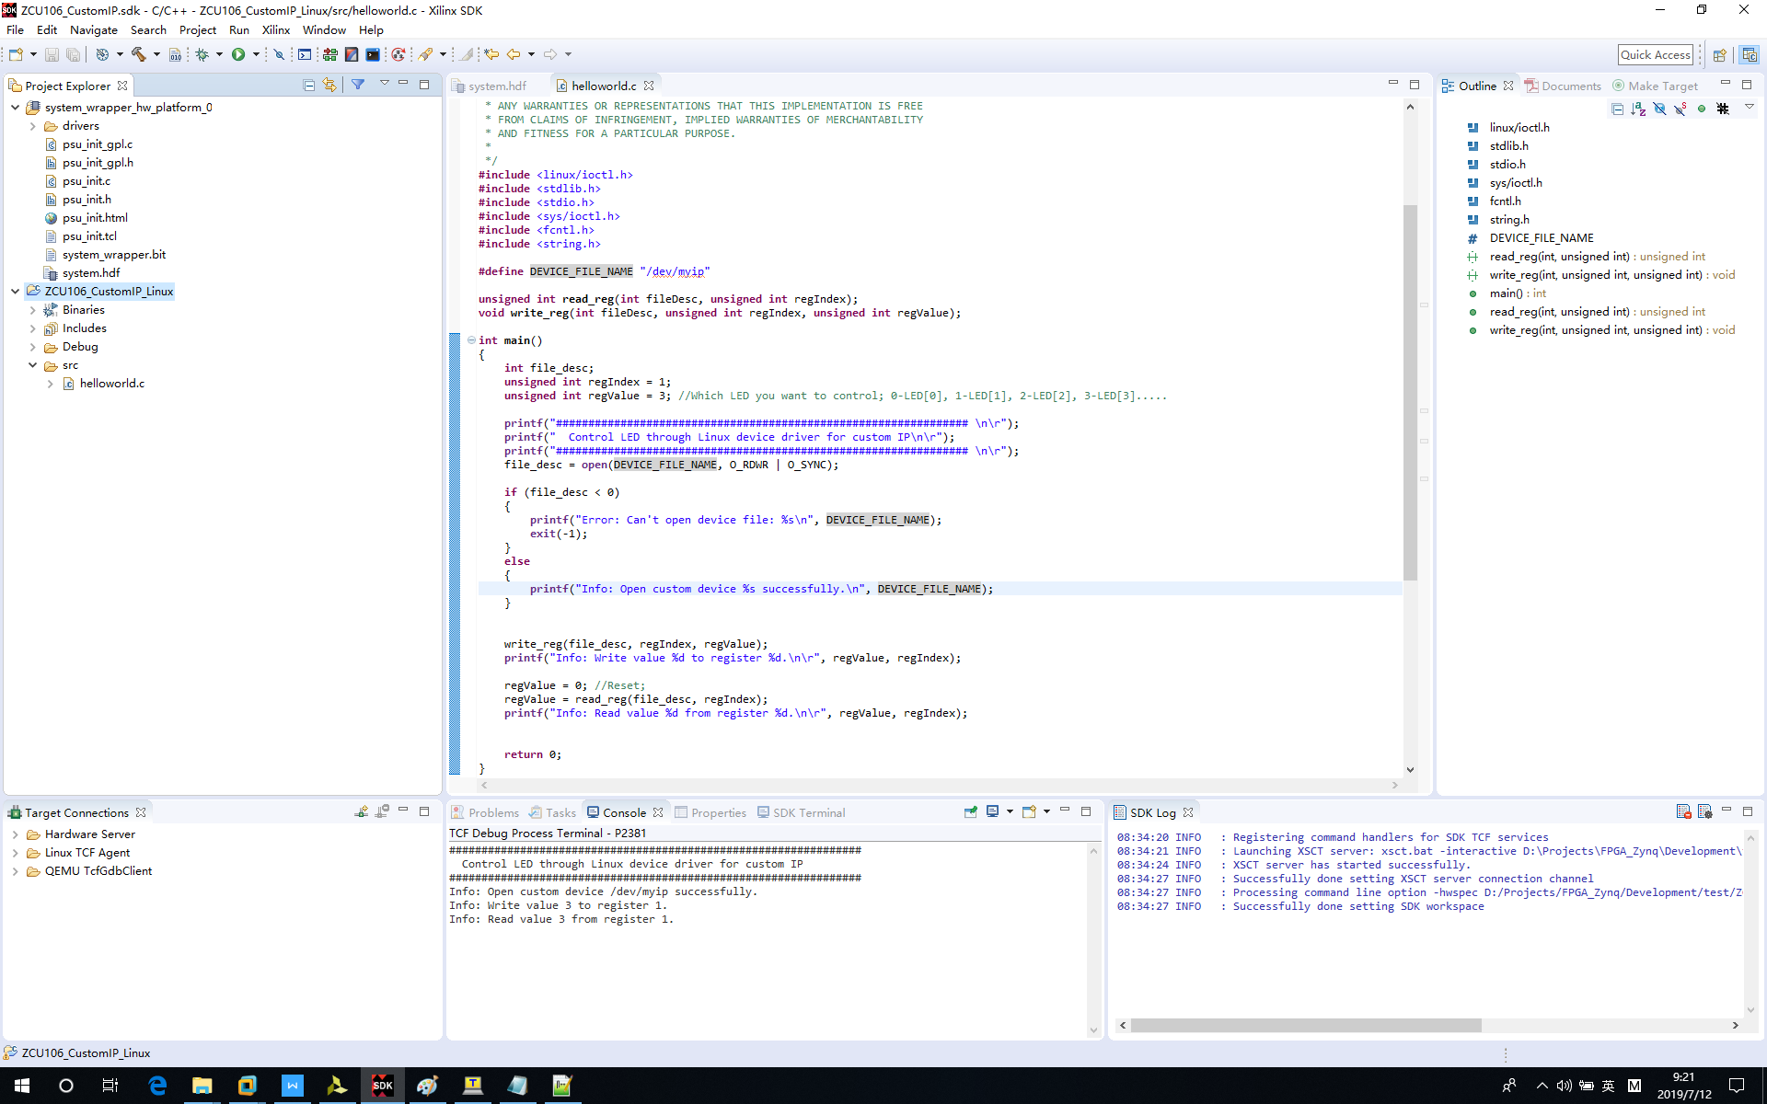

5‑26 Linux Application Message Out

# Reference

[1] <https://www.xilinx.com/products/boards-and-kits/zcu106.html>

[2] <https://www.xilinx.com/video/soc/linux-device-drivers-part-1-the-basics.html>

[3] <https://www.xilinx.com/video/soc/linux-device-drivers-part-2-platform-character-drivers.html>

[4] <https://www.xilinx.com/support/documentation/sw_manuals/xilinx2015_1/ug1165-zynq-embedded-design-tutorial.pdf>